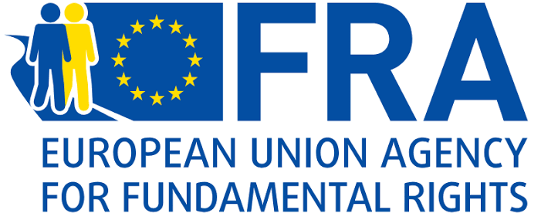
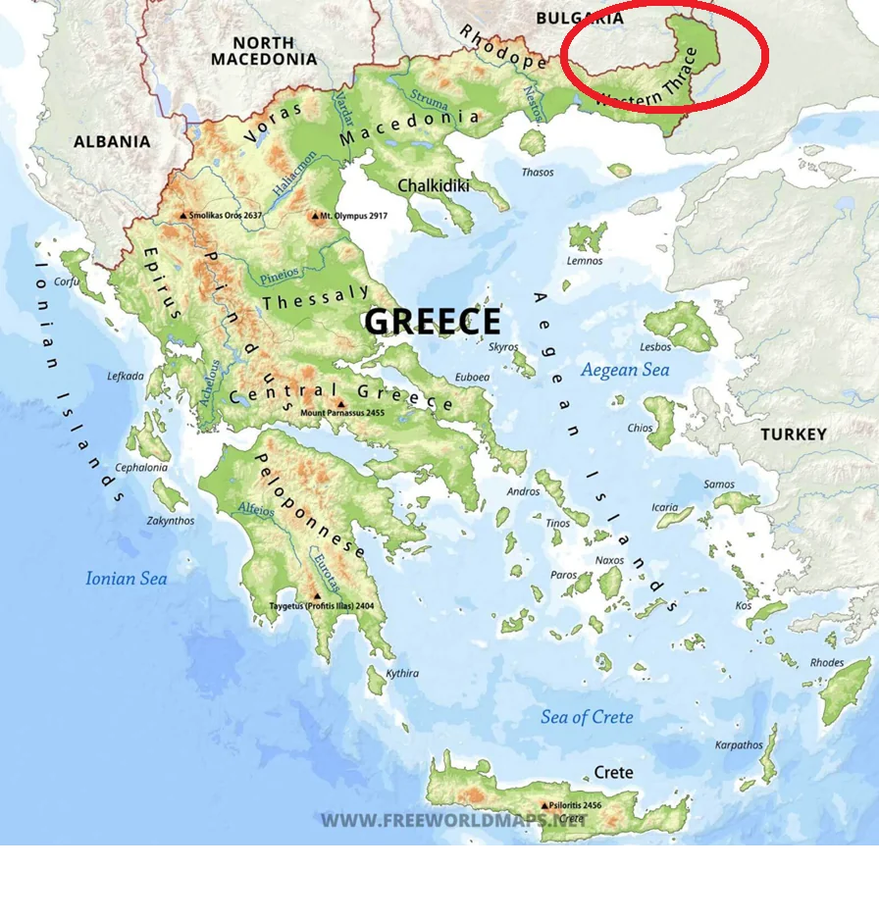
The minority rights of Western Thrace Turks are guaranteed by the Treaty of Lausanne. However, Western Thrace Turks face challenges, particularly in the field of education. There are indications that these issues may not align with certain articles of the European Union (EU) Charter of Fundamental Rights.
The research question addressed in this study is: "What challenges do Western Thrace Turks face in the field of education within the framework of the EU Charter of Fundamental Rights, and what solutions can be proposed?" My hypothesis is that "improving educational resources and teacher qualifications is necessary to alleviate the educational problems faced by Western Thrace Turks." The study's findings indicate a need to improve educational resources, increase the number of teachers, and enhance school conditions. To mitigate these issues, it is recommended that minority representatives participate more effectively in decision-making processes, that support programs for teacher training be established, and that financial and technological support be provided to minority schools.
KEY POINTS

1. The problems faced by Western Thrace Turks in the field of education raise questions regarding compliance with the articles on the right to education and the prohibition of discrimination enshrined in the European Union Charter of Fundamental Rights.

2. The problems the minority faces in the field of education pose difficulties, particularly regarding language usage.

3. To alleviate educational problems, minorities should participate in decision-making processes, and support programs should be established to train qualified teachers and provide financial support to schools.

  - Challenges Faced by Western Thrace Turks in Education: Their Relation to the European Union Charter of Fundamental Rights and Proposed Solutions

  - Role: Minority Rights Expert
  - Audience: European Commission and European Union Agency for Fundamental Rights
  - Summary

ÇAĞ POLICY BRIEF ISSUE 2026 | 2
It has had certain implications, particularly regarding the safeguarding of the right to education. Article 40 of the Treaty provides for the right of minorities to establish and manage their own educational institutions. Article 41 states that arrangements may be made to enable minorities to receive education in their own mother tongues. (Treaty of Lausanne, Articles 40–41) As is evident from these articles of the Treaty of Lausanne, the right to education is of great importance for minorities to preserve their identity, cultural existence, and language.
The minority rights contained in the Treaty of Lausanne are addressed from a broader human rights perspective in the Charter of Fundamental Rights of the European Union (EU). The aim of the Charter of Fundamental Rights prepared by a commission composed of representatives from the European Parliament, the Council of the EU, and the European Commission is to protect fundamental rights by ensuring that EU institutions respect human rights. (Metin, 2002)
1) Problems Experienced in the Field of Education and Their Relationship to Relevant Articles of the EU Charter of Fundamental Rights
The Western Thrace Turkish minority faces numerous problems in the field of education.
An overview of the Western Thrace Turks
Western Thrace is one of the geographical regions located in northeastern Greece. Comprising the prefectures of Xanthi, Komotini, and Alexandroupoli, Western Thrace has a population of between 350,000 and 400,000. The population of the Turkish minority living in the region is approximately 150,000. The Turkish presence in the Western Thrace region began with the Oman Empire's initial conquest of Didymoteicho in 1359. Subsequently, the Empire established its dominance in the region by conquering Komotini in 1360, followed by Alexandroupoli and Xanthi in 1361 (Yıldız and Erkem, 2024). The Ottoman Empire suffered a severe defeat during the Balkan Wars of 1912–1913. As a result, Ottoman rule which had lasted approximately 550 years came to an end, and the region was ceded to Bulgaria. World War I followed, necessitating another change in the region's political status. Bulgaria was defeated in the war, and the Allied Powers decided to cede the region to Greece. This arrangement was legally finalized with the Treaty of Lausanne, signed in 1923.
The legal framework established by the Treaty of Lausanne has played a decisive role in shaping the various rights of the Western Thrace Turkish minority.

POLICY BRIEF 2026 | 2
Furthermore, Greece has restricted donations to minority schools; this has led to the schools' economic weakening and, consequently, a decline in their preference among the public (Ergün, 2023).
Another issue in this regard is the provision of bilingual education in Greek and Turkish. Although instruction began in Turkish during the early years of the minority schools' establishment, it shifted to Greek dominance in subsequent years due to various factors. Amidst this confusion, minority students failed to receive adequate instruction in either their mother tongue or Greek, resulting in deficiencies in their language education.
A significant problem in the field of education is the shortage of qualified teachers. Greece established the Thessaloniki Special Pedagogical Academy (SÖPA) with the aim of reducing the number of teachers arriving from Turkey and granting teaching authorization to members of the Turkish minority in Greece. However, instruction at the academy was conducted predominantly in Greek, while Turkish-language training remained limited. Consequently, the teachers trained there lacked sufficient proficiency in Turkish grammar and professional competence. (Impramoglou and Çağla, 2025)
The problems faced by the Muslim Turkish minority living in Western Thrace raise certain questions regarding compliance with Articles 14 and 21 of the EU Charter of Fundamental Rights.
For instance, institutions that were once entirely owned by the minority gradually became semi-public entities as the state increased its intervention in educational affairs. The most significant consequence of this development was that the administration of minority-established schools eventually passed into the hands of the Greek state. (Impramoglou and Çağla, 2025)
Another major issue in the field of education concerns the use of Turkish textbooks. In 1969, Greece banned the distribution of certain Turkish textbooks printed in Turkey. Consequently, minority schools were forced to use outdated editions, which negatively impacted education. The Turkish minority staged a boycott in 2015 in response to this situation. Following the boycott, the use of these textbooks resumed after the Greek Pedagogical Institute approved certain textbooks printed in Turkey. (Impramoglou and Çağla, 2025)
The closure of certain minority schools is also a significant issue. Eight minority primary schools were closed in the 2020–2021 academic year, 12 in 2021–2022, and four in 2022–2023. Although the Greek State cites insufficient student numbers and economic reasons for these closures, it is considered that this practice fails to comply with Article 40 of the Treaty of Lausanne, which enshrines the right of minorities to establish and manage their own educational institutions.
POLICY BRIEF 2026 | 2
As previously mentioned, issues regarding the provision of textbooks, insufficient teacher proficiency in the mother tongue, and the shift from initial Turkish-language instruction to the dominance of Greek-language instruction in later stages—resulting in inadequate education in both languages—have negatively impacted the ability of minority groups to use their mother tongue.
On the other hand, the use of the mother tongue is crucial, particularly for minority communities to preserve their cultural identities and pass them on to future generations. Therefore, it is essential to keep the language alive and preserve it through active use.
3) Proposed Solutions for Addressing Problems in the Field of Education
Although the European Union Charter of Fundamental Rights is an important legal document concerning the right to education and the prohibition of discrimination, these rights fall short in alleviating the problems minorities face in the field of education. Various solutions could be proposed to address these shortcomings.
Recommendations:
• The first proposal I developed regarding this matter is that decision-makers within minority schools and educational processes should consist of minority representatives. The education received in schools shapes people's futures; therefore, members of minority groups should shape their own futures, and minority representatives must play an active role in school administration.

POLICY BRIEF 2026 | 2
Article 14 of the Charter of Fundamental Rights guarantees the freedom to establish educational institutions and the right of everyone to education (European Parliament, Council of the EU, and European Commission, 2000). However, as previously noted, Greece is intervening in the administration of minority schools and reducing their number. Additionally, issues regarding the use of Turkish textbooks and a shortage of qualified teachers are matters that must be considered under this article. Article 21 stipulates that there shall be no discrimination based on grounds such as sex, race, colour, ethnic or social origin, language, religion or belief, political or any other opinion, or membership of a national minority (European Parliament, Council of the EU, and European Commission, 2000). Practices such as the refusal to accept donations for minority schools and the denial of rights granted to state schools indicate differential treatment between minority schools and state schools. These disparities constitute situations that must be evaluated within the scope of Article 21, which prohibits discrimination.
2) The Negative Impact of the Problems Faced by the Minority in the Field of Education on the Ability to Use Their Mother Tongue
Language is the vehicle that transmits the history, culture, and identity of a community speaking the same language to future generations.
Therefore, language is not merely a tool for communication. Furthermore, the development of a language depends largely on its use in cultural, social, and scientific spheres. For this reason, the use of the mother tongue as the medium of instruction is of great importance. (Osman, 2016)
REFERENCES
1. Ergün, H. (2023). Birlik ve Rodop Rüzgârı Haberlerinde Batı Trakya Türklerinin Eğitim Sorunları. İnsan Ve Toplum Bilimleri Araştırmaları Dergisi, 12 (3), 1989-2008.
2. Impramoglou, G., & Çağla, C. (2025). Batı Trakya Müslüman Türk Azınlığının Sorunları: Eğitim. Dumlupınar Üniversitesi Sosyal Bilimler Dergisi, 83, 247-267.
3. Metin, Y. (2002). Avrupa Birliği Temel Haklar Şartı. Ankara Üniversitesi SBF Dergisi, 57(04).
4. Taş, G. (2025). Avrupa Birliği kurucu antlaşmalarında azınlık hakları ve çokkültürlülük yaklaşımları çerçevesinde incelenmesi. Disiplinlerarası Yenilik Araştırmaları Dergisi
5. Yılmaz, G. (2015). Avrupa'da Azınlıklar ve Azınlık Hakları. Ankara Avrupa Çalışmaları Dergisi, 14 (2), 109-122.
6. Avrupa Parlamentosu, Avrupa Birliği Konseyi, & Avrupa Komisyonu. (2000). Avrupa Birliği Temel Haklar Şartı (2000/C 364/01)https://www.ceidizleme.org/ekutuphaneresim/dosya/687_1.pdf
7. Türkiye Büyük Millet Meclisi. (1923). Lozan Sulh Muahedenamesi. Türk Tarih Kurumu. https://www.ttk.gov.tr/wp-content/uploads/2016/11/3-Lozan13-357.pdf
8. Osman, N. (2016). Batı Trakya Türklerinin Ana Dili Korunumu, Dil Kullanımı ve Kimlik Algıları. (Yüksek lisans tezi, Trakya Üniversitesi) https://avesis.trakya.edu.tr/yonetilen-tez/b395a6f5-c365-41df-9cc4-829f079c80ca/bati-trakya-turklerinin-ana-dili-korunumu-dil-kullanimi-ve-kimlik-algilari
9.

Author: Sude Nur Akbulut, Undergraduate student in the Department of International Relations at Çağ University.
This Policy Brief has been prepared as part of the participants / students’ assessment in the framework of the EU Politics lecture.
The content of this policy brief lies entirely with the author. It does not reflect the official opinion of Çağ University.
• As noted in the first section, there are challenges regarding the training of qualified teachers. In this context, another proposal I have developed is the need to organize support programs to enhance teachers' professional competence and their command of their native language. These support programs should specifically include courses on the effective use of the native language and provide practical training through internships in minority schools. Such support programs would increase the number of qualified teachers, which in turn would have a positive impact on resolving issues within minority education.
• Another recommendation of mine is to provide financial support to improve the educational conditions of minority schools. This support should be used specifically to upgrade the technology infrastructure in schools, facilitate access to educational resources, and enhance educational facilities.
Key idea to stress out
Although minority rights are guaranteed by the Treaty of Lausanne, the Turks of Western Thrace face challenges, particularly in the field of education. To alleviate these issues and ensure protection in line with the EU Charter of Fundamental Rights, minority representatives must play an active role in the management of educational institutions. At the same time, support programs should be established to train qualified teachers, and financial support should be provided to ensure access to technological and educational resources in schools.

