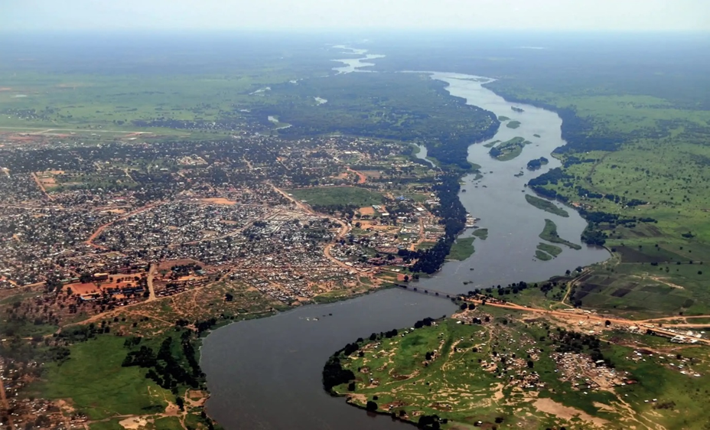
The Nile is one of the world's longest rivers, and the countries situated within the Nile River basin are Eritrea, Egypt, Burundi, Tanzania, Rwanda, the Democratic Republic of the Congo, Kenya, Uganda, Sudan, Ethiopia, and South Sudan (Paisley, 2017). The fact that the Nile flows through these countries significantly impacts them in both political and economic terms. The Nile is fed by two main tributaries; one is the Blue Nile, which originates in Ethiopia, and it appears to provide the majority of the river's water. The Blue Nile is also of great importance for Ethiopia's hydroelectric power generation. Indeed, the Grand Ethiopian Renaissance Dam (GERD) harnesses the waters of the Blue Nile and has an installed capacity of 5,150 MW (Webuild, 2026). Rapid population growth and the risk of drought in the region also appear to be placing immense pressure on the Nile. Furthermore, the inequitable water-sharing regime stemming from historical disputes, combined with climate change, is escalating regional tensions regarding the Nile's waters.
Image source: TELGRAF GAZATESİ(2023)
Summary
KEY POINTS
1. Renaissance Dam (GERD) represents a cornerstone of Ethiopia's national energy strategy.
2. A vast majority of Egypt's population lives along the banks of the Nile River and relies on it to meet their freshwater needs.
3. Developing a shared approach to water management among the basin countries is also required to alleviate issues surrounding the Nile River.
The Political-Economic Impact of the Nile River Dam on the Region

Role: Regional Policy Analyst
Audience: Water Resource Authorities of Nile Basin Countries

ÇAĞ POLICY BRIEF ISSUE 2026 | 1

The Grand Ethiopian Renaissance Dam: A Game-Changer
Renaissance Dam (GERD) represents a cornerstone of Ethiopia's national energy strategy. It was designed to double national energy production and generate a surplus sufficient for export to neighboring countries, including Kenya, Sudan, Djibouti, and Tanzania. Construction of the GERD has been largely funded through local resources; beyond its technical significance, the dam holds immense strategic and institutional value.
GERD has also significantly benefited the surrounding region. It has generated both economic and social impacts through the establishment of facilities such as schools, sports complexes, hospitals, medical clinics, and bakeries. The construction of this dam has effectively created a new town. Furthermore, since the majority of the workforce employed at the dam were Ethiopians, they have gained valuable expertise for future projects. (Webuild, 2025)
Impacts on Egypt and Sudan
Although Ethiopia views the dam as a means to accelerate development and generate energy, the situation is vastly different for Sudan and Egypt. They believe the dam will obstruct the natural flow of the Nile; furthermore, as both nations rely heavily on the river, they regard this project as a major national security crisis. Key factors driving this perspective include the uncertainty surrounding the filling timeline and water-sharing arrangements, as well as the significant potential impact on economic activities.
Egypt
A vast majority of Egypt's population lives along the banks of the Nile River and relies on it to meet their freshwater needs.
Since Egypt’s economic and social structure is heavily dependent on the Nile River, the construction of the Grand Ethiopian Renaissance Dam (GERD) poses a serious strategic threat to the country (Aydın, 2019).
POLICY BRIEF 2026 | 1
Strategic Solutions
Beyond the Nile River's economic and political significance in the region, it is necessary to mitigate disputes regarding the sharing of water resources; therefore, cooperation among the countries in the region must be strengthened. Information sharing is essential—particularly among Ethiopia, Sudan, and Egypt, which play major roles—regarding the processes of filling and operating the dams. Developing a shared approach to water management among the basin countries is also required to alleviate issues surrounding the Nile River. In particular, collaborative action by these countries regarding water usage and allocation could help reduce existing disputes (Aydın, 2019).Furthermore, maintaining discussions regarding the use of Nile waters on a regular basis—rather than only during times of crisis—would make a significant difference. Establishing a long-term cooperation framework that takes into account the parties' diverse priorities—such as agriculture, the economy, water security, and energy production—could help alleviate regional tensions.
Furthermore, Egypt views the Nile River as a matter of national security; consequently, even a minor restriction associated with the GERD project is perceived as a threat. One of Egypt's concerns is that a reduction in water flow during the dam's filling process could cause the agricultural sector to collapse, potentially leading to unemployment and a food crisis. Therefore, it is crucial for the parties to reach a mutual agreement regarding the sharing of the Nile's waters.
Sudan
Compared to Egypt, Sudan adopts a more positive and balanced approach toward the GERD. Regulating the water flow of the Blue Nile could help reduce river flooding in Sudan. A study projected that, under cooperative operation of the GERD, the proportion of years in which at least one flood alert is issued for Khartoum could drop from 37% to 11% (Basheer, 2021).Sudan could also benefit economically from lower-cost electricity supplied by Ethiopia. Therefore, although Sudan generally views the project favorably, it harbors concerns regarding potential uncertainties surrounding water release. Another of Sudan's fears is that the Roseires Dam—one of its key dams—could be jeopardized in terms of both agricultural operations and safety.
POLICY BRIEF 2026 | 1
3. Paisley, R. K. (2017, August 27). Why the 11 countries that rely on the Nile need to reach a river deal soon. The Conversation https://theconversation.com/why-the-11-countries-that-rely-on-the-nile-need-to-reach-a-river-deal-soon-75868
4. Webuild. (2025, September 9). Grand Ethiopian Renaissance Dam (GERD) inaugurated, biggest hydropower project ever built in Africa https://www.webuildgroup.com/en/media/press-releases/grand-ethopian-renaissance-dam-gerd-inaugurated/
REFERENCES:
1. Basheer, M. (2021). Cooperative operation of the Grand Ethiopian Renaissance Dam reduces Nile riverine floods. River Research and Applications, 37 https://doi.org/10.1002/rra.3799
2. Maskan, A. (2021). Rönesans Barajı’nın Etiyopya, Mısır ve Sudan ilişkilerine etkisi-2. Kriter Dergi https://kriterdergi.com/dosya-tarim/ronesans-barajinin-etiyopya-misir-ve-sudan-iliskilerine-etkisi

Author: ____________________
This Policy Brief has been prepared as part of the participants / students’ assessment in the framework of the EU Politics lecture.
The content of this policy brief lies entirely with the author. It does not reflect the official opinion of Çağ University.

