POLICY BRIEF ISSUE 2026 | 3

Tax Incentives & Production Competition in Hollywood

Summary

KEYPOINTS

- As manufacturing activities shifted away from California due to increased competition, the state resorted to increasing tax incentives.

- Studios, employees, and local businesses can benefit from the incentives, but a portion of the cost is reflected in the public budget.

- The competition to produce films is increasingly tying private companies investment decisions to government incentives.
The main purpose of this policy brief is to analyze from the perspective of political economy the tax incentives offered by California to prevent film and television productions from shifting out of the state. Increasing competition at the global and national levels has caused the private sector's production location preferences to change. While the loss of employment and economic activity experienced as a result has made the cinema sector a matter of public policy. In this context, California significantly expanded the film and television tax credit program in 2025 and expanded the support to include post production processes in 2026. This policy brief highlights the potential of these incentives to attract production, investment and employment to California, but also notes that the loss of public revenues has significant economic consequences. While studios, industry professionals, and local businesses benefit from this policy, a portion of the cost is borne by the public budget. The key policy takeaway is that the program's success should be judged not only by total expenditure or project size, but by the value it creates in terms of additional production and employment that would not have occurred in California without the incentives, compared to the public cost.



[Figure1]

POLICY BRIEF 2026 | 3

The Shift of Film Production Out of California & Tax Incentive Policy
Although California has been the center of the United States film and television industry for many years under the influence of Hollywood, it has recently lost some of this position. According to Legislative Analyst's Office data, California's employment share in the US film industry was over 54% in 2010, but has decreased to 46% in 2023. This decline cannot be explained only by tax policy also with the pandemic, the actor and screenwriter strikes in 2023 and the general decrease in production in the sector have also been important factors. In addition, lower costs and strong incentives offered by states such as New York, Georgia and New Mexico, as well as countries such as Canada, the United Kingdom and Australia, have made Californias competitive situation difficult. The fact that film production can be moved to other places with crews, actors and materials leads studios to pay more attention to cost and incentive elements when choosing a production location. Outdoor shooting permits in Greater Los Angeles will increase to 19 by 2025. It decreased by 16.1% compared to the previous year, falling to 694 shooting days. This decrease reveals that Hollywood's cultural influence alone doesn’t guarantee that productions will remain in California for economic reasons. Shifting productions to different regions negatively affects not only studios but also technical teams, suppliers and local businesses serving the film industry. Thus, the investment decisions of the private sector related to costs have become a political issue for the provincial government due to the effects it will have on employment and local economic activities. California's decision to increase tax incentives is part of efforts to minimize this loss and preserve Holywood's status as a production hub. [1][2]
In 2025, California significantly expanded its Film and Television Tax Credit Program, thereby increasing its competitiveness. The annual tax credit amount of this program has been increased from $ 330 million to $ 750 million as of the 2025 2026 financial year and it has been decided that this level will continue until 2029 2030. With the same regulations, the types of productions that can benefit from the program have been expanded. It has been stated that a total of 170 projects will be eligible to receive tax credits in the first year of the expanded program, between July 2025 and June 2026. According to the California Film Commission, these projects generated approximately $6.6 billion in direct production expenses in the state, ranking 34th. It is planned to provide team members with 921 players. However, these figures indicate the total estimated level of activity of the projects receiving support, not the net gain of the tax incentives to the California economy. In September 2026, a new tax incentive was also implemented, covering post-production activities such as editing, sound, music, and visual effects. This shows that California aims to ensure that not only the filming. But also the more complex stages of film production remain within the state.This policy constitutes an example of an open political economy aimed at changing the decisions of private companies in the direction of production and also investment by using the state tax system. The most important issue here isn’t overall size of the supported projects. But how much production and employment there is that would not be realized in California without this public support. [3][4][5]

POLICY BRIEF 2026 | 3

Economic Effects & Public Cost of Tax Incentives
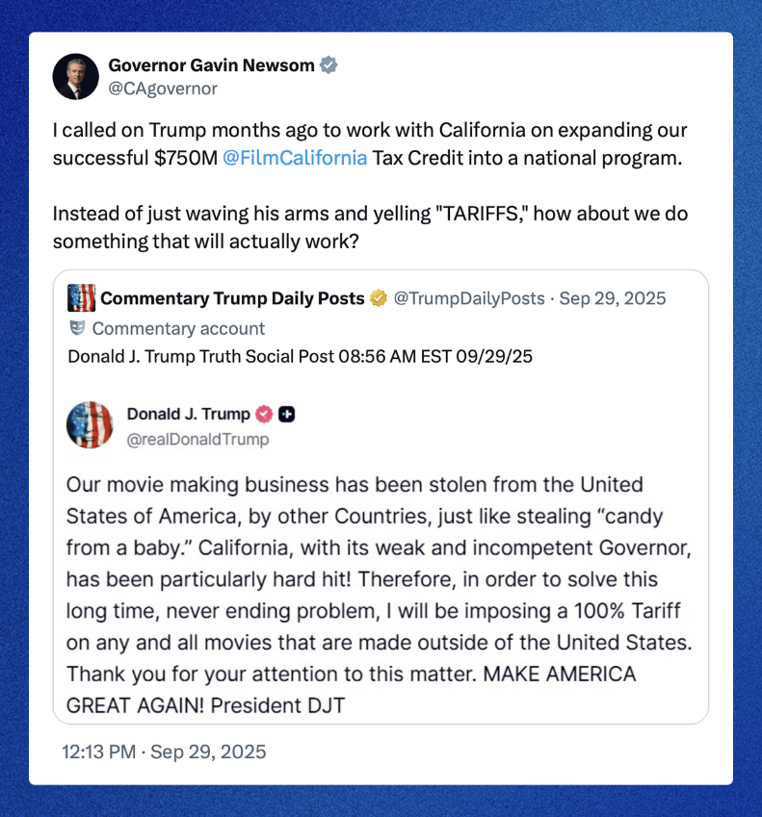
In order to understand whether tax incentives are really effective, we first need to look at whether companies have changed their decisions about movie or TV production locations. Amazon Prime Video's series Fallout provides a current and concrete example of this. While the first season of the series was filmed in New York, the second season was moved to California with $25 million in tax incentives. The third season remained in California with an additional tax credit of October 42 million and provided employment for approximately 600 employees and 30 actors in the project. Jonathan Nolan, the executive producer of the series, stated that tax incentives were instrumental in bringing the production back to California. This example shows that public incentives can indeed affect where at least some major projects are located. However, more comprehensive academic findings show that this effect isnt guaranteed to translate directly into economic development. Patrick Button proposed a study examining film incentives in US states. In this study, it was revealed that these supports affect the filming locations of television series, but feature films did not find a significant and consistent effect on employment, wages and the number of businesses in the industry. Therefore, the arrival of a production in California doesn’t equate to the growth of the state's overall economy. This difference shows that the political justifiability of film incentives doesn’t necessarily mean they are economically efficient in all cases. [6][7]
The advantages and disadvantages of this policy are not distributed equally among all stakeholders. While studios that benefit from the tax advantage benefit by spending less on production, projects performed in California can create additional income opportunities for industry employees and local businesses. However, support for projects to be carried out in California without incentives means that no new economic activity is created, despite the waiver of public revenue. The expanded program is expected to reduce the state's tax revenues by approximately $209 million annually during the 2028-2029 period. Therefore, the program's success should be evaluated not only by the number of projects supportedit but also by the additional production and employment actually achieved through the incentive. If California's goal is to preserve Hollywood's industry influence, the economic benefit provided through public funds must be continuously compared. The main issue isn't about keeping Hollywood in California at all costs, but its about demonstrating whether public resources truly create new economic value. [1][3]
[Figure1]

FOOTNOTES

- Button, P. (2019). Do tax incentives affect business location and economic development? Evidence from state film incentives. Regional Science and Urban Economics, 77, 315–339. https://doi.org/10.1016/j.regsciurbeco.2019.06.002
- California Film Commission. (2026, July 7). Lights, camera, action! 41 new film projects to receive California’s Film & T.V. Tax Credit; first year of expanded program projected to bring $6.6 billion in economic impact. https://film.ca.gov/lights-camera-action-41-new-film-projects-to-receive-californias-film-first-year-of-expanded-program-projected-to-bring-6-6-billion-in-economic-impact/
- Chmielewski, D. (2026, June 16). ‘Fallout’ producer lauds tax breaks for luring show to Hollywood. Reuters. https://www.reuters.com/legal/transactional/fallout-producer-lauds-tax-breaks-luring-show-hollywood-2026-06-16/
- FilmLA. (2026, January 15). Rising California film & TV tax credit productions signal growing industry momentum amid 2025 production losses. https://filmla.com/rising-california-film-tv-tax-credit-productions-signal-growing-industry-momentum-amid-2025-production-losses/
- Legislative Analyst’s Office. (2025, February 28). The 2025–26 budget: California’s film tax credit. https://lao.ca.gov/Publications/Report/5000
- Legislative Analyst’s Office. (2025, October 16). The 2025–26 California spending plan: Other provisions. https://www.lao.ca.gov/Publications/Report/5081/
- Office of Governor Gavin Newsom. (2026, September 19). Governor Newsom expands film and TV tax credits with new legislation, creates tax credit to support post-production jobs. https://www.gov.ca.gov/2026/09/19/governor-newsom-expands-film-and-tv-tax-credits-with-new-legislation-creates-tax-credit-to-support-post-production-jobs/

4

