As an independent energy policy analyst advising European institutions, this brief addresses a core question : How can the EU overcome its winter gas deficit without causing industrial shutdowns or dependency on volatile LNG markets
? Regional conflicts in the Middle East and a January ban on Russian LNG contracts leave the EU with a gas shortfall of up to 14 billion cubic meters. In addition, European gas reserves sit at record lows because commercial traders sold gas during high summer prices. Relying entirely on US LNG is both costly and limited by terminal capacities. This brief argues against uncoordinated spot purchases. It reccomends mandatory storage baselines, joint EU gas purchasing, and early industrial efficiency measures.
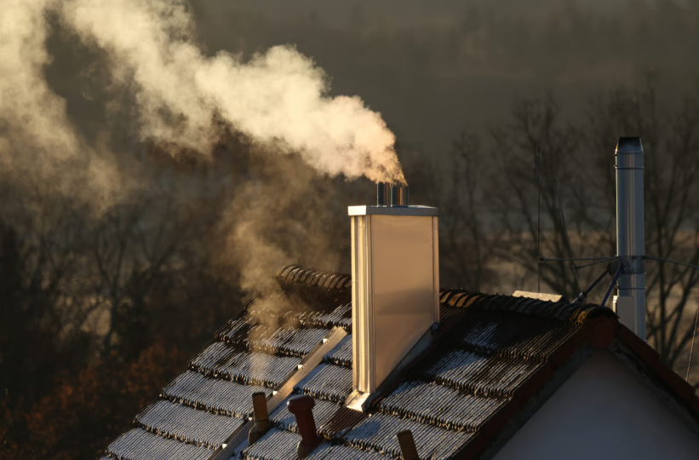

KEY POINTS

1.Supply Deficit: The EU faces a 14-billion-cubic-meter gas shortage this winter, threatening power for 12 million homes.

2.Depleted Storage: Summer gas sales pushed European reserves to record lows, leaving minimal buffers against cold weather.

3.Strategic Vulnerability: High reliance on expensive US LNG and bans on Russian contracts create serious price and industrial risks.

  - Managing the Winter Gas Deficit: Strategic Energy Vulnerabilities and Policy Options for the EU
  - Role: Independent Energy Policy Analyst
  - Target group: European Commission

  - Summary

ÇAĞ POLICY BRIEF ISSUE 2026 | 3
1- MOUNTING SUPPLY DEFICITS AND GEOPOLITICAL SHOCKS
The Europen Union approaches winter with severe energy security risks. Continued conflicts in the Middle East has disrupted global supply routes, creating an estimated winter deficit of 14 billion cubic meters. This shortfall equals 7% of total EU demand and affects energy for 10 to 12 million households. Additionally, an EU ban on Russian long-term LNG contracts begins in January, eliminating another 7 billion cubic meters. With pipeline imports flat and historical Russian buffers gone, Europe depends entirely on storage withdrawals and seaborne LNG shipments.
2- DEPLETED RESERVES AND COMMERCIAL STORAGE RISKS
Europe’S internal energy buffer is dangerously low. Storage levels fell to roughly 70%, the lowest seasonal level since 2011. This drop occurred because elevated summer prices led energy traders to sell gas immediately rather than storing it for winter needs. European gas network operators (ENTSO-G) warn that a cold winter could deplete reserves to 11%, reaching critical operational limits.

POLICY BRIEF 2026 | 3
Entering spring with emptied tanks would force countries to refill reserves at four-year high prices, causing price spikes, higher consumer bills, and prolonged market vulnerability.
3- STRATEGIC AUTONOMY AND THE LIMITS OF IMPORT SUBSTITUTION
Substituting pipeline shortfalls with imported LNG exposes critical strategic limitations. Most imported supplies come from the United States, where export terminals operate near full capacity. Replacing lost gas volumes would cost Europeans an additional 3 billion euros, a 12% increase from previous rates. High energy prices also damage European industry. European manufacturing has already lost 20% of its gas demand since 2022. Forcing factory cuts to protect a 30% storage minimum would harm economic competitiveness. The EU cannot replace old pipeline dependencies with price volatility on international LNG markets.
POLICY RECOMMENDATIONS :
To prevent winter shortages and protect industry, the EU should take three targeted actions :

“Vivamus porta
est sed est.”
FOOTNOTES
1. Munster, B. (2026, October 9). EU faces gas supply shortage as winter looms. POLITICO Europe.
https://www.politico.eu/article/eu-faces-gas-supply-shortage-iran-war-winter-looms/
2. Institute for Energy Economics and Financial Analysis (IEEFA). (2026). Europe’s Winter Gas Dilemma : Storage Deficits and Global Supply Risks.
https://ieefa.org/resources/europe-bets-mild-winter-when-it-should-be-cutting-gas-demand
3. European Network of Transmission System Operators for Gas (ENTSO-G). (2026).
https://www.entsog.eu/sites/default/files/2026-10/SO0072-26_Winter%20Supply%20Outlook%202026-27.pdf
4. European Commission. (2022). REPowerEU Plan : Joint European Action for more affordable, secure and sustainable energy. COM(2022) 230 final.
https://eur-lex.europa.eu/TodayOJ/index.html?uri=COM:2022:230:FIN
5. Tagliapietra, S., & Zachmann, G. (2023). Building a European Energy Union that works : Security, competitiveness, and climate goals. Bruegel Policy Brief, Issue 14/2023.
https://www.bruegel.org/policy-brief/better-coordination-for-a-more-efficient-european-energy-system

-Enforce a 30% Storage Floor : Mandate a minimum 30% gas storage level by winter’s end and restrict summer offloading to ensure physical reserves for cold spells.
-Expand Joint Purchasing (AggregateEU) : Pool EU buying power to purchase LNG collectively, preventing member states from competing against each other and driving up spot prices.
-Support Industrial Efficiency : Incentivize voluntary energy savings in factories and heating before peak winter, avoiding forced shutdowns and safeguarding industrial output.

Author : Özge Nur Yılmaz

This Policy Brief has been prepared as part of the participants / students’ assessment in the framework of the EU Politics lecture.
The content of this policy brief lies entirely with the author. It does not reflect the official opinion of Çağ University.

