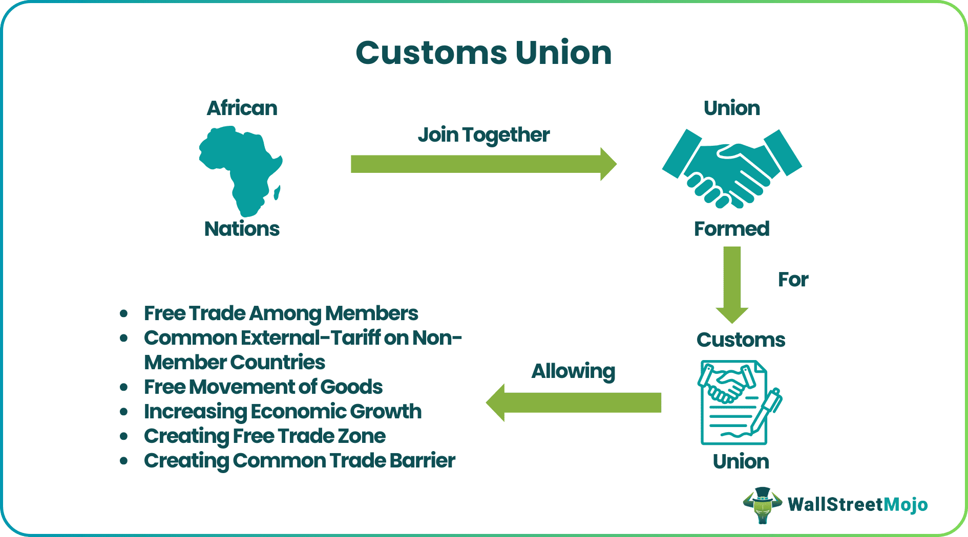
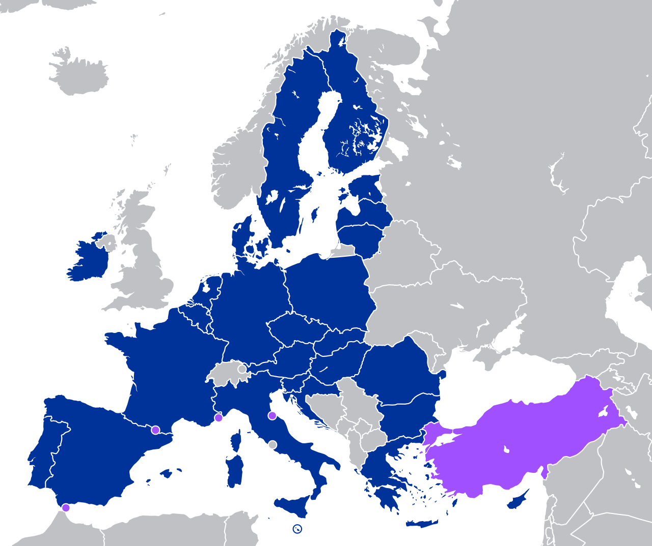
The Customs Union was established by the founding members of the European Union to eliminate trade barriers and create a common market in Europe. Turkey, viewed as a strategic partner of the EU, is also among the Union's members. However, it has been observed that certain aspects of the Customs Union have negatively affected Turkey's economy.
The research question of this policy paper is: "What are the negative impacts of the Customs Union on Turkey's economy, and what solutions can be proposed?" My hypothesis regarding this issue is that the formulation of joint trade and competition policies would alleviate these problems. The findings of my research indicate that the issues encountered have led, in particular, to a loss of competitiveness. My recommendation in this regard is the development of joint trade and competition policies.
KEY POINTS

1. The Customs Union has certain negative economic effects on Türkiye.

2. It has been determined that the adverse situations experienced have had an impact on the loss of competitiveness, particularly in the economic sphere.

3. It has been proposed that common competition and trade policies be established to alleviate economic problems.

  - Summary
  - Disadvantages of the Customs Union for the Turkish Economy within the Context of Türkiye-European Union Relations and Proposed Solutions

  - Role: Economic Policy Expert
  - Audience: Turkish Ministry of Trade and Ministry of Foreign Affairs

ÇAĞ POLICY BRIEF ISSUE 2026 | 3
The Customs Union was established by the founding countries of the European Union (EU) with the aim of creating a common market, accelerating economic development, eliminating quotas, lowering tariffs, adopting common trade policies, and increasing economic prosperity. Achieving economic integration is also among the objectives of the Customs Union.
The Customs Union has had a positive impact on the Turkish economy in many respects. First and foremost, it has transformed Turkey’s economic structure, leading to increased productivity and improved product quality. It has also fostered competitiveness, enabling Turkey to become an integral part of the European production chain in sectors such as automotive, textiles, and white goods. Consequently, it is evident that European companies view Turkey as a production hub. This has facilitated integration into the global trade chain. In line with this, investments in Turkey come predominantly from European companies. This is crucial, as foreign investment generates employment and brings in foreign currency—outcomes that the Customs Union helps to encourage.
1) Negative Effects of the Customs Union on the Turkish Economy
Turkey’s largest trading partner is the European Union. (EU)

Overview of the Customs Union
The founding countries of the European Union (Italy, West Germany, the Netherlands, Belgium, France, and Luxembourg) decided to establish a Customs Union and a common market in Europe through the Treaty of Rome, which entered into force in 1958. In line with this decision, the Customs Union—created to eliminate customs duties and reduce trade-restricting barriers—came into effect in 1968 (Özdemir and Aytekin, 2016).
Turkey also sought to become a member of the Customs Union. The membership process began with the Ankara Agreement, signed in 1963. Under the agreement, Turkey was to be admitted to the Union after completing three stages: the Preparatory Stage, the Transitional Stage, and the Final Stage. Turkey completed all three stages, and the 22-year transitional period concluded in 1995. A decision regarding Turkey's transition to the Customs Union was made in 1995, and full membership was realized in 1996 (Özdemir and Aytekin, 2016).
According to liberal theory, trade fosters interdependence and cooperation among states. In other words, it can be said that trade is the easiest way to ensure peace according to liberalism. For this reason, the Customs Union is of importance.
POLICY BRIEF 2026 | 3
Graphic (OPTIONAL)
POLICY BRIEF 2026| 3
Under the framework of the Customs Union Agreement, Turkey is required to align with the European Union’s trade policies. However, since it is not a full member of the EU, it cannot play an active role in decision-making processes or in the mechanisms for resolving emerging issues. Consequently, Turkey does not participate in EU decision-making regarding financial processes. If the European Union concludes a Free Trade Agreement (FTA) with a country, that country gains access to the Turkish market, whereas Turkey does not secure reciprocal access. This situation creates difficulties for Turkey in its trade relations with other countries. (Hobikoğlu, 2007)

Therefore, the European market is of great importance to Turkey. The Customs Union Agreement has strengthened the partnership and increased Turkey’s trade volume (Nart, 2010).
While the Customs Union Agreement has had positive effects on the Turkish economy, it has also had some negative impacts.
Issues of importance to Turkey—such as agriculture, the service sector, and the free movement of persons—are excluded from the scope. Although Article 41 of the Additional Protocol, signed by Turkey during its accession process, stipulates that no restrictions should be imposed in these areas, the free movement of persons and services between Turkey and the European Union (EU) has not yet been achieved. This situation constitutes an obstacle to achieving fully comprehensive integration. (Özdemir and Aytekin, 2016)
There are firms in the agriculture, food, and textile sectors that are not prepared for competition. Firms unable to compete have faced difficulties during the integration process, and some have shut down. While this situation has a negative impact on employment, it can also lead to an increase in unemployment (Hatipler, 2011).
2) The Impact of Economic Problems on the Loss of Competitiveness
As previously mentioned, the Customs Union has had certain adverse effects on the Turkish economy. An examination of the consequences of these effects reveals that challenges have arisen, particularly regarding competitiveness. A loss of competitiveness entails certain risks. It particularly impacts small and medium-sized enterprises (SMEs) that lack adequate financing and technological infrastructure; for these businesses, production declines, and in some cases, they may even be forced to close down. Such closures inevitably lead to rising unemployment rates.

FOOTNOTES
1. Haykır Hobikoğlu, E. (2013). GÜMRÜK BİRLİKLERİNİN EKONOMİK ETKİLERİ VE TÜRKİYE EKONOMİSİ: GÜMRÜK BİRLİĞİ YANSIMALARI. Sosyal Bilimler Dergisi, 1, 65-82.
2. Özdemir, Y., & Koç Aytekin, G. (2016). Avrupa Birliği AB Gümrük Birliği’nin Türkiye Ekonomisine Etkileri. Ufuk Üniversitesi Sosyal Bilimler Enstitüsü Dergisi, 5(9), 45-59.
3. Hatipler, M. (2011). TÜRKİYE- AB GÜMRÜK BİRLİĞİ ANTLAŞMASI VE ANTLAŞMANIN TÜRKİYE EKONOMİSİNE ETKİLERİ. Trakya Üniversitesi Sosyal Bilimler Dergisi, 13(1), 14-32.
4. Kızıltan, A., Ersungur, M., & Polat, Ö. (2010). GÜMRÜK BİRLİĞİNİN TÜRKİYE’NİN AVRUPA BİRLİĞİ İLE İHRACAT VE İTHALATINA ETKİSİ. Atatürk Üniversitesi İktisadi ve İdari Bilimler Dergisi, 22(1), 83-99.
5. Yıldırım, AGE ve Dura, PDC (2007). Gümrük Birliğinin Türkiye Ekonomisi Üzerindeki Etkileri Konusundaki Edebiyat Bir Bakış. Erciyes Üniversitesi İktisadi Ve İdari Bilimler Fakültesi Dergisi,28.
6) Nart, E. Ç. (2010). GÜMRÜK BİRLİĞİ’NİN TÜRKİYE’NİN DIŞ TİCARETİ ÜZERİNE ETKİLERİ: PANEL VERİ ANALİZİ. Yaşar Üniversitesi E-Dergisi, 5(17), 2874-2885.
7) World Bank. (2014, March 28). *Evaluation of the EU-Turkey customs union*. https://www.worldbank.org/content/dam/Worldbank/document/eca/turkey/tr-eu-customs-union-eng.pdf

Furthermore, a drop in production signals a potential decline in Turkey’s market share. At the same time, if firms fail to compete effectively, foreign companies' confidence in them will diminish, leading to a corresponding reduction in investment. In short, a loss of competitiveness can give rise to such economic risks.
3) Development of Common Competition and Trade Policies
Common competition policies must be developed to prevent problems in the economic sphere. Such policies should ensure equal rights for all members. Trade policies in this area must also be formulated. Establishing common competition and economic policies would enable members to trade under equal conditions within a free trade environment, thereby having a direct positive impact on the economy.
On the other hand, since the existing Customs Union does not cover certain sectors (such as agriculture and services), its scope must be expanded—in other words, the Customs Union must be modernized.
Author: Sude Nur Akbulut, Undergraduate student in the Department of International Relations at Çağ University.

This Policy Brief has been prepared as part of the participants / students’ assessment in the framework of the EU Politics lecture.
The content of this policy brief lies entirely with the author. It does not reflect the official opinion of Çağ University.

