Women in Afghanistan face many restrictions in their daily lives, especially in education, work and participation in society. Since the Taliban returned to power in 2021, many girls have been unable to continue their education, and women have faced more difficulties in working and making their own decisions. The European Union provides humanitarian aid to Afghanistan, but I think more attention should be given to women's rights. This study focuses on women's rights, gender inequality and the problems women face in Afghanistan. It asks the question: "What policies can the European Union implement to reduce human rights violations against women and girls in Afghanistan and ensure their access to fundamental rights?" The study focuses on three possible actions: helping girls continue their education, supporting women who want to earn their own money, and working with other countries to defend women's rights. I believe these steps could give Afghan women more opportunities and help make their voices heard.

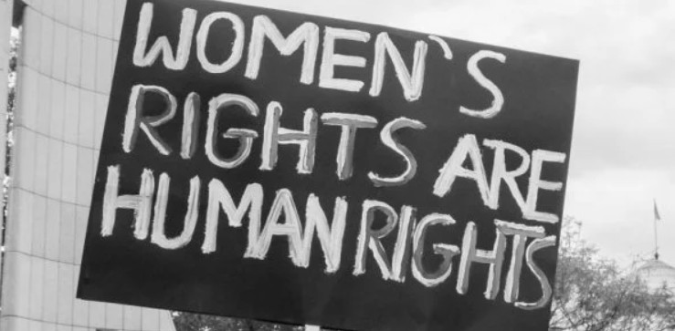
  - Summary

KEY POINTS
1. Human Rights: Universal human rights and the fundamental rights and freedoms possessed by individuals—including equality, education, and liberty—and their official protection

2. Women's Rights and Injustices Against Women: Women's rights to education, employment, access to healthcare, and equal participation in society, as well as violations of these rights.

3. Human Rights Violations Against Women in Afghanistan: The restrictions and human rights violations faced by Afghan women and girls regarding education, employment, and daily life under Taliban rule.

  - What policies can the European Union implement to reduce human rights violations against women and girls in Afghanistan and ensure their access to fundamental rights?

  - Role: Member of the European Commission Audience: Directorate-General for International Partnerships (DG INTPA) and European External Action Service (EEAS)

ÇAĞ POLICY BRIEF ISSUE 2026 | 3
Economic embargoes and diplomatic restrictions are imposed on such countries. Binding treaties and international courts based on the UDHR come into play to prosecute those responsible. Furthermore, the erosion of confidence causes foreign investment to halt, domestic chaos ensues, and major refugee crises spilling across borders are triggered. Nowadays, we frequently encounter human rights violations, particularly issues related to gender inequality.
"Globally, 31.6% of women (approximately one in three—an estimated 840 million women) experience a violation of their fundamental human rights by being subjected to physical and/or sexual violence at least once in their lives." (WHO,2021)
2. Women's Rights and Injustices Against Women:
Women's rights refer to women having equal rights with men in various fields such as education, work, politics, law, and culture. However, today we see that women do not have equal rights with men and that gender inequality still persists. In many parts of the world, women face discrimination and have to struggle against various obstacles in exercising their fundamental rights. This situation negatively affects women's freedoms, their right to make decisions about their own lives, and their participation in social life. "The United Nations also emphasizes that gender equality is important for creating more peaceful, just, and inclusive societies" (United Nations, n.d.).

In particular, the obstruction of women's access to education, employment, and participation in public life makes gender inequality even more visible.

1. Human Rights:
Human rights are rights we possess simply by virtue of being human. These rights are not granted to us by any state; they are universal. They are inherent to all of us, regardless of nationality, gender, national or ethnic origin, color, religious belief, language, or any other status. Formally, these rights are embodied in the Universal Declaration of Human Rights (UDHR). This is a historic human rights declaration adopted by the United Nations General Assembly on December 10, 1948. It is the first legal document to define the fundamental human rights that are to be universally protected. The first two articles form the foundation of human rights:
"Article 1: All human beings are born free and equal in dignity and rights. They are endowed with reason and conscience and should act towards one another in a spirit of brotherhood.
Article 2: Everyone is entitled to all the rights and freedoms set forth in this Declaration, without distinction of any kind, such as race, colour, sex, language, religion, political or other opinion, national or social origin, property, birth or other status. Furthermore, no distinction shall be made on the basis of the political, jurisdictional or international status of the country or territory to which a person belongs, whether it be independent, trust, non-self-governing or under any other limitation of sovereignty." (United Nations [UN], 1948)
Although the Universal Declaration of Human Rights (UDHR) is not a law that directly imposes penalties, states that fail to adhere to its principles face global isolation.
POLICY BRIEF 2026 | 3
According to UNESCO's data for 2025, 1.5 million girls in the country are unable to continue their education (UNESCO, 2025). I think what's important here is not only that children can't go to school, but also that the opportunities they have for their future are taken away. It is also becoming difficult for girls who cannot get an education to get a profession and gain economic independence in the future.
The restrictions faced by women do not end with education either. The restriction of their participation in working life and the restriction of their freedoms in the public sphere directly affect their daily lives. Women also experience difficulties in making decisions about their own lives and gaining economic independence. The United Nations Assistance Mission in Afghanistan (UNAMA) also addresses the problems faced by women in its reports on the human rights situation in the country (UNAMA, 2025).

When we look at all this, we see that the problem of women's rights in Afghanistan is still unresolved. More efforts need to be made at the international level so that women can get an education, work and participate freely in society. At this point, it becomes important what kind of role the European Union can assume. It is necessary to evaluate the policies that the EU can implement to support women in Afghanistan and reduce the impact of rights violations.

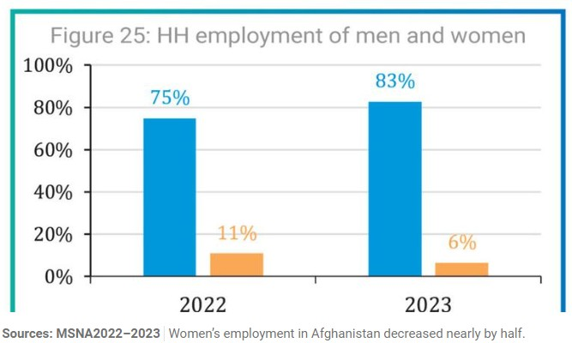
POLICY BRIEF 2026 | 3
These problems not only affect women's individual lives but also hinder the social and economic development of societies. Therefore, to protect women's rights, it is necessary to provide women with equal opportunities, prevent discrimination, and increase women's participation in decision-making processes. The ability of women to freely exercise their fundamental rights is of great importance in creating a more equal and just society.

While women's rights and gender inequality remain significant issues worldwide, Afghanistan provides one of the most striking examples. Particularly after the Taliban seized power, restrictions on women's rights to education, work, and participation in social life have exacerbated human rights problems in the country.

3. Human Rights Violations Against Women in Afghanistan:
Although there have been some improvements in women's rights today, we see that inequality against women still persists. Afghanistan is one of the most obvious examples of this problem. Since the Taliban took over the government again in August 2021, many restrictions have been imposed on women's education, work and participation in public life. According to the information published by UN Women in 2025, women in Afghanistan face serious difficulties in exercising their rights in different areas of life (UN Women, 2025).

These problems experienced by women attract attention especially in the field of education. In Afghanistan, girls' access to secondary education and women's access to university education are blocked.

Graphic (OPTIONAL)

2. Helping Women Achieve Financial Independence

Another important step is to support women who cannot work freely. The EU can work with local organisations to provide online training and help women develop skills they can use to earn money. This can make their lives a little easier and help them become more independent.

3. Putting More Pressure on the Taliban

The EU should also continue to work with the United Nations and other countries to defend women's rights in Afghanistan. We must continue to raise the issue of restrictions on girls' education and women's employment. I believe international pressure is important because these restrictions should not be accepted as normal.
In conclusion, I believe the EU should focus not only on providing aid but also on ensuring women have more opportunities in their daily lives. While changing the situation in Afghanistan will not be easy, supporting education, employment, and women's rights can be an important step.

Key idea to stress out
The EU should do more than provide humanitarian aid to Afghanistan. It should also support women's access to education and employment and help protect their basic rights. This support should reach women and girls who need it most.

References :
1-United Nations. (1948). Universal declaration of human rights. https://www.un.org/en/about-us/universal-declaration-of-human-rights/

POLICY BRIEF 2026 | 3
4. Implementation in the EU

The EU already gives humanitarian aid to Afghanistan. "In 2025, the European Commission announced €161 million in aid to support people in the country, including women and girls. The aid covers areas such as healthcare, education and food" (European Commission, 2025). Still, I think more support is needed, especially for women who cannot continue their education or work freely. The EU could help girls study online and support local organisations that provide women with education and job opportunities. It could also work with the United Nations to encourage the Taliban to lift restrictions on women's rights.
In my opinion, financial aid alone is not enough. It is also important to make sure that women and girls can actually benefit from this support. Working with trusted organisations in Afghanistan could help the EU reach more women and make a difference in their lives.

Recommendations:
I believe the European Union can do more to support women in Afghanistan. In my view, education, financial independence, and international cooperation are three key areas that require more attention.

1. Helping Girls Continue Their Education

The EU can help Afghan girls continue their education through online courses and scholarships. Since many girls cannot attend school, online education can give them another chance to learn. I believe every girl should have the opportunity to receive an education and build her own future.

Graphic (OPTIONAL)

2-United Nations. (n.d.). Gender equality and women's empowerment. https://www.un.org/sustainabledevelopment/gender-equality/

3- United Nations Human Rights Office of the High Commissioner. (t.y.). What are human rights? OHCHR Representation Office to the European Union. https://europe.ohchr.org/human-rights/what-are-human-rights
4- UN Women. (2025, August 14). Afghanistan: Ten facts about the world’s most severe women’s rights crisis. https://unwomen.org.au/afghanistan-ten-facts-about-the-worlds-most-severe-women-rights-crisis/

5- UNESCO. (2025, March 26). Banned from education: A review of the right to education in Afghanistan. https://www.unesco.org/en/articles/banned-education-review-right-education-afghanistan

6- United Nations Assistance Mission in Afghanistan. (2025). Human rights situation in Afghanistan: July–September 2025 update. https://unama.unmissions.org/

7- European Commission. (2025, June 17). EU to provide €161 million in humanitarian aid for Afghanistan in 2025. https://civil-protection-humanitarian-aid.ec.europa.eu/news-stories/news/eu-provide-eur161-million-humanitarian-aid-afghanistan-2025-2025-06-17_en
8- United Nations. (2024, 18 Ocak). Women's rights key for Afghanistan's economic recovery. UN News. https://news.un.org/en/story/2024/01/1145657
9-Altman, M. J. (2023, 6 Aralık). The Universal Declaration of Human Rights is turning 75: Here’s what you need to know. UN Foundation. https://unfoundation.org/blog/post/the-universal-declaration-of-human-rights-is-turning-75-heres-what-you-need-to-know/
10-United Nations. (2026, 5 Ekim). ICC unseals four arrest warrants over Taliban persecution of women and girls. UN News. https://news.un.org/en/story/2026/10/1168521
11-Liboreiro, J., & Genovese, V. (2026, 23 Haziran). AB, Taliban ile Afganların ülkelerine geri dönüşünü görüştü. Euronews. https://tr.euronews.com/2026/06/23/ab-taliban-ilke-afganlarin-ulkelerine-geri-donusunu-gorustu

Author : Dilara Gayir

This Policy Brief has been prepared as part of the students’ assessment in the framework of the EU Politics lecture.
The content of this policy brief lies entirely with the author. It does not reflect the official opinion of Çağ University.

