  - The Arctic Climate Crisis and the EU's Environmental Responsibility
  - Role: Climate Policy Analyst
  - Target Audience: European Commission & EU Policymakers

KEY POINTS
1. Warming three times faster than the global average, the Arctic region is exhibiting the most tangible and devastating effects of the climate crisis.

2. The European Union’s claim to normative global climate leadership stands in contradiction to its role as one of the actors contributing to high emissions and black carbon accumulation in the region.

3. The European Union should focus on concrete actions such as an HFO ban, mandatory port inspections, and fossil fuel restrictions and adopt the identity of a realistic climate actor.

Today, climate change in terms of its impacts and consequences has evolved from a merely regional issue into a global crisis affecting the international system. Faced with this crisis, the European Union positions itself as a global climate leader and a normative power that sets environmental standards, placing its Arctic policy at the heart of its efforts to combat climate change. Against this backdrop, this policy note examines the EU’s Arctic climate policy by addressing the contradiction between its rhetoric of global leadership and its environmental footprint in the region.
Ultimately, the EU should reinforce the ban on heavy fuel oil (HFO) for commercial fleets in Arctic waters through robust port inspections, steadfastly pursue black carbon reduction targets, and by refraining from supporting new oil and gas exploration adopt the identity of a realist climate actor that focuses on concrete actions within its own sphere of influence.
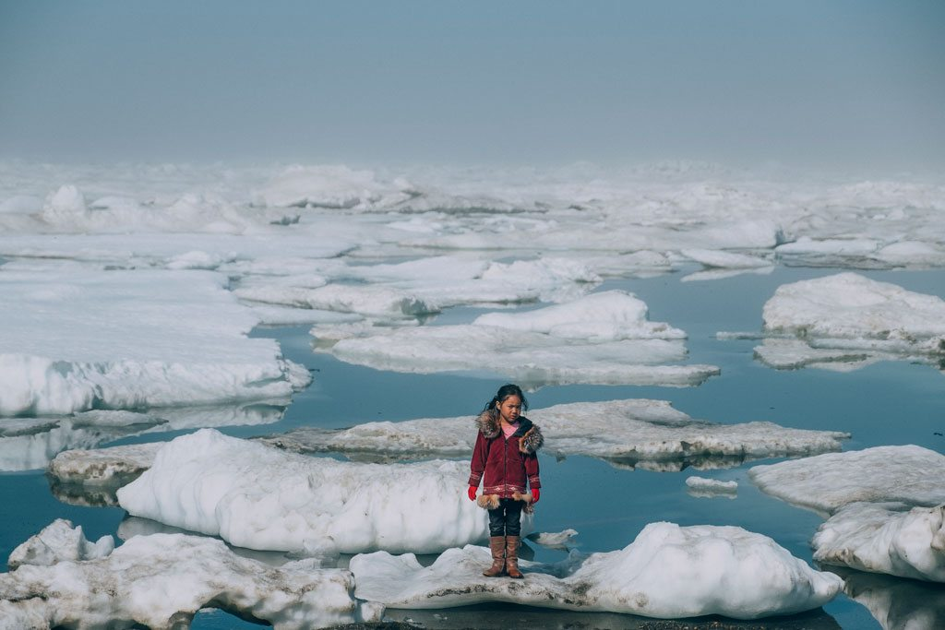

ÇAĞ POLICY BRIEF ISSUE 2026 | 3
  - Summary
It would be incorrect today to reduce climate change to merely an environmental issue in terms of its effects and consequences. Having evolved into a problem that impacts the international system, climate change manifests its most tangible and destructive effects in the Arctic region. Compared to other parts of the world, the Arctic is experiencing warming at three times the rate. This rapid warming process has caused the thawing of ice layers within the region's permafrost, leading current ice cover to recede to its lowest levels since 1850.
Indeed, based on scientific assessments, it is projected that the Arctic Ocean could become completely ice-free during the summer months before 2050. While the melting of the ice threatens the region's extremely fragile and sensitive ecosystem, it simultaneously creates the potential to shorten maritime transport distances between Asia and Europe, opens up new shipping routes, and facilitates access to the region's vast, untapped natural resources.
In the face of this ongoing global crisis, the European Union positions itself on the international stage as a "global climate leader" and a normative actor that sets environmental standards, demonstrating that it has placed the fight against climate change at the heart of its Arctic policy.

POLICY BRIEF 2026 | 3
In contrast, concrete data indicates that the European Union contributes to the crisis in the Arctic—driven by environmental issues arising from greenhouse gas emissions associated with maritime transport between Europe and Asia—given its 8% share of global greenhouse gas emissions; furthermore, it has been revealed that the EU is responsible for approximately 36% of the black carbon accumulating in the Arctic, a harmful air pollutant that accelerates warming and the melting of ice sheets in the region
As evidenced by these concrete statistical data, a discrepancy between rhetoric and action is apparent in the European Union’s policies regarding the Arctic region. While the EU maintains its claim to global climate leadership at the rhetorical level, it cannot overlook the fact that its own commercial fleet and transboundary emissions are among the drivers of environmental degradation in the Arctic ecosystem.
Consequently, the core problem identified in this policy brief is the imperative need for the EU to shift from developing normative rhetoric regarding the Arctic toward adopting a realist climate strategy that prioritizes the responsibility to clean up and reduce its own environmental footprint.
“Vivamus porta
est sed est.”
POLICY BRIEF 2026 | 3
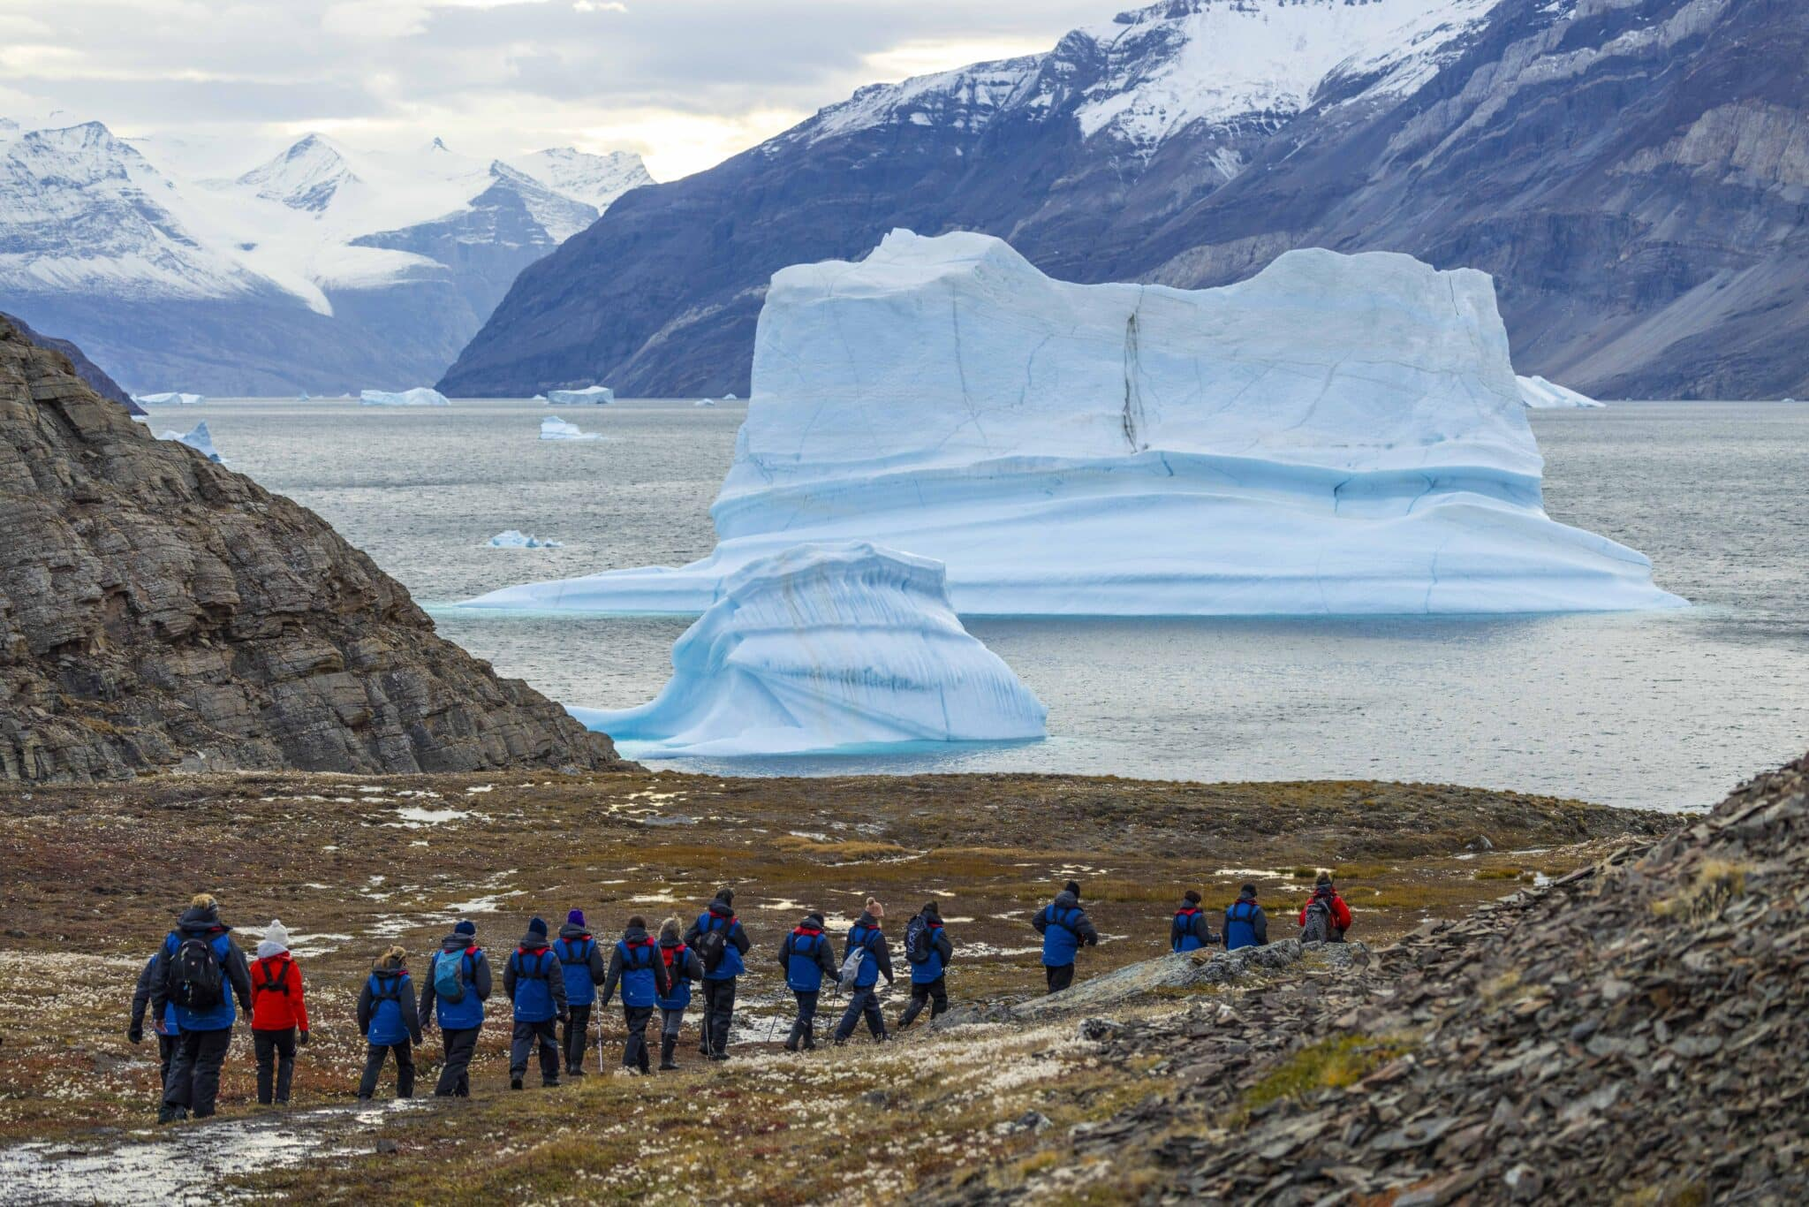
The Basic Framework of the EU's Arctic Climate Policy
A primary, concrete element of the European Union’s Arctic climate strategy is controlling pollution resulting from commercial maritime activities in the region. The EU supports the "Polar Code"—a set of regulations for ships operating in polar regions that entered into force under the International Maritime Organization (IMO) on January 1, 2017. In this context, the most recent of the many international regulatory efforts supported and coordinated by the EU is the ban on the use of heavy fuel oil (HFO) the most hazardous type of ship fuel which directly accelerates glacial melting. Furthermore, to align with targets set by the Arctic Council aimed at curbing black carbon emissions (which increase heat absorption), the EU has backed the goal of reducing black carbon emissions reaching the Arctic region to below 33% by 2025 and has prioritized zero-emission maritime transport for commercial fleets.
Shift in Focus in the EU's Arctic Policies
Over the course of its history, the EU’s most significant shift in focus regarding the Arctic region has been observed in the energy sector. While early policy documents supported the extraction of Arctic resource reserves to ensure supply security, this focus shifted after the EU became a party to the Paris Agreement and the European Commission announced the European Green Deal, aimed at decarbonizing the EU economy. Having legislated the goal of achieving climate neutrality by 2050 through the European Climate Law (Regulation 2021/1119), the EU began advocating for keeping fossil fuels such as natural gas, coal, and oil in the Arctic and surrounding areas in the ground. While committing to preventing the development of new hydrocarbon reserves and refraining from purchasing produced fossil fuels, the EU has simultaneously focused on developing renewable, clean energy sources. Concrete steps taken by the EU in this regard include the green partnership established with Greenland, as well as financial support provided via Council decisions for renewable energy projects and the blue economy.

Finally, although the European Union does not possess direct territorial sovereignty in the Arctic, it influences the region through the "Brussels Effect" by enacting legislation within its own legal framework that sets global environmental standards. It has translated the principles of the European Green Deal into regional norms through EU member states that are also members of the Arctic Council—namely Denmark, Sweden, and Finland—as well as through its European Economic Area partners, Norway and Iceland.
Policy Recommendations
The European Union’s climate policies regarding the Arctic are shaped by the contradiction between its rhetoric of global leadership and the environmental footprint it leaves in the region. Instead of attempting to project an image of global leadership in the Arctic, the EU should adopt the identity of a realist climate actor that takes concrete, measurable steps within its own spheres of influence.

Author : Buse KOÇAK, Department of International Relations, Çağ University

This Policy Brief has been prepared as part of the participants / students’ assessment in the framework of the EU Politics lecture.
The content of this policy brief lies entirely with the author. It does not reflect the official opinion of Çağ University.

To make its Arctic climate strategy more coherent and effective, the EU must phase out the use of heavy fuel oil on commercial vessels traversing Arctic waters and calling at its ports, back its black carbon reduction targets with binding and sustainable port inspections, and steadfastly maintain its commitment to withholding support for new oil and natural gas extraction activities in the region.
FOOTNOTES
1. Çeçen, H. (2025). Avrupa Birliği’nin Arktik Bölgesi’ne yönelik güncel iklim düzenlemelerinin hukuki açıdan değerlendirilmesi. Ankara Avrupa Çalışmaları Dergisi, 24(1), 31–66. https://doi.org/10.32450/aacd.1549085
2. Baldıran, S. (Yıl). Avrupa Birliği’nin Arktik politikası. Novus Orbis: Siyaset Bilimi ve Uluslararası İlişkiler Dergisi, cilt(sayı), sayfa aralığı.

POLICY BRIEF 2026 | 3

