KEY POINTS

1. In much of the EU, national social assistance fails to clear the poverty threshold, leaving over 95 million in danger of falling into poverty.

2. Onerous administration and strict eligibility rules deny welfare to millions who are in greatest need of it.

3. The EU must put a stop to this by having the Council’s Recommendations made into standards that can be enforced, with cohesion funding to see them through.
1. In much of the EU, national social assistance fails to clear the poverty threshold, leaving over 95 million in danger of falling into poverty. 2. Onerous administration and strict eligibility rules deny welfare to millions who are in greatest need of it. 3. The EU must put a stop to this by having the Council’s Recommendations made into standards that can be enforced, with cohesion funding to see them through.

The purpose of this policy brief is to test the European Union’s soft-law on minimum income schemes for its efficacy in putting people back to work and alleviating poverty in member states. Our view is that non-binding recommendations are not enough to guarantee a life of dignity in the absence of hard legal standards or the backing of European funds; they have a tendency to allow regional disparities in welfare to widen, as the numbers would have it. In many parts of the union the national safety net does not measure up to the at-risk-of-poverty line and low-income families are put off from what is their due by red tape. We therefore make the case for a framework directive to replace the 2023 Council Recommendation, one that ties cohesion funds to tangible results in poverty reduction and eases the application process.



ÇAĞ POLICY BRIEF ISSUE 2026 | 3
  - Summary
  - Rethinking Social Safety Nets in the EU: The Challenge of Adequate Minimum Income and Inclusive Protection
Welfare Gaps and Adequacy Deficits Across Member States
Principle 14 of the European Pillar of Social Rights leaves no room for doubt: a minimum income benefit is the right of anyone lacking sufficient resources, says the European Commission (2017). A glance at the single market however reveals structural inequalities that persist even with the Council Recommendation on Adequate Minimum Income (Council of the European Union, 2023). Eurostat (2023) has the data to prove it: more than 21 per cent of the population, some 95 million, face the prospect of poverty or social exclusion. For the most part, particularly in the South and East of Europe, the 60% median poverty line is not reached by the net income of safety-net transfers, so there is little chance of escaping long term poverty (Marchal et al., 2021). Without any uniformity in the level of support, an economic shock will see the vulnerable deprived.
POLICY BRIEF 2026 | 1
Administrative Barriers and Non-Take-Up of Social Assistance
How accessible a social safety net is is as important as the value of the benefits. One finds evidence of this in studies across the Union; Eurofound (2023) puts the non-take-up rate at between 30 and 50%, meaning up to half of all households eligible for minimum income support do not receive it. Frazer and Marlier (2016) identify the causes: inflexible rules, stigmatization, a bureaucracy that is hard to navigate and a rush to digitalise which those without the skills cannot cope with. And when activation policies are not well conceived, they are more likely to sanction than to provide a way to decent work, turning a protective cushion into a punitive affair (Cantillon et al., 2020).
“Vivamus porta
est sed est.”
Strengthening EU Governance and Cohesion for a Just Welfare System
Given that member states retain primary authority in social policy, the EU has traditionally turned to the Open Method of Coordination and other soft-law measures (Vandenbroucke et al., 2021). Yet the guidance of the European Semester is proving insufficient to bridge the gap between the Nordic and Western countries with their robust systems and the more limited provision in Central and Eastern Europe or the Mediterranean (Penalva-Verdú et al., 2022). To avoid geographic marginalisation and social dumping (European Anti-Poverty Network, 2022), the Union should be using the ESF+ and establishing benchmarks by which to judge the modernisation of national safety nets.
POLICY BRIEF 2026 | 1



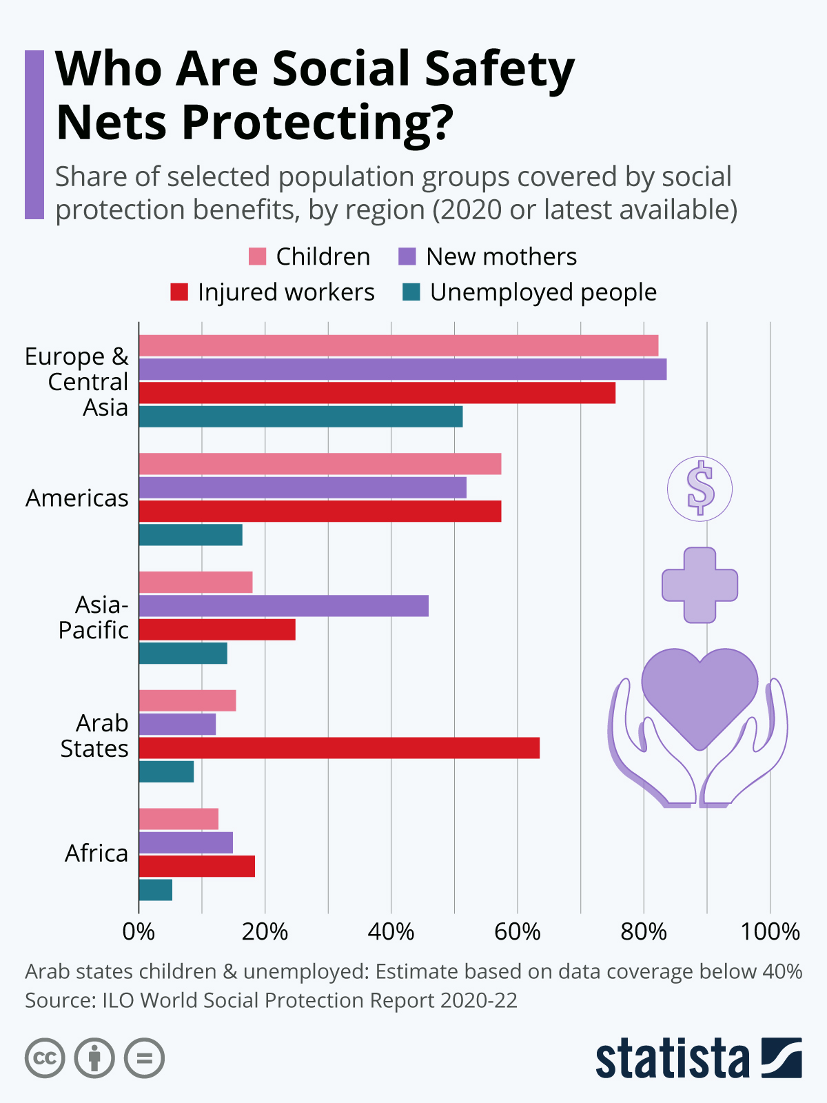
4-Abdullateef, A. O. (2025, September 22). Restructuring social safety nets in the AU-EU partnership: Why a youth-inclusive framework is a must. Premium Times. https://www.premiumtimesng.com/opinion/822906-restructuring-social-safety-nets-in-the-au-eu-partnership-why-a-youth-inclusive-framework-is-a-must-by-abdulkareem-o-abdullateef.html
5-BT Günlüğü. (n.d.). AB fonlarından yararlanmak için 10 ipucu [10 tips to benefit from EU funds]. Retrieved October 11, 2026, from https://www.btgunlugu.com/ab-fonlari-yararlanmak-icin-10-ipucu/
6-Cantillon, B., Goedemé, T., & Hills, J. (Eds.). (2020). Decent incomes for all: Improving policies in Europe. Oxford University Press. https://doi.org/10.1093/oso/9780190849696.001.0001
7-Marchal, S., Siöland, L., & Goedemé, T. (2021). Are minimum income benefits adequate and accessible? An analysis of European safety nets. Journal of European Social Policy, 31(4), 421–437. https://doi.org/10.1177/09589287211018314

POLICY BRIEF 2026 | 1
RECOMMENDATION
Put in place a Framework Directive on Minimum Income: Move on from voluntary guidance to a binding directive that sets out transparent methods for fixing benefit levels in excess of the national poverty threshold.
FOOTNOTES
1-Marchal, S., Siöland, L., & Goedemé, T. (2021). Are minimum income benefits adequate and accessible? An analysis of European safety nets. Journal of European Social Policy, 31(4), 421–437. https://doi.org/10.1177/09589287211018314
2-Penalva-Verdú, C., Aguilar-Hendrickson, I., & Matsaganis, M. (2022). Minimum income schemes in the European Union: Divergent paths and common challenges. Social Policy & Administration, 56(6), 897–913. https://doi.org/10.1111/spol.12816
3-Vandenbroucke, F., Burgoon, B., Kuhn, T., Nicoli, F., & Sacchi, S. (2021). The European Union’s social dimension: What does European solidarity mean for national welfare states? Oxford Review of Economic Policy, 37(4), 743–761. https://doi.org/10.1093/oxrep/grab028

Author : Zeynep ŞİMŞEK, Translation and Interpreting, Çağ University

This Policy Brief has been prepared as part of the participants / students’ assessment in the framework of the EU Politics lecture.
The content of this policy brief lies entirely with the author. It does not reflect the official opinion of Çağ University.
8-Penalva-Verdú, C., Aguilar-Hendrickson, I., & Matsaganis, M. (2022). Minimum income schemes in the European Union: Divergent paths and common challenges. Social Policy & Administration, 56(6), 897–913. https://doi.org/10.1111/spol.12816

