The textile sector constitutes a significant policy area in the fight against climate change due to the environmental impacts arising throughout its production and consumption processes. The aim of this policy brief is to examine climate governance within the textile sector and the European Union’s (EU) policy practices in this field. In this context, the study addresses the subject in three parts: changing consumption habits, climate governance and the policy framework within the EU textile sector, and the limitations of current policy.
The role and limitations of the European Union’s climate policies regarding the textile sector constitute the study’s central policy question. The EU has established a comprehensive policy framework aimed at reducing environmental impacts in the textile sector and transitioning to a circular economy. However, the multi-layered structure of the textile value chain and the dispersion of production processes across various stages and actors can limit the monitoring of environmental performance and the assessment of the implementation effectiveness of policies. The effectiveness of the EU’s climate policies for the textile sector is not limited to the scope of the regulatory framework. At the same time, this highlights the necessity of strengthening deterrence mechanisms. In this context, Ian Ayres and John Braithwaite’s "responsive regulation" approach offers a framework that combines the promotion of monitoring and compliance with the imposition of sanctions when necessary.

ÇAĞ POLICY BRIEF ISSUE 2026 | 3
KEY POINTS

1. The Climate Impacts of Fast Fashion and Changing Consumption Patterns

2. The European Union’s Climate Governance and Policy Framework in the Textile Sector

3. The Limitations of EU Policies in Promoting Sustainable Consumption

  - Summary
  - The European Union’s Climate Governance through the Lens of the Textile Sector
‘‘ The impact of our current production and consumption of textiles system continues to cause high pressures on our environment and climate, including through material use, water and land use, greenhouse gas emissions, chemical and microplastics.‘’ (European Environment Agency [EEA], 2025a, para. 3). The CORDIS Results Pack published by the European Research Executive Agency in 2026 presents a concrete framework regarding textile consumption and waste volumes in Europe, stating that “every European citizen uses on average 26 kg of textiles each year and throws away 11 kg” (European Research Executive Agency, 2026). ‘‘ Textiles are the fabric of everyday life - in clothes and furniture, medical and protective equipment, buildings and vehicles. However, urgent action is needed as their impact on the environment continues to grow.’’ (European Commission, 2022, para. 2).
2. The European Union’s Climate Governance and Policy Framework in the Textile Sector
‘‘ The EU's Strategy for Sustainable and Circular Textiles addresses the production and consumption of textiles, while recognising the importance of the textiles sector. It implements the commitments of the European Green Deal, the Circular Economy Action Plan and the European Industrial Strategy.’’ (European Commission, 2022, para. 2). ‘‘ The strategy looks at the entire lifecycle of textile products and proposes coordinated action to change how we produce and consume textiles.’’ (European Commission, 2022, para. 4).
Objectives
‘‘ The Textiles Strategy aims to create a greener, more competitive sector that is more resistant to global shocks. The Commission's 2030 vision for
1. The Climate Impacts of Fast Fashion and Changing Consumption Patterns
‘‘In the last few decades, the textile industry has evolved towards a “fast fashion” approach: inexpensive clothes, made of cheap materials, to be worn only for one season or less and then discarded. The production and consumption of textiles cause significant pressures on the environment and climate change. These can range from the land and water used to produce the fibres and the energy and chemical dyes used in its manufacturing and production, to its retailing and disposal.
Our assessments show that, compared with other consumption categories, textiles consumption in the EU caused in 2020 the third highest pressures on water and land use, and the fifth highest use of raw materials and greenhouse gas emissions.
At the same time, worldwide, the textiles sector is the third largest employer, after food and housing, with almost 13 million full-time equivalent workers employed worldwide in the supply chain to produce the amount of clothing, textiles and footwear consumed only in the EU-27 in 2020. Most production takes place in Asia, where low production costs often come at the expense of workers’ health and safety.
Circular business models and design can reduce the negative impacts of textile production and consumption by retaining the value of textiles, extending their life cycles and increasing the usage of recycled materials. This requires technical, social and business innovation, supported by policy, education and changes in consumer behaviour.’’ (European Environment Agency [EEA], 2026, paras. 1-4).

POLLEN BRIEF 2026 | 3
“Vivamus porta
est sed est.”
Implementation
- The Ecodesign for Sustainable Products Regulation, proposed in 2022, creates a framework to set ecodesign requirements for products, including textiles.
- The Empowering Consumers in the Green Transition Directive and Green Claims Directive, proposed in 2022 and 2023, aim to tackle greenwashing.
- The “Reset the Trend” campaign (#ReFashionNow) was launched in 2023 to raise awareness about sustainable fashion.
- The Waste Shipment Regulation, proposed in 2021, will help restrict the export of textile waste.
- Transition Pathway for the Textiles Ecosystem, published in 2023,and the European Circular Economy Stakeholder Platform (since 2018) promote and foster cooperation between industry, public authorities, social partners and other stakeholders.
- Calls have been launched under Horizon Europe to further develop technologies and processes increasing the circularity and sustainability of the textiles sector.
- In 2023 the Commission proposed a revision to the Waste Framework Directive to introduce mandatory and harmonised Extended Producer Responsibility (EPR) schemes for textiles in all EU Member States.
- The brochure published in October 2023 presents a state of play of the microplastic pollution in the EU, summarising developments in EU policy, research, innovation, and investment in the textiles sector.
textiles is that:
- All textile products placed on the EU market are durable, repairable, recyclable, and, to a great extent, made of recycled fibres, free of hazardous substances, and produced in respect of social rights and the environment
- Fast fashion is out of fashion, and consumers benefit longer from high-quality, affordable textiles
- Profitable re-use and repair services are widely available
- The textiles sector is competitive, resilient and innovative, with producers taking responsibility for their products along the value chain, with sufficient capacities for recycling and minimal incineration and landfilling
Actions
The strategy also lays out a forward-looking set of actions. The Commission has already or will:
- Set design requirements for textiles to make them last longer, easier to repair and recycle
- Introduce a Digital Product Passport
- Address the unintentional release of microplastics from synthetic textiles
- Introduce mandatory and harmonised Extender Producer Responsibility rules for textiles in all Member States and incentivise producers to design more sustainable products
- Restrict the export of textile waste and promote sustainable textiles globally
- Incentivise circular business models, including reuse and repair sectors
POLICY BRIEF 2026 | 3
Graphic (OPTIONAL)
as harmful substances can hinder material reuse and recycling.’’ (EEA, 2025b ).
♻︎ Implementation Limits of Circularity
‘‘In 2022, while the consumption of clothing, footwear and household textiles in the EU-27 increased to 19kg per person on average, textile waste levels have remained relatively stable, amounting to 16 kg per person on average in the same year. It is unclear whether this was due to textile products being kept for longer or being reused or whether it was because of challenges in collecting the data.
The amount of textile waste and shoes not separately collected is more than twice the amount of that reported to be separately collected. As the textiles that are not separately collected end up in the mixed household waste destined for landfills or incineration, this is a missed opportunity for reuse and recycling.
The Waste Framework Directive mandates that from 2025, EU Member States must establish separate collection systems for used textiles (EU, 2018). This will most likely increase the share of separately collected textile waste in the coming years. When more discarded textiles need handling, export volumes are expected to increase. This is unless new EU policies under the Waste Shipments Regulation (EU, 2024b) and United Nations (UN) agreements under the Basel Convention (UN, 2025) effectively restrict the exports.
Textiles exported to Africa are mostly reused or end up in dumps; alternatively, they are burned in open landfills. In contrast, textiles exported to Asia are largely recycled or re-exported (EEA, 2023) or else they end up in dumps or are burned

POLICY BRIEF 2026 | 3
- In 2023 the Commission launched a plan to update and revise the Textile Labelling Regulation.’’ (European Commission, n.d., “Objectives,” “Actions,” and “Implementation” sections)

3.The Limitations of EU Policies in Promoting Sustainable Consumption
The European Union’s (EU) policy framework for the textile sector is addressed through the lenses of climate and the circular economy. In this context, a policy framework has been presented that takes into account multidimensional impacts-environmental, social, and economic. However, the limitations inherent in the implementation process of these policies necessitate an assessment of their effects on sustainable consumption.
🛍️ The Paradox of Consumption
‘‘ Between 2010 and 2022, the textile value chain has made efficiency improvements. This has led to some decoupling between environmental pressures and production levels. Despite a 15% increase in consumption, absolute decoupling was achieved for GHG emissions (-24%) and raw material use (-22%). However, these efficiency gains have slowed down recently, stabilising the levels of GHG emissions and raw material use. For land (+3%) and water use (-1%), relative decoupling occurred. This suggests that pressures from land and water use have not significantly worsened. This is partly due to the increased use of synthetic fibres, which mainly causes other pressures such as raw material use and GHG emissions. Addressing chemical risks in textiles — including from PFAS — is crucial,
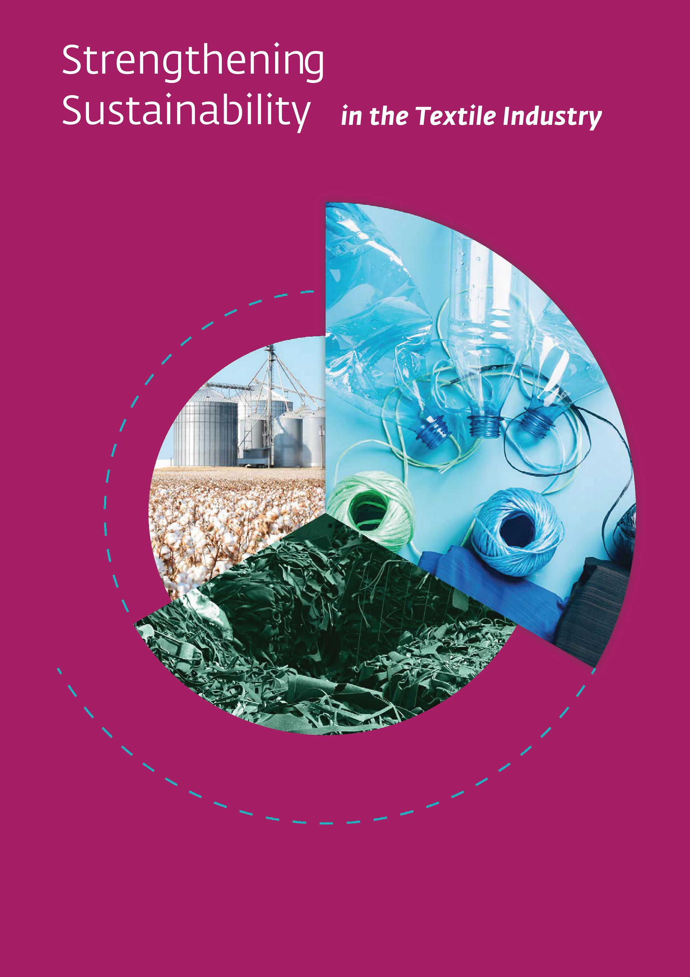
in open landfills. To handle the high and possibly increasing volumes, Europe will need to strengthen its sorting and treatment capacities. This will help limit the amount of textile waste sent to landfills or incineration in Europe and elsewhere. It is also vital to ensure that the newly established European collection systems are efficient.’’ (EEA, 2025b).
📊︎ Measuring Policy Effectiveness
‘‘ The lack of transparent, comprehensive and reproducible data means that it is difficult to effectively monitor the evolution of key metrics. Consequently, it is challenging to draw sound conclusions and develop actionable policy options. While EU-level data on textile production and consumption volumes are relatively robust, information is scarce about use-phase aspects, the implications of fast fashion and circular business models and also waste trade patterns. Examples of data gaps also include elements like the number of textile products put on the EU market, the speed of collection, product lifespans, repair efforts, reuse rates and recycling performance. These factors are critical in assessing circularity dimensions like lifetime extension and intensified product (re)use.
Addressing these gaps requires the formalisation of new data streams, consistency in data collection and assessment methods as well as improved transparency and accessibility of data. These steps would enhance the ability to evaluate the state of textile circularity in Europe. They would also help detect trends and disruptions as well as support decision-making from a systemic perspective.’’ (EEA, 2025b).

Source: (International Finance Corporation [IFC], 2023)
Policy Recommendation
An examination of the EU’s current policy regarding the textile sector reveals a holistic approach encompassing production, consumption, and waste management. The potential impacts of these policies have been evaluated from a multidimensional perspective, and existing limitations have been objectively identified. In this context, the fact that a policy framework has been comprehensively designed does not, in itself, guarantee that other actors will act in compliance with the regulations during implementation. In this context, deficiencies or inconsistencies between existing regulations and actual operational practices can lead to the emergence of a regulatory gap.
In this context, a scoring mechanism could be established to evaluate the environmental performance of manufacturers -the initial link in the textile value chain- based on common and measurable criteria; furthermore, deterrent measures, such as limiting production, could be implemented if the total scores calculated from these criteria fall below a minimum performance threshold.
Thus, taking into account the difficulty of oversight in the textile sector—where production processes and environmental impacts span numerous actors and stages—the aim is to address limitations through necessary regulations and strengthen oversight mechanisms, while ensuring alignment with the existing EU policy framework.
6. European Environment Agency. (2023). EU exports of used textiles in Europe’s circular economy. https://www.eea.europa.eu/en/analysis/publications/pfas-in-textiles-in-europes-circular-economy
7. European Parliament & Council of the European Union. (2018). Directive (EU) 2018/851 of the European Parliament and of the Council of 30 May 2018 amending Directive 2008/98/EC on waste. EUR-Lex. https://eur-lex.europa.eu/eli/dir/2018/851/oj/eng
8. United Nations. (n.d.). Basel Convention on the Control of Transboundary Movements of Hazardous Wastes and Their Disposal. https://www.basel.int/

FOOTNOTES
1. European Environment Agency. (2026, April 10). Textiles. https://www.eea.europa.eu/en/topics/in-depth/textiles
2. European Environment Agency. (2025a, March 26). Consumption of clothing, footwear, other textiles in the EU reaches new record high. https://www.eea.europa.eu/en/newsroom/news/consumption-of-clothing-footwear-other-textiles-in-the-eu-reaches-new-record-high
3. European Research Executive Agency. (2026, May 21). CORDIS results pack on the future of textiles: Achieving a circular economy for the textile sector (2nd ed.). https://rea.ec.europa.eu/publications/cordis-results-pack-future-textiles-0_en
4. European Commission. (n.d.). Sustainable and circular textiles strategy. https://environment.ec.europa.eu/strategy/textiles-strategy_en
5. European Environment Agency. (2025b). Circularity of the EU textiles value chain in numbers. https://www.eea.europa.eu/en/analysis/publications/circularity-of-the-eu-textiles-value-chain-in-numbers

Author : Ece Küçükler

This Policy Brief has been prepared as part of the participants / students’ assessment in the framework of the EU Politics lecture.
The content of this policy brief lies entirely with the author. It does not reflect the official opinion of Çağ University.

