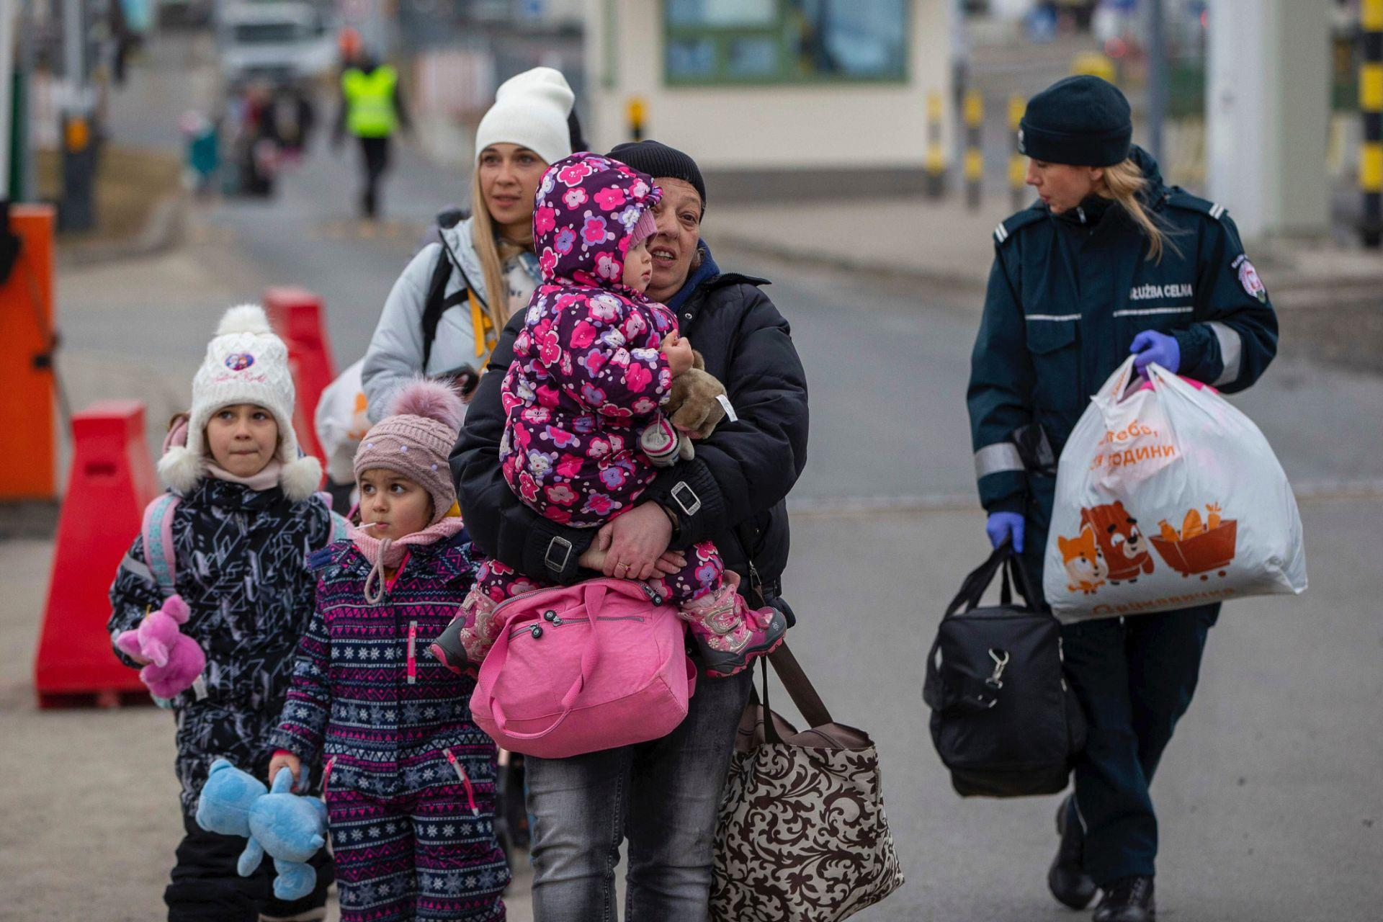

ÇAĞ POLICY BRIEF ISSUE 2026 | 3
KEY POINTS
1. Protecting Refugees’ Rights: Ensure access to housing, education and employment.
2. Strengthening European Solidarity: Improve cooperation and responsibility-sharing among Member States.
3. Developing Long-Term Solutions: Prepare sustainable options for residence or safe, voluntary return.

This policy brief addresses the protection provided by the EU to Ukrainian refugees who have fled their country due to the war, as well as integration challenges and long-term solutions. It is based on the EU’s extension of temporary protection through March 2028 and on future options for transitioning to other residence statuses or, when conditions permit, safe and voluntary return. The recommendations are as follows: They are based on protecting the rights of refugees, facilitating access to services, and strengthening cooperation among EU countries.
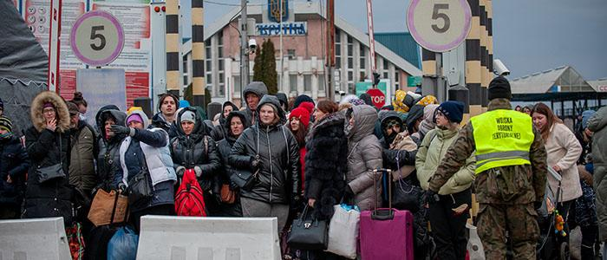
  - Summary
  - Role: Migration and Refugee Policy Advisor
  - The EU’s Temporary Protection Policy for Ukrainian Refugees

1) The EU’s Temporary Protection Directive
The European Union’s Temporary Protection Directive (2001/55/EC) was adopted to establish a rapid and common protection mechanism in situations where large numbers of people are forced to leave their countries due to war or similar crises. Following Russia’s large-scale invasion of Ukraine on February 24, 2022, the EU implemented this directive for the first time in its history on March 4, 2022. Thanks to this program, Ukrainians under protection have been able to access basic rights such as the right to work, residence, housing, health care, and education for children without having to wait for the outcome of their individual asylum applications. The European Commission states that this mechanism aims both to meet the urgent needs of people forced to flee their country due to the war and to alleviate the pressure on member states’ asylum systems. In this regard, the directive played a significant role in the EU’s ability to develop a swift and unified policy in response to the Ukraine crisis. While the rights granted under temporary protection are very important, there is ongoing debate over whether this mechanism is sufficient in the long term and whether it provides everything that is needed. In July 2026, the Council of the European Union announced that it had reached an agreement to extend

POLLEN BRIEF 2026 | 3
this temporary protection for Ukrainians until March 4, 2028. This development demonstrates that the need for protection persists due to the ongoing conflict. Meanwhile, a study by İrem Şengül published in the Journal of the Faculty of Law at İnönü University highlights that if temporary protection were to replace permanent solutions, it could create uncertainty regarding the future legal status of refugees. For this reason, the EU must not only provide temporary protection but also plan for refugees’ long-term residency options, their social integration, and—when conditions permit—opportunities for safe and voluntary return, and act accordingly.

“Vivamus porta
est sed est.”
2) Refugee Integration and European Solidarity
The EU provides various forms of support in the areas of housing, education, health care, and access to employment to help Ukrainian refugees integrate into their host countries. According to the European Commission, member states can draw on EU funds and joint programs to meet the needs of refugees and support their social integration. In particular, the integration of children especially those among refugees into the education system, as well as adults’ ability to find employment and have their professional qualifications recognized, is of critical importance for refugees’ participation in economic and social life. The Commission’s 2025 communication titled “A Predictable and Common European Way Forward for Ukrainians in the EU” also emphasizes that employment and education are important for both those who choose to remain in the EU and those who plan to return to Ukraine in the future. That said, the integration of refugees is not achieved solely through the provision of legal rights. Language barriers, housing costs, access to child care, and difficulties in having university degrees obtained in Ukraine recognized can limit refugees’ participation in the labor market.
POLICY BRIEF 2026 | 3
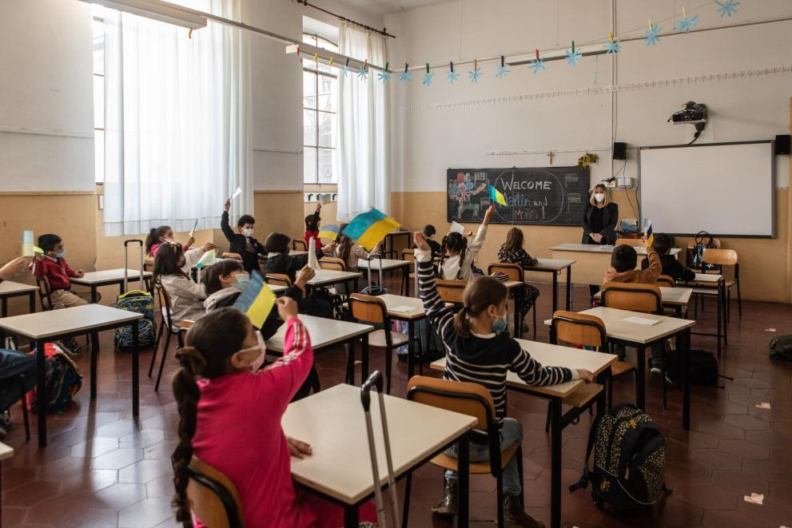
Karapınar Kocağ’s study, published in the journal *Ekonomi-tek* (2025), reveals that, in particular, the recognition of professional qualifications, housing conditions, and gender-based barriers play a significant role in the employment process. For this reason, stronger cooperation and a fair sharing of responsibilities are necessary in relations among EU member states. If member states work together in the areas of education, employment, housing, and social support, this could both improve refugees’ living conditions and help manage the strain on host communities in a more balanced way. To ensure the sustainability of the European approach, differences in implementation among member countries must also be reduced. While it is easier for refugees to access the labor market and social services in some countries, housing shortages, high costs of living, and limited support services in other countries can hinder the integration process. This situation may prevent refugees from benefiting from equal opportunities across Europe. For this reason, the EU should increase the sharing of information and resources among member states, promote successful integration practices, and regularly assess the needs of refugees and improve the available resources. Furthermore, supporting the participation of Ukrainian refugees in decision-making processes can help ensure that the policies implemented better meet their actual needs. In this way, European solidarity is not limited to emergency humanitarian aid but can also strengthen long-term social cohesion and a sense of shared responsibility

POLICY BRIEF 2026 | 3

Ukrainians to their home country. However, for return to be possible, it is not enough for the intensity of the war to simply decrease. The availability and suitability of security, education, housing, employment, and health services must also be assessed and discussed. The European Commission has announced that it will develop a pilot program for voluntary return and recovery, aimed at providing assistance in the areas of employment, housing, and education to support those wishing to return to Ukraine in June 2026. This approach makes clear that return should not be a mandatory measure, but rather an option that individuals can consider based on their own preferences.
For this reason, refugees should not be forced to return until conditions in Ukraine become safe for their return, and they must be provided with support to help them reintegrate into society after their return. The EU must develop sustainable, long-term solutions for Ukrainian refugees that go beyond temporary protection. Cooperation among member states must be strengthened, and long-term residency options must be further facilitated. Return to Ukraine, however, should only be supported when safe and voluntary conditions are in place. The primary goal is to secure the future of refugees while protecting their rights and safety.
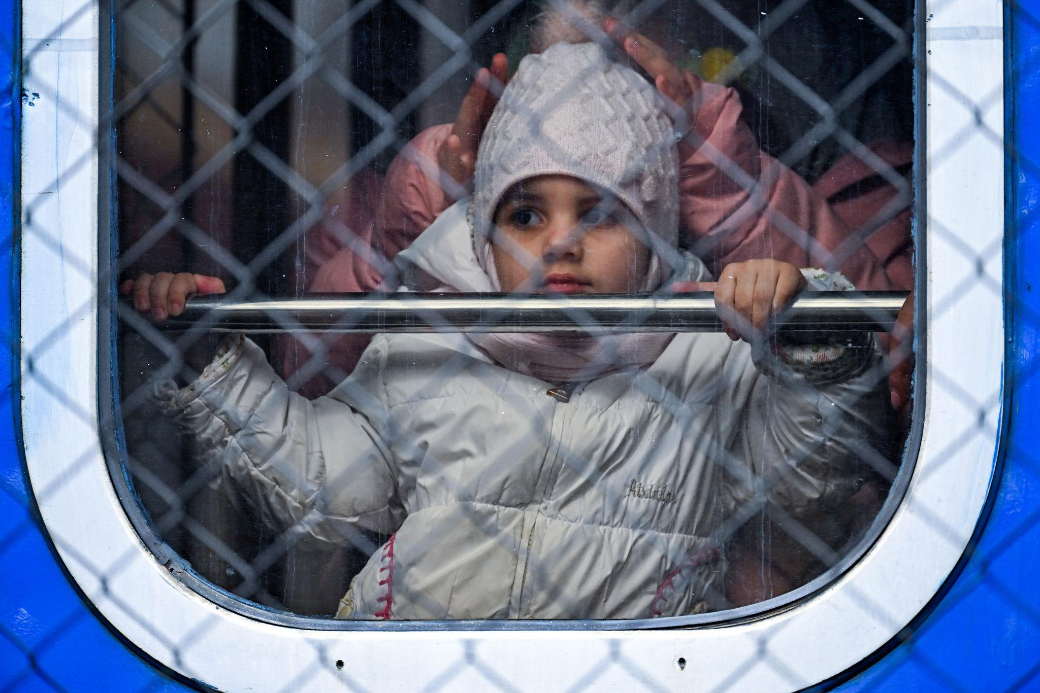
3) Long-Term Solutions for Ukrainian Refugees
One of the most important issues in the European Union’s policy toward Ukrainian refugees is how to transition from temporary protection to long-term solutions. The ongoing war creates uncertainty regarding where millions of people will live in the future and what legal status they will have. The Council of the European Union, in its decision dated July 30, 2026, extended temporary protection until March 4, 2028. This decision demonstrates that the need to protect the safety and legal status of Ukrainians remains. However, the continuous extension of temporary protection does not, on its own, provide a lasting solution. Therefore, it is of great importance for the EU to both maintain the current protection and develop plans for the refugees’ future. One of the long-term solutions is to allow Ukrainians who meet the necessary conditions to transition to different types of residence permits in EU countries. In a recommendation adopted in September 2025, the Council of the European Union recommended evaluating residence options based on reasons such as work, education, and family ties. This approach can help individuals living in the EU who have integrated into their host communities plan for their future without facing legal uncertainty. A report by the European Migration Network also notes that some member states have developed practices that facilitate the transition from temporary protection to more permanent residency options. However, differences in national legislation and application requirements can make it difficult to access these options. For this reason, it is also important to develop more harmonized practices among EU countries and to provide refugees with clear and understandable information. Another option is to support the safe, voluntary, and sustainable return of

Graphic (OPTIONAL)

Key idea to stress out – Optional
The EU must step up its diplomatic efforts to end the war in Ukraine and secure lasting peace. Ukrainian refugees’ access to housing, education, healthcare, and employment opportunities must be safeguarded. Member states should enhance cooperation to provide refugees with equal support and better living conditions. Integration programs and social support should be expanded. All policies must prioritize human rights, the safety of refugees, and finding a peaceful, sustainable solution to the crisis.

Author : İrem Tufan, Third-Year International Relations Student at Çağ University.

This Policy Brief has been prepared as part of the participants / students’ assessment in the framework of the EU Politics lecture.
The content of this policy brief lies entirely with the author. It does not reflect the official opinion of Çağ University.
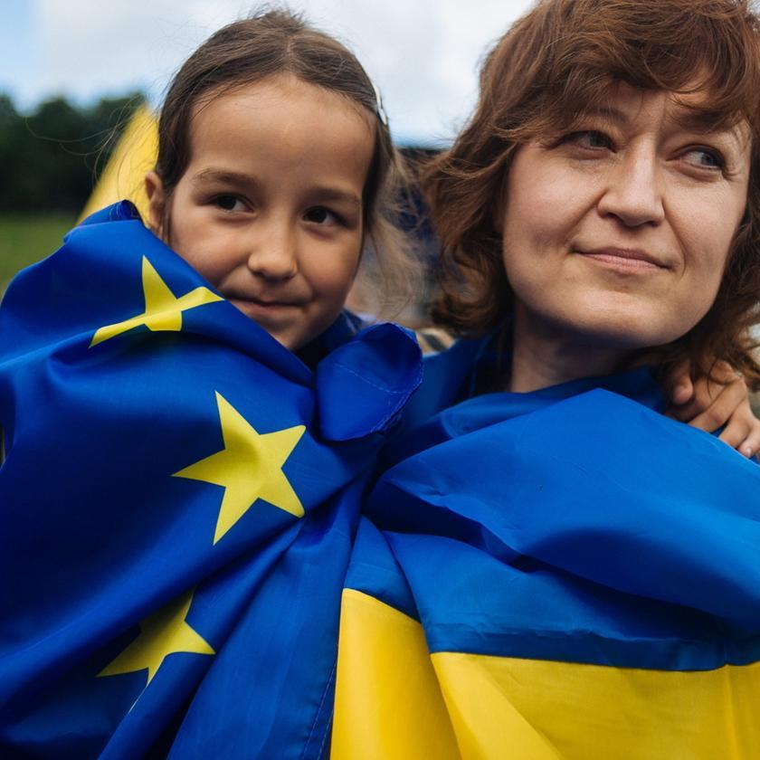
“European Solidarity, Refugee Protection and the Pursuit of Peace”

FOOTNOTES :
1) Council of the European Union. (2001). Council Directive 2001/55/EC of 20 July 2001 on minimum standards for giving temporary protection in the event of a mass influx of displaced persons and on measures promoting a balance of efforts between Member States in receiving such persons and bearing the consequences thereof. EUR-Lex. https://eur-lex.europa.eu/legal-content/EN/TXT/?uri=CELEX:32001L0055
2) Council of the European Union. (2025, September 16). Protection of displaced Ukrainians: Council adopts recommendation about transition out of temporary protection. https://www.consilium.europa.eu/en/press/press-releases/2025/09/16/protection-of-displaced-ukrainians-council-adopts-recommendation-about-transition-out-of-temporary-protection/
3) Council of the European Union. (2026, July 15). EU countries agree to extend temporary protection for those fleeing Ukraine until March 2028. https://www.consilium.europa.eu/en/press/press-releases/2026/07/15/eu-countries-agree-to-extend-temporary-protection-for-those-fleeing-ukraine-until-march-2028/
4) Council of the European Union. (2026). Council Implementing Decision (EU) 2026/1912 extending the temporary protection introduced by Implementing Decision (EU) 2022/382. EUR-Lex. https://eur-lex.europa.eu/legal-content/EN/TXT/?uri=CELEX%3A02026D1912-20260804
5) European Commission. (n.d.). Audiovisual Service. https://audiovisual.ec.europa.eu/en/
6) European Commission. (2023). Temporary protection for those fleeing Russia’s war of aggression against Ukraine: One year on. https://home-affairs.ec.europa.eu/system/files/2023-03/Temporary%20protection%20for%20those%20fleeing%20Russia%E2%80%99s%20war%20of%20aggression%20against%20Ukraine%20one%20year%20on.pdf
7) European Commission. (2025). A predictable and common European way forward for Ukrainians in the EU. EUR-Lex. https://eur-lex.europa.eu/legal-content/EN/TXT/?uri=CELEX:52025DC0649
8) European Commission. (n.d.). Fleeing Ukraine: Support for education. https://commission.europa.eu/topics/eu-solidarity-ukraine/eu-assistance-ukraine/information-people-fleeing-war-ukraine/fleeing-ukraine-support-education_en
9) European Commission. (n.d.). EU countries welcoming those fleeing Ukraine. https://commission.europa.eu/topics/eu-solidarity-ukraine/eu-countries-welcoming-those-fleeing-ukraine_en
10) European Commission. (2026, June 26). Commission proposes to extend temporary protection of people fleeing Ukraine for an additional year. https://home-affairs.ec.europa.eu/news/commission-proposes-extend-temporary-protection-people-fleeing-ukraine-additional-year-2026-06-26_en
FOOTNOTES :
11) European Commission. (n.d.). Returning to Ukraine: Questions and answers. https://commission.europa.eu/topics/eu-solidarity-ukraine/returning-ukraine-questions-and-answers_en
12) European Migration Network. (n.d.). Sustainable inclusion of displaced persons from Ukraine. European Commission. https://home-affairs.ec.europa.eu/networks/european-migration-network-emn/emn-publications/emn-annual-reports/european-migration-network-asylum-and-migration-overview-amo-2024/sustainable-inclusion-displaced-persons-ukraine_en
13) İneli Ciğer, M. (2026). A comparative analysis of exit strategies from temporary protection in the European Union and Türkiye. Law and Justice Review, (32). https://dergipark.org.tr/tr/pub/ljr/article/1879358
14) Karapınar Kocağ, E. (2025). Labour market aspirations of Ukrainian refugees: Determinants and challenges. Ekonomi-tek, 14(1), 132–153. https://dergipark.org.tr/en/download/article-file/4349253
15) Şengül, İ. (2022). Mültecilerin geçici korunması: Kalıcı çözümlerin başarısızlığı ve belirsizlikler. İnönü Üniversitesi Hukuk Fakültesi Dergisi, 13(1). https://dergipark.org.tr/en/pub/inuhfd/article/992439
16) European Commission Audiovisual Service

