The European Union’s (EU) green and digital transitions face a major structural vulnerability; extreme dependency on China for Critical Raw Material Act. The Criminal Raw Material Act (CRMA) directly addresses this strategic fragility, serving as a cornerstone of the EU’s Economic Security Strategy to prevent supply chain weaponization. By establishing concrete 2030 benchmarks for domestic extraction, processing, recycling and capping single country reliance at %65 the CRMA marks a decisive shift from passive market regulation to proactive geopolitical self reliance. However, domestic capacity alone cannot fulfill European demand. Achieving true resilience requires integrating CRM diplomacy into the Common Foreign and Security Policy and leveraging the Global Gateway to build mutually beneficial partnerships across resource rich regions in Latin America and Africa. Ultimately, the CRMA provides a vital frameworks for operationalizing EU strategic autonomy, safeguarding European industrial competitiveness while securing a resilient, sovereign role in an increasingly multipolar global order.


  - Summary
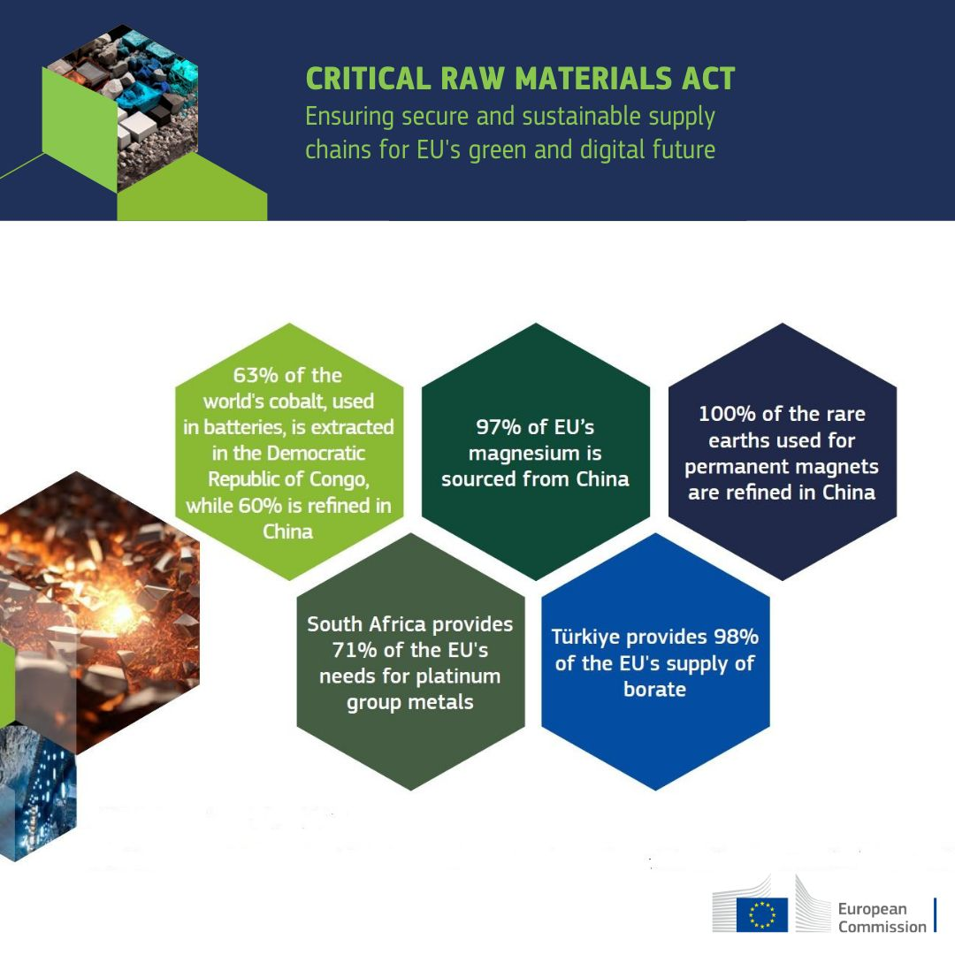

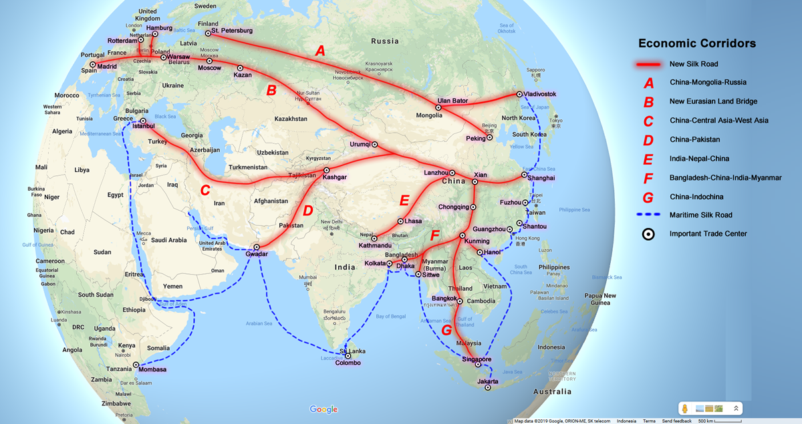
KEY POINTS
1. What is Critical Raw Materials Act? The areas they target and their objectives.

2. Why is CRMA important and why should it be implemented?

3. Potential negative consequences if the CRMA is not implemented.

  - From Dependency to Sovereignty: Analyzing the EU Critical Raw Materials Act in a Contested World
  - Role: Analyst at the European External Action Service (EEAS)
  - Audience: High Representative of the Union for Foreign Affairs and Security Policy

ÇAĞ POLICY BRIEF ISSUE 2026 | 3
Figure 1: https://ciranproject.eu/eu-critical-raw-materials-act-2/
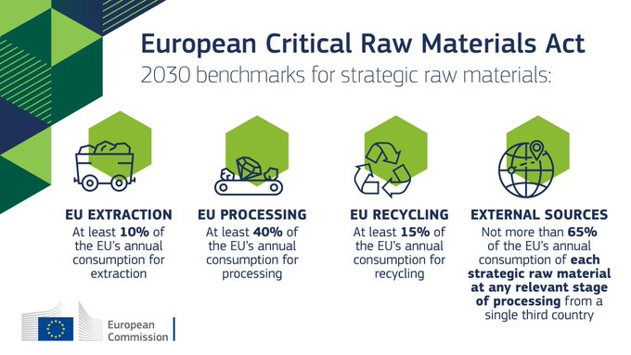
3) Analysis of the failure to follow the CRMA and the potential negative consequences arising from this lack of follow up
If this act is not implemented, challenging political and environmental situaitons will arise. Companies that use permanent magnets or import critical raw materials are specifically required to declare information regarding recycled content and their environmental footprints. It becomes difficult for companies unable to transparently present this data to sell their products in the EU market (complymarket, 2026). Under the act ventures that receive financial support from the EU or are granted “Strategic Project” status lose this designation if they fail to fulfill their commitments. The loss of this statuse entails th cancellation of expedited permitting processes and the closure of funding channels (eversheds sutherland, 2026). The EU currently imports %97 of its magnesium and almost all of its rare earth elements from China, while sourcing %98 of its borates from Türkiye. If the CRMA is not implemented, the goal of avoding more than %65 dependency on any single country will fail, leaving the EU vulnerable to raw material balckmail during geopolitical crises (Nater and partners,2026). Problems such as these likely to arise if this act is not implemented.
4) Recommendations
- Instead of competing with the US (Inflation Reduction Act) and allied nations, joint raw material networs among democratic countries (such as the Mineral Security Partnership) should be strengthened and market fragmentation prevented.

1) What is CRMA and explanations in this context
The Critical Raw Material Act (CRM Act) is a regulation by the European Union (EU) which aims to secure supply of critical raw materials to EU member states. The CRM Act primarily focuses on the expansion of the EU’s domestic capacities to extract, process and recycle raw materials. It has entered into force on 23 May 2024 [Wikipedia,2026]. The legislation has established the following non-binding criteria to be met by 2030, aimed at reducing the EU’s reliance on a single third country primarily China for critical materials [Reuters, 2026].
2) Highlighting the importance of CRMA and the requirements for the implementation of this Act
The focus of this legislation is to secure the EU’s green and digital transition and to reduce its excessive reliance on single source external suppliers, such as Asia and China in particular. While the EU successfully initiated its green transition through the European Green Deal, it created a paradox; reducing reliance on fossil fuels while escalating structural dependencies on critical minerals. A significant portion of the raw materials used in electric vehicles, wind turbines, solar panels, chip manufacturing and the defense industry (such as critical minerals, lithium, cobalt and rare earth elements) is imported from a single country. However the importance of this legislation lies in its role in helping to eliminate this dependency. Beyond quantitative metrics, the CRMA introduces streamlined permitting processes for strategic projects; lowering administrative bottlenecks while maintaining environmental standards. It reflects a major paradigm shift, the European Commission moving from a passive soft power regulator to an active geopolitical actor. Consequently, the EU can no longer treat CRMA supply chains merely as commercial matters but as vital elements of European foreign and security policy.

POLICY BRIEF 2026 | 3

- The EU’s Global Gateway funds, intended to counter China’s Belt and Road Initiative (BRI) should be directed straight to mining and transport infrastructure projects in these countries.

- To alleviate the pressure on mining, significant tax exemptions and incentives should be provided to recycling facilities engaged in “urban mining” that extract minerals from used electronic waste and batteries.

- The approval of mining and processing projects within the EU can take years. For investments granted “Strategic Project” status, bureaucratic permitting processes should be reduced to under 24 months without compromising environmental standards.

- A system similar to “Aggregate EU” implemented during the energy crisis should also be established for critical minerals. EU member states and companies should be encouraged to leverage collective purchasing power (rather than competing individually in the global market) to determine prices and ensure security of supply.

FOOTNOTE
- Eversheds sutherland. (2026, June 11). Eu tightens control over critical raw materials. https://www.eversheds-sutherland.com/en/mauritius/insights/critical-raw-materials-act-and-updates

- ComplyMarket. (2026, June 24). CRMA compliance guide : prepare for EU raw materials act. https://complymarket.com/en/blogs/crma

- Narter and Partners. (2024, June 14). Eu critical raw materials act. https://narterlaw.com/avrupa-birligi-kritik-hammaddeler-yasasi/

- Payne J. (2026, October 9). European commission picks 46 new strategic critical mineral project. Reuters. https://www.reuters.com/business/aerospace-defense/european-commission-picks-46-new-strategic-critical-mineral-projects-2026-10-09/

- Wikipedia. (n. d.). Critical raw material act. https://en.wikipedia.org/wiki/Critical_Raw_Materials_Act

Author: Begüm Ravza Dursun
This Policy Brief has been prepared as part of the participants / students’ assessment in the framework of the EU Politics lecture.
The content of this policy brief lies entirely with the author. It does not reflect the official opinion of Çağ University.

