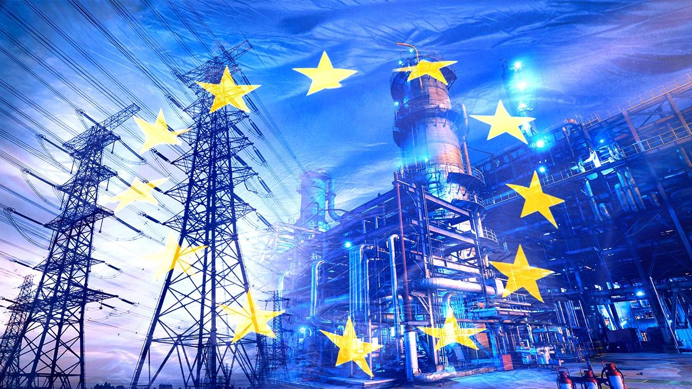

How can the EU improve energy security and reduce its dependence on energy imports? The main hypothesis of this policy brief is that investment in renewable energy and cooperation between Member States can improve energy security. However, the EU must also protect reliable energy supplies and affordable prices. The EU has taken important steps to increase the use of renewable energy and diversify energy sources. However, dependence on fossil fuels and energy prices remain significant problems. For this reason, the EU should Decelerate its investments in renewable energy, develop cross-border energy infrastructure and strengthen coordination between Member States. This approach can Decouple between energy security and economic stability.

ÇAĞ POLICY BRIEF ISSUE 2026 | 3
KEY POINTS

1. The EU should reduce its dependence on energy imports.

2.The EU should increase renewable energy and infrastructure investments.

3.Energy cooperation between the Member States should be strengthened.

Summary
STRENGTHENING EU ENERGY SECURITY AND STRATEGIC AUTONOMY
Author: Ecenaz Özalp
Role: Policy Analyst working on EU energy security
Target Audience: The European Commission and EU policymakers responsible for energy policies
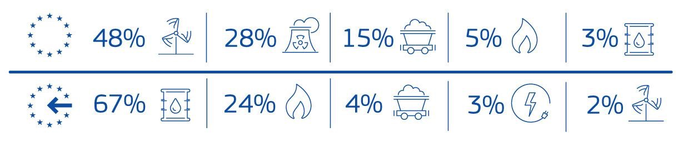
POLICY BRIEF 2026 | 3
“Vivamus porta
est sed est.”
Therefore, the main problem is to reduce dependence on foreign energy while protecting reliable supplies and economic stability.
2.RENEWABLE ENERGY AND CURRENT EU POLITICS
Renewable energy is an important tool for reducing the EU’s energy dependence. Sources such as solar and wind energy can increase local energy production and reduce the need to import fossil fuels. According to the European Commission (2026b), renewable energy made up 25.2% of the EU’s total energy consumption in 2024. The EU also aims to have at least 42.5% renewable energy in its total energy consumption by 2030.
The REPowerEU plan supports different energy sources, energy savings, and faster development of renewable energy. However, the energy transition is moving at different speeds across Member States. Renewable energy also needs strong electricity networks, energy storage, and infrastructure investment.
It is not realistic to completely stop using fossil fuels in the short term. Therefore, the EU should increase renewable energy while also protecting reliable energy supplies, improving energy efficiency, and protecting consumers. A balanced policy should consider both long-term independence and short-term energy needs.
1.THE EU’S DEPENDENCE ON ENNERGY IMPORTS
Energy security is important for the EU’s economic stability and the well-being of its citizens. However, dependence on energy imports can affect energy supplies and prices during international crises and political tensions. According to the European Commission (2026a), the EU met 57% of its energy needs through net imports in 2024. In the same year, oil and oil products made up 67% of EU energy imports, while natural gas made up 24%.

The energy crisis after Russia’s attack on Ukraine showed the risks of depending too much on one supplier. The EU has taken steps to use different energy sources and reduce its dependence on Russian fossil fuels through plans such as REPowerEU (European Commission, n.d.). However, energy security is not only about changing suppliers. The EU should also increase its own energy production, improve energy efficiency, and help keep energy prices affordable for citizens and businesses.
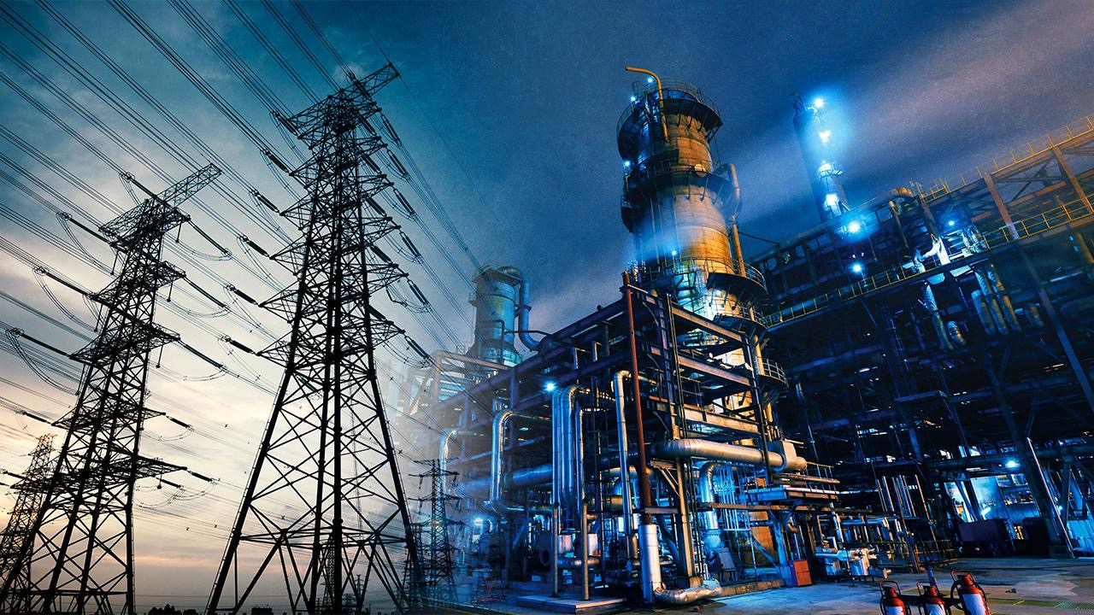
POLICY BRIEF 2026 | 3
Graphic (OPTIONAL)
3.STRENGTHENING COOPERATION AND COMMON INFRASTRUCTURE IN THE EU
Energy security cannot be achieved through national policies alone. Cooperation between Member States can reduce the effects of energy crises and help deliver energy to areas that need it. The European Commission (2026b) explains that connections between countries and coordinated action are important for secure energy supplies.
The EU should invest in electricity networks and connections between countries. It should also improve energy sharing and strengthen common plans for energy crises. In addition, the EU should support joint investment in solar and wind energy, energy storage, and energy efficiency. These actions can help countries use energy more effectively and become stronger against supply problems.
The policy recommendations are:
- Investment in renewable energy production and energy storage should increase.
- Electricity connections between Member States and common crisis plans should become stronger.
- The EU should use different energy sources while keeping energy prices affordable and supplies reliable.
Author : Ecenaz Özalp, Student of International Relations at Çağ University

This Policy Brief has been prepared as part of the participants / students’ assessment in the framework of the EU Politics lecture.
The content of this policy brief lies entirely with the author. It does not reflect the official opinion of Çağ University.
REFERENCES
European Commission. (2026a, April 20). In focus: EU energy security explained. Directorate-General for Energy. https://energy.ec.europa.eu/news/focus-eu-energy-security-explained-2026-04-20_en
European Commission. (2026b, April 22). A more secure and stable energy system. https://commission.europa.eu/topics/energy/eu-action-address-energy-crisis/more-secure-and-stable-energy-system_en
European Commission. (n.d.). Commission proposes a plan to phase out Russian gas and oil imports. https://commission.europa.eu/news-and-media/news/commission-proposes-plan-phase-out-russian-gas-and-oil-imports-2025-06-17_en

