POLICY BRIEF ISSUE 2026 | 2

Can an African Country Industrialize Instead of Just Being a Raw Materials Supplier? Zimbabwe Case

Summary

KEYPOINTS

- Zimbabwe is turning to local processing methods for lithium to achieve greater economic gains.

- The lack of sufficient processing capacity and financing difficulties are increasing the need for foreign investments.

- The fundamental risk is that dependence on raw materials transforms into dependence on external sources and technology.

This policy brief analyzes Zimbabwe's strategy of turning to local processing by restricting the export of unprocessed and under processed minerals to obtain greater economic benefits from lithium resources from a political economy perspective. The main goal of the government is to turn lithium into a powerful industrial tool that will create local production, investment and employment by removing it from being considered only as an exported raw material.
However, this target creates a serious contradiction with Zimbabwe's current economic resources. Just as the lithium processing capability in the country has not yet reached a sufficient level, providing the energy and transportation infrastructure necessary for new facilities also requires a significant investment. Zimbabwe's foreign debts and overdue debts pose difficulties in accessing international finance. So foreign capital is of vital importance in this transformation process. Although Chinese companies are among the main investors, the country's dependence on foreign capital and technology raises questions about the extent to which this transformation can reduce its reliance on raw material exports. This policy brief emphasizes that local processing policy can create higher added value and industrialization potential for Zimbabwe. But the success of the policy depends on the creation of sufficient processing capacity, the exclusion of small producers from this transformation and the transformation of foreign investments into local employment, technology and production capacity. The real issue isn’t just the processing of lithium in Zimbabwe, but how much of the economic value created will actually remain within Zimbabwe's borders.

POLICY BRIEF 2026 | 2

Zimbabwe's Local Processing & Industrialization Strategy for Lithium
Although Zimbabwe's lithium production has been increasing rapidly recently, higher exports do not always mean greater revenue. While spodumene concentrate exports increased in 2025, export revenue did not rise at the same rate due to low lithium prices. Additionally, a large portion of the lithium is sent abroad for further processing. This situation causes Zimbabwe to receive a limited share of the more profitable segments of the value chain, despite its ownership of natural resources. Therefore, the government has begun to consider lithium not only as a exported mine. But also as a strategic resource that can be used for local production and industrialization. This method became more evident with the National Development Strategy 2, which was announced in late 2025. The plan aims to gradually end the export of lithium concentrate by January 2027 and redirect production to higher value products such as lithium sulfate, then lithium carbonate and hydroxide. Concentrate exports were temporarily halted in February 2026. In April, exports were permitted to resume under certain quotas and local trading conditions. Thus, the government encourages companies to make processing investments domestically by using export policies. And the government tries to transform the lithium sector from mining into a more comprehensive industrial structure. [1][2]

Figure[1]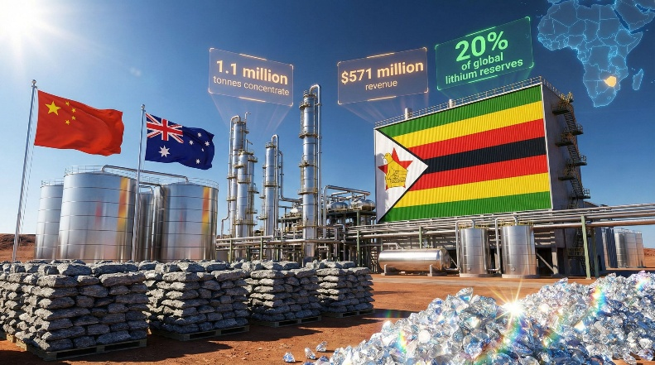

The Problem of Financing and Capacity
The first challenge underlying Zimbabwe's 2027 target is the mismatch between the set timeframe and current processing capacity. As of July 2026, only one lithium sulfate plant is completed in the country, and this plant processes only its own production, with no additional capacity to process lithium from other miners. Although new facilities are being built at the Kamativi projects of Sinomine, Bikita Minerals and Yahua Group, these facilities are not expected to catch up with the export ban that will start in January 2027. Mining companies requested additional time from the government. But the government stated that it would continue the current program. If the necessary capacity isn’t provided on time, some manufacturers may face the danger of not being able to carry out concentrated exports and not being able to process their products domestically. Therefore, the realization of the local processing target depends not only on taking a political decision. It also depends on ensuring the necessary economic and technical competence to implement this decision. [3]

POLICY BRIEF 2026 | 2

Second fundamental issue is how this transformation will be financed. In addition to new processing facilities, significant investments are also required in reliable electricity, transportation infrastructure, and technology. However, Zimbabwe's access to external financing has remained limited for a long time. According to IMF data, the country's external debt has reached about $15.2 billion by the end of 2025. And its overdue debt to official external creditors has reached about $7.7 billion. The country has been deprived of international capital markets and the majority of official foreign financing for over 25 years. The Staff Monitored Programe in 2026 aims to improve the credibility of economic policies and help Zimbabwe regain access to international finance through debt restructuring, rather than aiming to provide new financing directly. These economic constraints reduce the government's ability to finance its industrialization policy and increase the importance of foreign capital. [5] 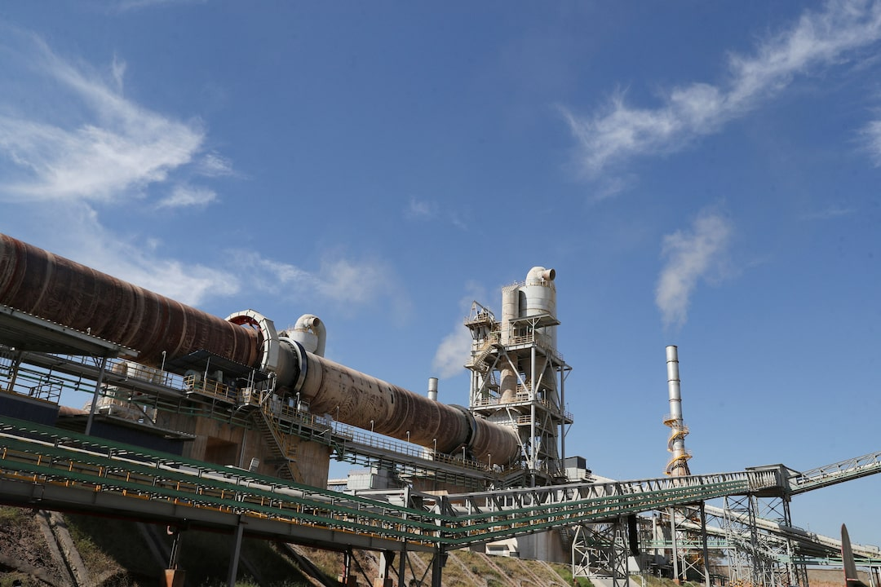 Figure[2]

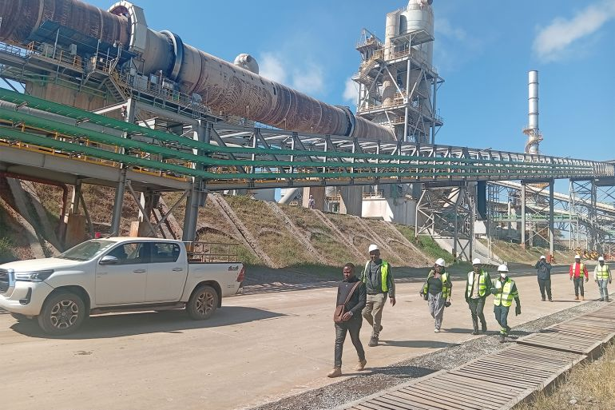
Figure[3]
Chinese companies play an important role in meeting this financing need. Since 2021, Chinese companies have invested over $2 billion in Zimbabwe's lithium extraction and processing facilities. The Zimbabwe government is also discussing financing models with China, in which future mineral revenues can be used for paying loans for road and railway investments. This approach can contribute to obtaining the necessary resources and infrastructure more rapidly. However, there’s also a risk that Zimbabwe which aims to reduce its dependence on lithium exports, will develop a new dependence on foreign players in financing. While large companies have enough capital to build the necessary infrastructure, small manufacturers have more difficulties adapting to the new system due to high investment costs, transportation to finance and electricity shortages. Therefore, the restriction of exports by the government alone will not be enough. Diversification of financing sources, ensuring access of small producers to common processing capacity and linking foreign investments with local employment. Technology and skill development are of great importance for transforming lithium wealth into a more comprehensive economic development. [5][6]

FOOTNOTES
- Banya, N., & Muronzi, C. T. (2026, June 24). Zimbabwe exploring minerals-backed deals with China to fund infrastructure, minister says. Reuters. https://www.reuters.com/world/africa/zimbabwe-exploring-minerals-backed-deals-with-china-fund-infrastructure-minister-2026-06-24/
- Bulawayo, P. (2026, July 17). Zimbabwe’s sole lithium salt plant unable to process third-party metal, official says. Reuters. https://www.reuters.com/world/africa/zimbabwes-sole-lithium-salt-plant-unable-process-third-party-metal-official-says-2026-07-17/
- Denhere, E. (2026, July 26). Can Zimbabwe’s mineral ambitions benefit smaller producers? Al Jazeera. https://www.aljazeera.com/news/2026/7/26/can-zimbabwes-mineral-ambitions-benefit-smaller-producers
- International Monetary Fund, African Department. (2026). Zimbabwe: Request for a staff-monitored program—Press release; and staff report (IMF Country Report No. 2026/104). https://doi.org/10.5089/9798229046947.002
- Reuters. (2026, April 8). Zimbabwe to introduce lithium export quotas, sets conditions for resumption of shipments. https://www.reuters.com/world/africa/zimbabwe-introduce-lithium-export-quotas-sets-conditions-resumption-shipments-2026-04-08/
- Reuters. (2026, February 3). Zimbabwe spodumene exports up 11% in 2025, revenue flat on soft prices. https://www.reuters.com/world/africa/zimbabwe-spodumene-exports-up-11-2025-revenue-flat-soft-prices-2026-02-03/

4

