POLICY BRIEF ISSUE 2026 | 1

How Can Governments Reduce Profit Shifting by Multinational Companies?

Summary

KEY POINTS
- Profit shifting can separate where profits are reported from where business activity occurs.
- Tax coordination needs reliable information and effective domestic administration.
- Governments should assess revenue gains alongside compliance costs and enforcement capacity.
Profit shifting by multinational enterprises can erode government revenues by reporting profits in countries where the actual activity is carried out only to a limited extent. At the same time, governments need to promote investment in their countries. By concluding international agreements, governments can reduce the scope for profit shifting and encourage tax compliant behavior by companies. However, such agreements only have the desired effect if the agreed rules are applied consistently and in a practical manner. In addition to this, there are limits to the information available and the administrative capacity that is required to uncover and to counter aggressive tax planning. This brief deals with the potential of coordinated minimum taxation, extended reporting requirements and improved information exchange as well as strengthened tax administration. Governments should be able to identify artificial constructions and to collect the revenue to which they are entitled, while at the same time clear rules are laid down for genuine business activity. The effectiveness of reform should be measured against the revenue gained, the costs of implementation and the ability of countries to apply the new rules.

(4)

POLICY BRIEF 2026 | 1

PROFIT SHIFTING AND LOST TAX REVENUE

Profit shifting enables multinational enterprises to create groups where total taxes are lower than if all units were taxed at the level of their country of residence. Profits can be shifted to countries with low tax rates by exploiting three main channels of profit shifting: intragroup debt, intangible assets and transfer pricing. (1) Needless to say, all cross-border transactions are also loans, Intellectual Property or payments between associated enterprises, which need to be assessed in order to distinguish between Sound and aggressive taxation. Using historical investment stock data for 79 countries the 2019 paper estimates approximately US$420 billion in shifted profits and corresponding losses in tax revenues of at least US$125 billion every year. Importantly, these figures are based on a sample of countries, not the total number of countries world-wide. A policy response aimed at preventing loss of public revenues should thus focus on detecting artificial arrangements rather than implying that all cross-border transactions between affiliated enterprises are abusive.

WHY CURRENT RESPONSES ARE NOT ENOUGH

TAX COMPETITION AND FRAGMENTED RULES
Avi-Yonah and Kim show how countries compete for mobile capital by lowering their effective corporate tax rates. They analyze Pillar Two’s minimum effective tax rate (METR) of 15% and arrive at the conclusion that it is intended to put a floor on the downward competition to cut corporate tax rates. This is a collective action problem as a single government may fear losing investment while multinationals can easily organize their worldwide operations to be carried out through several countries. Their 2022 article furthermore detailed the existing framework of the BEPS rules, including a €750 million revenue threshold, a number of substance-based exclusions and other exceptions. While concessions will weaken tax coordination in general, the design of effective tax coordination furthermore requires more than a collective agreement on a headline rate. In addition to setting the tax base, all exceptions must also be coordinated between the participating jurisdictions. This brief does not aim to describe all currently applicable rules in detail.

INFORMATION GAPS AND MEASUREMENT LIMITS

Multinationals may conduct parts of their activities through companies that are part of a group using a brand, or using specific know-how or other firm-specific resources. Because of this it is often difficult to attribute income to a particular group of companies. Estimating losses of tax in developing countries on the basis of available data with the use of necessary assumptions is also problematic. More than the low profit before tax reported by a company therefore is needed to conclude that abusive structures are in place. Studies such as Janský and Palanský find limited empirical support for distributional findings of tax losses across different income groups. Importantly, a single study of global tax losses has limited applicability to individual countries’ tax gaps, and the use of better quality domestic data can help to pinpoint specific sectors and transactions that require greater scrutiny.

IMPLEMENTATION AND ADMINISTRATIVE CAPACITY

Avi-Yonah and Kim describe the need for international coordination as well as concerns that implementing the new rules will not be beneficial to developing countries as two of the main challenges to the successful implementation of the reforms. (2) Thus, the revenue to be generated by these reforms world wide is not the only factor to be considered when evaluating the proposed reforms, rather the key factor is which country or countries can effectively collect the revenue and enforce the new rules. To be effective, these international obligations need to be matched by preparatory action in each country. The form that reporting should take will depend on the information needs of tax auditors. The obligations placed on others should be matched by the provision of appropriate staff, IT systems and a mechanism for dealing with queries and disputes.
POLICY BRIEF 2026 | 1

What Needs to Change

COORDINATE MINIMUM TAXATION

Minimum tax rates should be coordinated by governments, with Review of exemptions to prevent continued design of artifices to shift artificial profits. The design concerns identified by Avi-Yonah and Kim underlie this recommendation. (2) Finance ministries must assess the impact of new rules on domestic tax revenues. Countries where economic activities actually take place must be treated as equal players in negotiations, with due assistance to be provided to administrations that need help. Such help must be published, implementation assistance and dispute resolution assistance must be made accessible to taxpayers in order to increase their certainty.

IMPROVE REPORTING AND INFORMATION EXCHANGE

Governments should improve the availability of consistent information on group profits, taxes and business activities across jurisdictions. Recommendation (3) refers to Country-level reporting that supports auditors in singling out structured arrangements which require a more detailed check. Exchanges of information between tax authorities must be implemented in a manner and using tools that enable the protection of confidential information. Risk indicators should guide investigation rather than be used as automatism for assessing tax evasion.

STRENGTHEN TAX ADMINISTRATION

Treasury departments should establish a number of specialist teams dealing with related-party transactions. These teams should receive training in accounting, in valuations and in international tax. Initially audits should focus on the biggest revenue at risk transactions. Governments’ enforcement work should be accompanied by guidance and by compliance requirements that are proportionate to the obligations imposed on companies. The success of the brief should be measured in terms of additional revenue, speed of resolution and the costs of compliance to companies. These are the brief’s implementation proposals and not the findings of the three above sources.
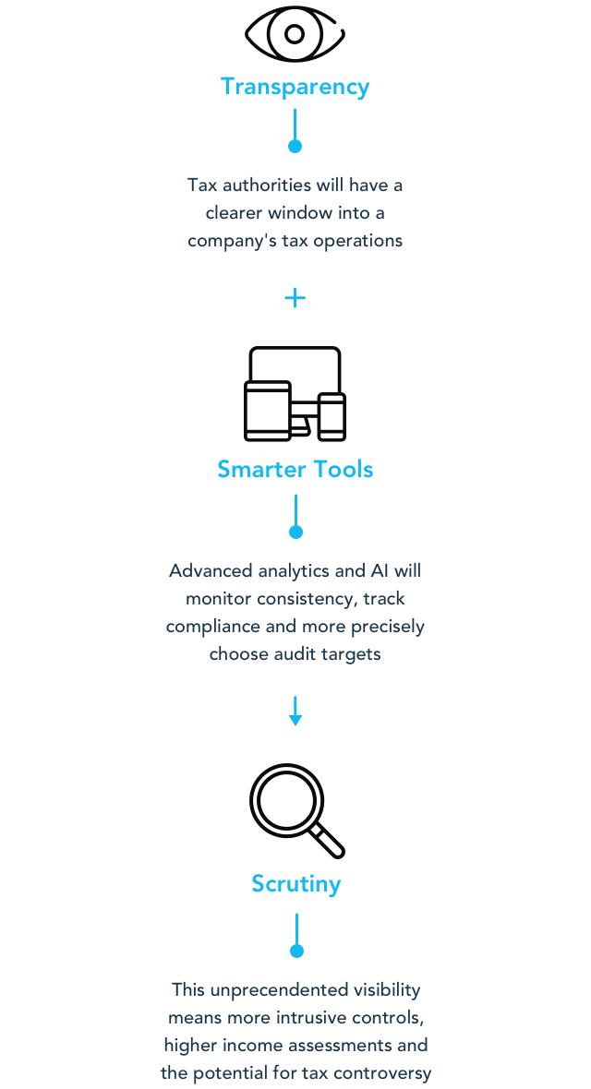
(5)
FOOTNOTES
- Janský, P., & Palanský, M. (2019). Estimating the scale of profit shifting and tax revenue losses related to foreign direct investment. International Tax and Public Finance, 26, 1048–1103. https://doi.org/10.1007/s10797-019-09547-8
- Avi-Yonah, R., & Kim, Y. R. (2022). Tax harmony: The promise and pitfalls of the global minimum tax. Michigan Journal of International Law, 43(3), 505–556. https://doi.org/10.36642/mjil.43.3.tax
- Fuest, C., & Riedel, N. (2012). Tax evasion and tax avoidance: The role of international profit shifting. In P. Reuter (Ed.), Draining development? Controlling flows of illicit funds from developing countries (pp. 109–141). World Bank. https://doi.org/10.1596/978-0-8213-8869-3
- Tax Natives. (n.d.). Global minimum tax to boost revenues for tax havens: OECD. https://taxnatives.com/blog/global-minimum-tax-to-boost-revenues-for-tax-havens-oecd/
- Forbes Insights With Sovos. (2019, April 18). Global taxation is going digital. Here’s how to prepare. Forbes. https://www.forbes.com/sites/insights-sovos/2019/04/18/global-taxation-is-going-digital-heres-how-to-prepare/

This Policy Brief has been prepared as part of the participants / students’ assessment in the framework of the EU Politics lecture.
The content of this policy brief lies entirely with the author. It does not reflect the official opinion of Çağ University.

