POLICY BRIEF ISSUE 2026 | 1

How Should Energy-Importing States Respond to the 2026 Energy Shock?

Summary

KEY POINTS

Iran conflict and disruptions in the Gulf have increased energy prices and inflationary pressure.

Broad fuel subsidies provide quick relief but create high fiscal costs.

Targeted support, supplier diversification and renewable investment offer a more sustainable response.
The 2026 energy shock again vividly underlined how fast geopolitical tensions can impact the global energy market and heap pressure on countries depending on imports. High oil prices increase the costs of transportation and of production in general, threatening to let the inflation genie out of the bottle and upset trade balances. While cuts in fuel taxes and broad subsidies for oil products are an immediate, emotionally convincing measure to cushion the social costs of high prices on low-income households, their fiscal implications are considerable and could even stifle incentives to save energy in the long run. In the short term, such households will need protection from high prices, but in the long term it is more beneficial to a country’s energy security to introduce a number of measures to reduce its dependence on a few suppliers, to make better use of its strategic oil stocks, and to encourage investment in domestic and alternative energy sources.

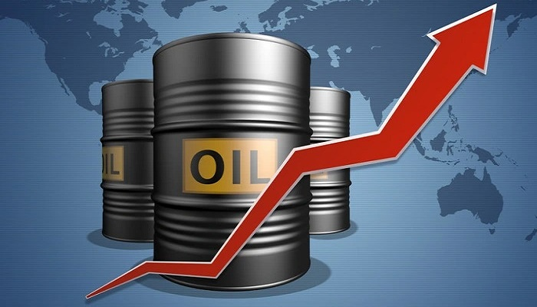

BRIEF 2026 | 1

THE 2026 ENERGY SHOCK

It is no secret that humanity’s history is riddled with wars that have tremendous impacts on the Earth’s geography, economy, and society. It is interesting to observe a current conflict between Iran, the US, and Israel. The full or partial closure of the Strait of Hormuz by Iran during periods of conflict caused dramatic price fluctuations on global markets. While the average price of oil stood at $70 per barrel before the conflict, it shot up to $110 per barrel (1). It is worth noting that the world is still experiencing the effects of these dramatic fluctuations. Many countries, including energy-importing Turkey, experience changes in the prices of diesel and gasoline on a weekly basis. Higher oil prices impact almost every sector of society today. The farming, manufacturing and distribution sectors are very energy intensive. Thus the impact of higher oil prices will affect everyone from the farmers that produce our food to the end user of that food. High oil prices also have the potential to fuel inflation in countries that are large energy importers. The additional cost of energy imported into a country also places additional pressure on a country’s foreign currency reserves in order to pay for the same volume of energy imports. In turn this can put further upward pressure on domestic prices and create further difficulties for a country’s balance of trade.

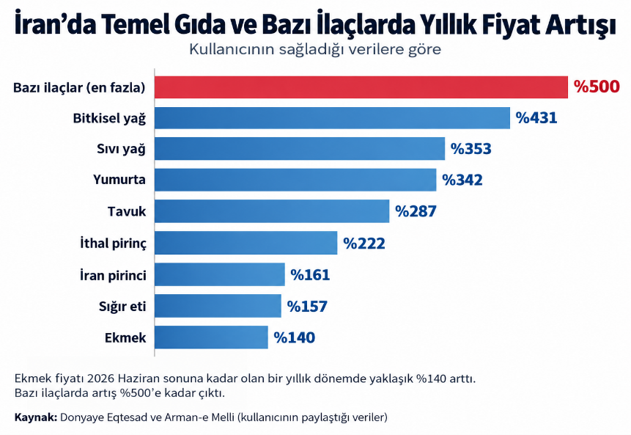
(2)

WHY CURRENT RESPONSES ARE NOT ENOUGH

IMF notes that net energy-importing countries are particularly exposed to prolonged period of high energy prices. For countries still depending on refined fuels imports (diesel, gasoline, Jet-A1), prices are still above pre-conflict levels. For households and businesses, high fuel prices represent a strong burden, temporarily alleviated by broad-based fuel subsidies. While such subsidies might alleviate short-term hardship, broad-based fuel subsidies are generally considered an inefficient long-term solution. This is mainly because all consumers, not just the poor, benefit, placing a burden on government’s budget. More importantly, keeping fuel prices below market levels for too long has an adverse effect on energy savings, because there is little incentive for consumers or businesses to reduce their energy consumption. So, while implementing temporary and targeted measures to cushion the impact, a country’s exposure to external energy price shocks in the long run has to decrease. (3)
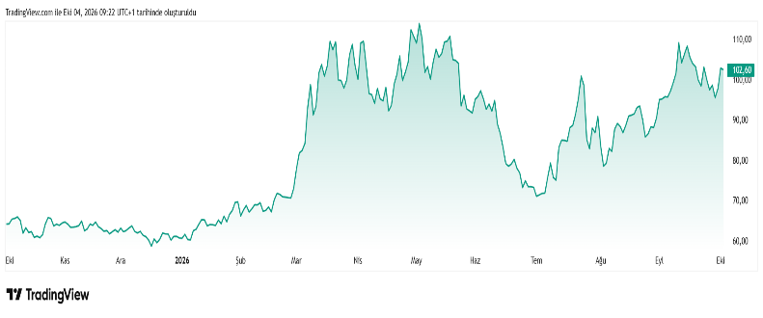 (4)
Governments often respond to unexpected spikes in energy prices by cutting fuel taxes or introducing subsidies to reduce the impact of the higher oil price in domestic markets and cushion the shock on consumers in the short term. But these measures have a cost for governments’ budgets, and keeping prices below market levels for extended periods can even have a negative effect on energy savings. Thus, short-term price measures have to be supported by a midterm to long-term energy policy.
BRIEF 2026 | 1

What Neest to Change?

TARGETED SUPPORT INSTEAD OF BROAD-BASED SUBSIDIES

To immediately address extreme cases of suffering brought about by the crisis, the government can temporarily grant fuel subsidies to the very poor. Such temporary measures could, however, be costly to the public sector in the long run, since those with higher incomes (who also use more electricity) shall likely enjoy more from the subsidies than the poor. Providing financial or other forms of support and incentives, however, would be more desirable as this shall enable the federal agency to save on cost of subsidies to be enjoyed by high income households while at the same time protecting the poor from the effects of the crisis. In the long run, such an approach can also help curb excessive consumption of energy.

RESOLVING ISSUES AMONG ENERGY SUPPLIERS

Energy-importing countries risk massive losses when an energy crisis occurs. Energy customers in general, and countries depending on a single supplier in particular, can suffer losses of a magnitude comparable to those caused by natural disasters. Countries currently going through an energy crisis experience the effects of a political crisis and of conflict in a region elsewhere in the world impairing energy supplies and their distribution. Only by searching for alternative suppliers and, above all, alternative distribution channels, can a country impede possible jeopardies to its national interest. The increase in price may not be prevented, but it can be eased by more diversity.

INVEST IN LOCAL AND RENEWABLE ENERGY

Countries dependent on foreign energy sources need to transition to renewable energy -specifically wind, solar, and hydroelectric power- to ultimately reduce this dependency. Over time, investing in these energy sources curbs capital flight and strengthens energy security. Indeed, this transition requires allocating resources to infrastructure, capacity building, and storage systems. Therefore, renewable energy should be viewed not merely as a climate change issue, but also as a matter of energy security. In this way, the country will be better prepared to cope with potential disasters and reduce its vulnerability to regional crises.
FOOTNOTES
- Bayoumi, M., & Mason, R. (2026). Conflicts and energy transitions: The case of the 2026 Iran War. PLOS Sustainability and Transformation, 5(8), e0000265.
- Galestan, M. (2026, October 2). Iran’s economy at breaking point: Inflation, falling incomes and a crisis that reaches into every home. National Council of Resistance of Iran. NCRI article
- International Monetary Fund. (2026, October 1). IMF press briefing transcript: October 1, 2026. https://www.imf.org/en/news/articles/2026/10/01/tr-10012026-imf-press-briefing-transcript-october-01-2026
- TradingView. (n.d.). Brent ham petrol CFD'leri (UKOIL). Retrieved October 4, 2026, from TradingView – Brent Ham Petrol UKOIL

The content of this policy brief lies with the author. It does not reflect the official opinion of Çağ University.

