Keypoints
1- Global rice market is so senstive because it is about %10-%11 in whole trade. India that accounted %40 of rice exports increased prices by more than %22
2-With shipments falling by more than 50%, Sub Saharan Africa was hit by a direct supply shortage, while South and Southeast Asia, where rice is a basic food, were affected by severe food inflation and price ceiling applications.
3-The main way to overcome the crisis is investment in agricultural R&D and infrastructure, increasing productivity for each hectare, promoting smart technologies (e.g., sensor-based systems in Vietnam), and expanding climate-resilient production techniques.

India’s Rice Export Restrictions and Global Food Security: Regional Impacts on Africa and Asia and the Role of Agricultural Innovation

SUMMARY
In July 2023, India that used to produce %40 need of rice on earth, brought new restrictions on rice Because of stabilizing local market dynamics. Restrictions were upon non basmati white rices (Thomas and Satheesha, 2024). This decision came after the rice export ban introduced in September 2022 and the additional customs duties imposed on parboiled rice, triggering a widespread shock in global agricultural trade. Global rice production is only about %10-11 of whole international trade (Thomas and Sateesha, 2024), so this restriction increased global benchmark prices more than %22 (Glauber and Mamun, 2023). Because rice is the one of the basic foods for half of the globe.
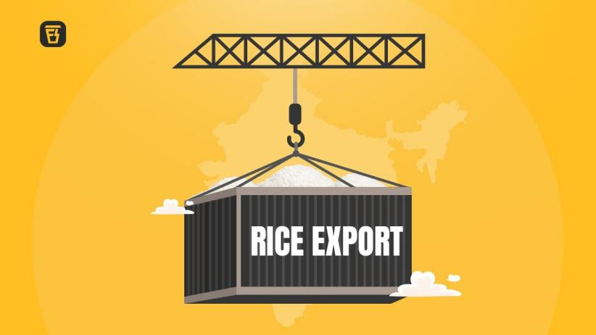
Image is got from Finshots.com

-Drivers of India's Export Ban and Global Supply Shock
Finding of “Thinly Traded” structure of global rice production is based on analysis of ISAS and IFPRI. Additionally, crucial part of this production is consumed by local consumption of Asian countries, thus this situation makes the rice production so fragile also makes global supply utterly sensitive by some main suppliers (Thomas and Sateesha, 2024).
Indian Govenment gradually progressed restrictions to take local food inflation under control and to secure public food distribution programs that ensure free food to more than 800 million people (Pradhan Mantri Garib Kalyan Yojana) (Thomas and Sateesha, 2024). In September 2022 broken rice export was completely banned; non basmatş white rice that is part of %30 of export was banned and %20 additional customs duty was brought to parboiled white rice. (Glauber and Mamun, 2024).
%45 of rice that is exported by India used to go African countries (Thomas and Satheesha, 2024). After export restrictions, rice shipments from India to Africa; to West Africa %54, to East Africa %58 and to Middle Africa %80 decreased (Glauber and Mamun, 2024). Because of restrictions several African countries obligated to shift toward more expensive alternatives. For example: Senegal used to meet %80 of its rice need (Glauber and Mamun, 2024), after restriciton rice shipments from India decreased by %50. Because of this it had to shift toward more expensive alternatives (Glauber and Mamun, 2024). Like Senegal, Madagascar used to import %80 of its rice need from India and after restrictions its imported decreased by %44. Moreover in Kenya that used to ensure %70 of its rice import from India in first 7 months of 2023 after the situation (Glauber and Mamun, 2024).
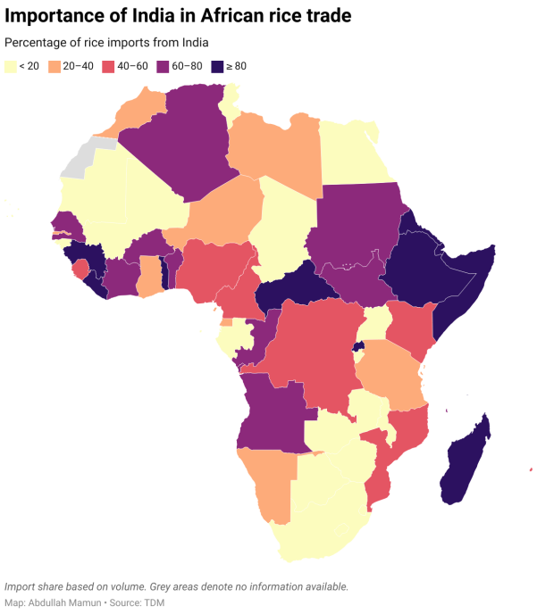
From South and Southeast Asian Countries’ aspect: Restrictions stroke directly Asians kitchens directly because rice accounts %40-%67 daily calorie intake in the region (Glauber and Mamun, 2023). For instance: In Philippines, inflation increased %4.1 and food costs accounted %50-%70 of this inflation, thus government had to make price ceiling on rice and to guarantee supply they signed a 5 year supply contract with Vietnam (Donelly, 2024). Also in India’s neighbors, Nepal and Sri Lanka, local prices increased rapidly (Thomas and Satheesha, 2024). Moreover El Nino drought brought extra difficulties for several countries like Indonesia: It had food security risks due to drought so it stocked rice urgently from Cambodia and Myanmar (Thomas and Satheesha, 2024). ASEAN members took decision to give priority to rice trade with each other (Donelly, 2024).
In September 2024, the Indian government lifted its 14-month ban on non-basmati white rice exports, establishing a floor price of $490 per metric ton to manage domestic supply while alleviating global shortages (Reuters, 2024). Although this policy shift caused immediate price declines in global markets, it exposed how domestic political pressure from Indian farmers—demanding export access amid surplus stocks—directly shapes the food security trajectory of import-dependent West African nations.

Policy Suggestions
Although the restrictions are lifted mostly, an important part of world witnessed hard times in daily life, in particular on their diet. In this context, new ways have to be ready against any possible scenarios. Firstly regional reserve mechanisms should be promoted in the countries that are bound import. On the other hand; a long term could be more essential for countries; public investments for rise on productivity: Developing countries’ increasing rice yield for each hectare by using R&D and infrastructure investments, for example, the average rice yield per hectare is 2,717 kg in India, compared with 4,824 kg in China (Thomas and Satheesha, 2024). Additionally spread of smart agriculture technics is essential, in particular; The technologies that uses less water resources against any irregular rain and drought for example, using sensor-based water pumps in Vietnam to conserve water during dry periods, as well as implementing crop rotation and intercropping to maintain soil quality.
REFERENCES
-Glauber, J., & Mamun, A. (2024, February 7). India’s export restrictions on rice continue to disrupt global markets, supplies, and prices. International Food Policy Research Institute. https://www.ifpri.org/blog/indias-export-restrictions-rice-continue-disrupt-global-markets-supplies-and-prices/
-Glauber, J., & Mamun, A. (2023, July 25). India’s new ban on rice exports: Potential threats to global supply, prices, and food security. International Food Policy Research Institute. https://www.ifpri.org/blog/indias-new-ban-rice-exports-potential-threats-global-supply-prices-and-food-security/
-Reuters. (2024, September 28). India allows non-Basmati white rice exports in boost for global supplies. https://www.reuters.com/markets/commodities/india-allows-non-basmati-white-rice-exports-sets-floor-price-2024-09-28/
-Thomas, J. J., & Satheesha, B. (2024, August 30). India’s rice exports: World’s food security challenges. Institute of South Asian Studies, National University of Singapore. https://www.isas.nus.edu.sg/papers/indias-rice-exports-worlds-food-security-challenges/
-Donnelly, C. (2024, March 7). The politics of rice and security in Southeast Asia. Center for Strategic and International Studies. https://www.csis.org/blogs/new-perspectives-asia/politics-rice-and-security-southeast-asia

The content of this policy brief lies with the author. It does not reflect the official opinion of Çağ University.
Author: Süleyman Uğur Çetin, student of International relations at Çağ University
The content of this policy brief lies with the author. It does not reflect the official opinion of Çağ University.

