POLICY BRIEF ISSUE 2026|1

China’s Rise in Electric Vehicles & the Transformation of the European Automotive Industry

Summary

KEYPOINTS

- China has become the leader in the global EV sector.

- Germany's competitiveness especially in the Chinese market has weakened.

- The EU responded to Chinese sourced competition with additional taxes.

This policy brief highlights the effects of China's rise in the electric vehicle (EV) sector on the European automotive industry especially Germany, from the perspective of political economy. China's rise in this industry should be examined not only as a result of economic and technological success. But also as a result of long term industrial policies, battery production, government support, and a strong position established in critical raw material supply chains.

This policy brief, deals with the mutual shaping of economic competition and political decisions. Addresses the fact that China's increasing power in the electric vehicle and battery sector is putting economic pressure on Europe due to the trade and industrial policies of the European Union. The EU's trade measures for electric vehicles originating in China and Germany's approach to these policies emphasizes an important example of the relationship between economic interests and political decisions.

Finally, this policy brief aims to examine who gained from this transformation and who was negatively affected. Chinese manufacturers are also addressing the different impacts on the European automotive industry, employees, and consumers. This transformation is an international political economy issue where economic power and political decisions are intertwined.



POLICY BRIEF 2026|1

Electric Vehicle Transformation and China's Rise
Europe, especially Germany, has been one of the center of the global automotive industry for many years thanks to its strong production capacity, engineering expertise, and global brands. However, the transition to electric vehicles is changing the main elements of competition in the sector. Engine technology and mechanical engineering provided a significant competitive advantage in traditional production based on internal combustion engines. Battery technology, software, electronic and access to critical raw materials have become increasingly important for electric vehicles. This transformation is also effecting the distribution of economic power in the automotive sector. In 2025, nearly 22 million electric vehicles were produced worldwide, and China alone produced almost three quarters of global production with approximately 16 million vehicles. In the same year, the European Union's electric vehicle production increased by 30%, reaching approximately 3.2 million. And it remained the world's second largest production center. Despite, the increase in production in Europe, the difference in production volume between Europe and China can’t be ignored. To summarize, this transformation should be considered not as the disappearance of the European automotive industry, but rather as a change in the global competitive balance and Europe's relative position in the sector as a result of China's rapidly fast rise. [1]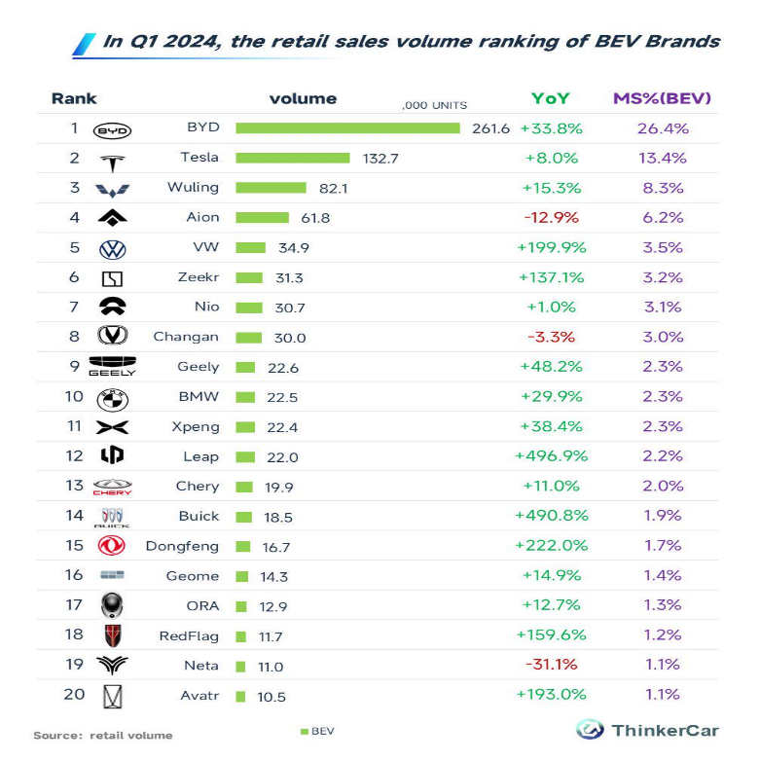
Figure[1]

China's current position cannot be explained solely by technological success or low production costs. Long term state led industrial policies, support for electric vehicles and battery technologies, a large domestic market, and high production volumes have all played a role in the development of China's economic capacity. Critical raw materials and the battery supply chain are crucially important in this regard. Electric vehicle production has made raw materials such as lithium, cobalt, nikel, graphite, and rare earth elements even more strategic. Of course this competition isn't just about possessing these minerals. The real challenge is being able to process them and transform them into a battery production chain. By 2025, China had accounted for more than 80% of global battery cell production, and approximately 85% of cathode active materials and more than 90% of anode active materials used in electric vehicle batteries were produced in China. For these reasons, China's rise in the EV sector is one of the most important examples of how state policies, combined with production capacity, technology, and strategic supply chains, have transformed into an international economic power. [2]

POLICY BRIEF 2026|1
Political & Economic Effects of the EV Transition in Europe and Germany

The consequences of the transition to electric vehicles have become most visible for Germany in the Chinese market. While German car brands were strong in the Chinese market for many years, the increasing preference for Chinese brands in their own markets has reversed this situation. According to Deutsche Bundesbank data, the market share of German brands in China fell from almost 24% in 2018 to 12% in 2025. There has also been a noticeable decrease in Germany's exports of motor vehicles to China. Nevertheless, the production and export of electric and plug in hybrid vehicles in Germany continues to increase. Therefore, the main problem isn’t the complete decline of Germany's automotive production, but the necessity to adapt to new competitive conditions along with the weakening of its position in the Chinese market, where it was strong for many years. [3]
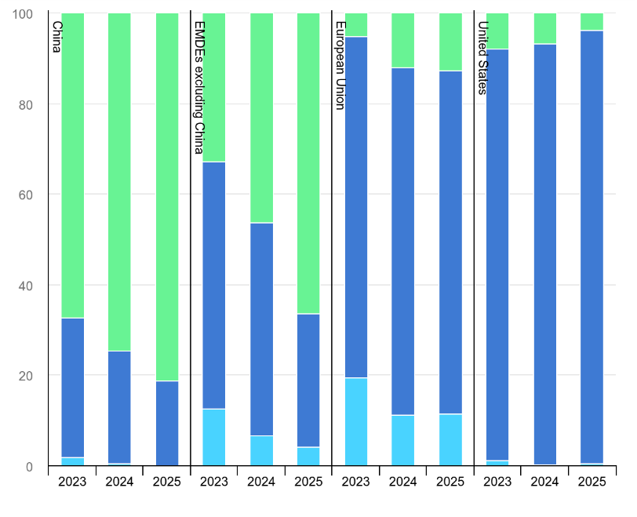
With increasing competition due to China, the European Union's economic concerns have also been reflected in its political decisions. In 2023, the European Commission launched an investigation to examine state aid provided to Chinese electric vehicle manufacturers, and in 2024, it imposed additional tariffs on electric vehicles imported from China ranging from 7.8% to 35.3%. However, instead of completely restricting trade relations with China, the EU has continued negotiations. In 2026, alternatives such as a specific minimum selling price and investing in Europe have also come to the fore. This approach proves that the EU is trying to maintain its economic relations with China. While protecting its own automotive industry, and that economic interests directly influence political decisions. In this new competitive environment, Chinese electric vehicle and battery manufacturers are strengthening their position in the global market day by day, while German manufacturers have experienced a significant loss of market share, especially in China. Furthermore, while approximately 29.9 million cars were produced in China in 2025, this number remained at 4.15 million in Germany. When these data are analyzed, it shows that the balance of power in the global automotive sector is increasingly shifting in favor of China. While European automotive manufacturers face increasing competitive pressure, consumers have access to more and more affordable electric vehicle options. [4][5]

FOOTNOTES
- Deutsche Bundesbank. (2026). Monthly report: March 2026. https://publikationen.bundesbank.de/caas/v1/media/991174/referenceDoc/4823a4e553803fd1e05d16de13e4f4f0
- European Commission. (2024, October 29). EU imposes duties on unfairly subsidised electric vehicles from China while discussions on price undertakings continue. https://ec.europa.eu/commission/presscorner/detail/en/ip_24_5589
- European Commission. (2026, January 12). Commission issues guidance document on submission of price undertaking offers for battery electric vehicles from China. https://policy.trade.ec.europa.eu/news/commission issues guidance document submission price undertaking offers battery electric vehicles 2026 01 12_en
- International Energy Agency. (2026). Global EV outlook 2026. https://www.iea.org/reports/global ev outlook 2026
- International Energy Agency. (2026). Global EV outlook 2026: Electric vehicle batteries. https://www.iea.org/reports/global ev outlook 2026/electric vehicle batteries

The content of this policy brief lies with the author. It does not reflect the official opinion of Çağ University.

