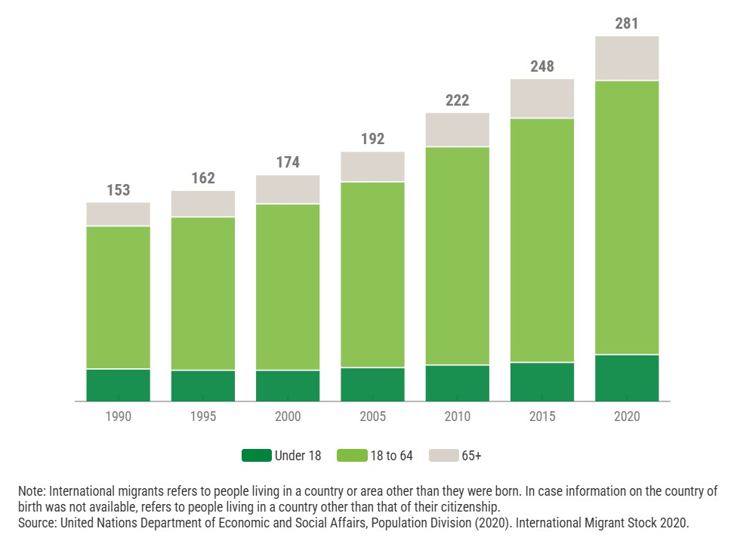
  - Summary

KEY POINTS
1. Migration: The movement of people from one place to another—including international migration, forced migration, refugees, asylum seekers, and irregular migration—and the EU's approach to migration and asylum.

2. Impacts of Migration on Children: The effects of migration processes on children, including family separation, limited access to education and healthcare services, violence, abuse, human trafficking, exploitation, inadequate housing, and protection risks faced by unaccompanied children.

3. Children's Rights and Protection Risks in EU Migration: Protection risks and challenges regarding children's rights in the context of migration to the EU, examined through statistical data and reports provided by UNICEF and UNHCR.

Migration is a global situation that directly affects the rights and well-being of groups, individuals, and especially children. Children experiencing migration face various challenges such as separation from family, experiencing violence, abuse, falling victim to human trafficking, being deprived of education, and lack of access to healthcare services. Children who become unaccompanied and separated from their families are in need of even more assistance. UNICEF and UNHCR data demonstrate the extent of the dangers children face during migration to Europe and highlight the challenges regarding the protection of children's rights. Based on this, the European Union (EU) has developed policies such as the EU Strategy on the Rights of the Child and the European Child Guarantee to strengthen the protection of children's rights. This study examines migration, the impacts of migration on children, and statistical data on children's rights and protection risks in migration to the EU. The study seeks an answer to the question "What policies can the European Union implement to protect children's rights and reduce the protection risks faced by children during migration?" This text argues that strengthening child-sensitive migration and asylum procedures, ensuring access to basic services, protecting family unity, and strengthening mechanisms against abuse can reduce protection risks and contribute to the effective protection of children's rights.
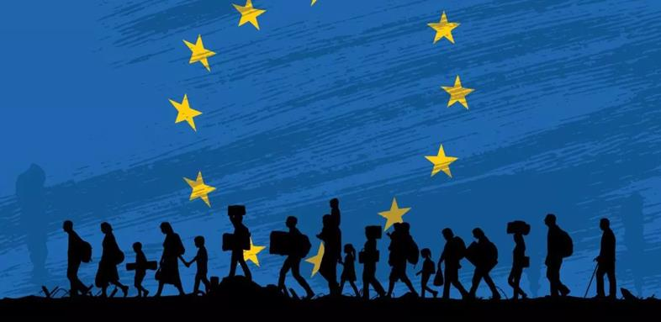

  - What policies can the European Union implement to protect children’s rights and reduce protection risks faced by children during migration?
  - Role: Policy Officer, Directorate-General for Migration and Home Affairs (DG HOME), European Commission

ÇAĞ POLICY BRIEF ISSUE 2026 | 2
Therefore, migration should be considered not only as the movement of people from one place to another, but also as a process that brings with it different risks and protection needs that children, in particular, may face.
2. Impacts of Migration on Children:
"Millions of children are on the move. Some are driven from their homes by conflict, poverty or climate change; others leave in the hope of finding a better life. Far too many encounter danger, detention, deprivation and discrimination on their journeys, at destination or upon return. It doesn’t have to be this way. The suffering and exclusion of migrant and displaced children is not only unacceptable, but also preventable. A child is a child, no matter why she leaves home, where she comes from, where she is, or how she got there. Every child has the right to protection, care and all the support and services they need to thrive.
Yet, too often migrant and displaced children face numerous challenges in transit, at destination and upon return, often because they have few – or no – options to move through safe and regular pathways whether on their own or with their families. They may be forced into child labour, pressed into early marriage, exposed to aggravated smuggling, subjected to human trafficking, and put at risk of violence and exploitation or. They often miss out on education and proper medical care, and don’t find it easy to feel at home in the communities they arrive in; trying to learn a new language and fit into a new culture can make things especially hard. These difficulties have lasting physical and psychological effects and can prevent children on the move from reaching their full potential" (UNICEF n.d.).

POLICY BRIEF 2026 | 2
1. Migration:
"Migration is a process of mobility that triggers social change and development in terms of its causes, effects, and consequences. Migration, which enables the re-imagining and production of the relationship between people and space, is a social phenomenon with sociological, economic, and psychological dimensions. The element that makes migration movements a priority agenda item for the international community and global actors can be expressed as the dynamic nature and social effects of migration." (Akkayan, 1979: 20; Demir, 2022a: 78). "In the European context, migration is not only a matter of border management but also includes cooperation on human rights and child protection. The European Union and the United Nations have developed cooperation mechanisms addressing migration and child protection issues and have demonstrated the importance of protecting vulnerable groups in migration processes." (Hosli, 2022). The protection of children in migration is also linked to the broader international framework of children's rights and the principle of protecting children from discrimination, violence, and separation from their families (UNICEF Türkiye, n.d.).

Children experiencing migration face various challenges such as separation from family, experiencing violence, abuse, falling victim to human trafficking, being deprived of education, and lack of access to healthcare services.

Therefore, the protection of children during migration requires safe conditions, family reunification, access to essential services, and stronger child protection policies.

Implementation in the EU

The EU is currently implementing the Pact on Migration and Asylum, which entered into application on 12 June 2026. Under this system, migrants undergo identity, health and security checks, as well as vulnerability screening. The new rules also provide specific safeguards for children, including representatives for unaccompanied minors and measures to protect vulnerable children. The implementation involves the European Commission, EU Member States and EU agencies such as the European Union Agency for Asylum (EUAA). However, the implementation of the Pact is still developing, and the European Commission has identified remaining gaps in areas such as reception capacity, responsibility transfers and fundamental rights monitoring. Therefore, further support is needed to strengthen the protection of children during migration processes.

POLICY BRIEF 2026 | 2
3. Children's Rights and Protection Risks in EU Migration:
To fully examine children on the move, we can make use of numerical data. In 2025, approximately 31,103 children arrived in Europe via sea and land routes. These routes included countries such as Bulgaria, Cyprus, Greece, Italy, Malta, and Spain. UNICEF, UNHCR, and IOM reported that 20,777 of these children were unaccompanied, representing approximately 67% of the total number of children (UNICEF, UNHCR, and IOM, 2026). These data mean that children are traveling alone without their parents by their side. They are minors, on a journey, and all alone. Many dangers can happen to children. These migrant children, who are on a journey without an adult to protect them, may face many risks throughout the journey.
This situation can also be seen in international protection applications in the European Union. According to Eurostat, in 2025, 158,400 children under the age of 18 applied for international protection for the first time in EU countries. These children accounted for 23.7% of all first-time applicants. Among these child applicants, 13.3% consisted of unaccompanied children (Eurostat, 2026). Furthermore, 21,125 unaccompanied children applied for asylum for the first time in 2025 (Eurostat, 2026). These data show that children constitute a significant portion of the people applying for international protection in the EU.
UNICEF states that unaccompanied and separated children face serious risks during migration and displacement (UNICEF, 2025).

Graphic (OPTIONAL)
Key idea to stress out
More attention should be given to children during migration processes, especially to unaccompanied migrant children who face greater risks. My objective in these policy proposals is to provide stronger protection and support for migrant children while helping them feel safe, supported, and included in European society. I aim to help them return to society without feeling excluded, reconnect with the warmth of a family, and rebuild their sense of trust in the world. All of this should be achieved by giving the necessary attention to their psychological and physical well-being

References :
1-Akkayan, T. (1979). Göç ve değişme. İstanbul: Edebiyat Fakültesi Basımevi.
2-UNICEF Türkiye. (t.y.). Çocuk Haklarına Dair Sözleşme. Birleşmiş Milletler Çocuklara Yardım Fonu https://www.unicef.org/turkiye/çocuk-haklarına-dair-sözleşme
3-Hosli, M. O. (2022). The European Union and the United Nations in global governance. Leiden University. https://www.universiteitleiden.nl/en/research/research-output/governance-and-global-affairs/the-european-union-and-the-united-nations-in-global-governance
4- Demir, E. (2022a). Antalya’nın nüfusu ve sosyal özellikleri üzerine bir değerlendirme. Turkish Academic Research Review, 7(1), 75-96.
5-UNICEF. (n.d.). Migrant and displaced children. https://www.unicef.org/child-protection/migrant-displaced-children

Recommendations:
1. Child Protection Passport
An EU passport system valid only for children, for unaccompanied migrant children entering an EU country. A digital protection system that includes age and identity information, health needs, specific protection risks, educational status, family search process, and necessary psychological-social support. In this way, their safety can be ensured by keeping them under observation and monitoring. They can be reintegrated into social life.

2-An autonomous Child Protection Officer Robot
Here, we utilize artificial intelligence. We are addressing the initial hours spent with migrant children—those first moments when they find themselves in unfamiliar, frightening surroundings. This robotic system is designed to manage their first 48 hours. The reason we employ artificial intelligence is to bridge the language gap during what is already a difficult initial period for these children.

3- BELONG "Every child deserves to belong"
A matching application open to reliable families vetted by the state. It filters the characteristics of unaccompanied migrant children against the profiles of our trusted families and matches compatible pairs. In this way, the child can embrace life anew with a family that shares their values—without feeling like a stranger—and is successfully integrated into society without feeling lost.

Graphic (OPTIONAL)
POLICY BRIEF 2026 | 2

6-Eurostat. (2026a, April 29). 24% of first-time asylum applicants were minors in 2025. European Commission. https://ec.europa.eu/eurostat/de/web/products-eurostat-news/w/ddn-20260429-1
7-Eurostat. (2026b). Applications by unaccompanied minors. European Commission. https://ec.europa.eu/eurostat/statistics-explained/SEPDF/cache/5777.pdf
8-UNICEF. (2025). Alone, on the move and unseen: The global situation of unaccompanied and separated children. https://data.unicef.org/resources/alone-on-the-move-unseen-idac/
9-UNICEF, UNHCR, & IOM. (2026). Migrant and refugee children in 2025 via mixed migration routes in Europe. UNICEF. https://www.unicef.org/eca/documents/migrant-and-refugee-children-2025-mixed-migration-routes-europe

10-Chzhen, Y., de Neubourg, C., Plavgo, I., & de Milliano, M. (2016). Child poverty in the European Union: The multiple overlapping deprivation analysis approach (EU-MODA). _Child Indicators Research, 9_(2), 335–356. https://doi.org/10.1007/s12187-015-9321-7

11-Office of the United Nations High Commissioner for Human Rights. (t.y.). _Convention on the Rights of the Child_. https://www.ohchr.org/en/instruments-mechanisms/instruments/convention-rights-child
12-European Commission. (2021). _The EU Strategy on the Rights of the Child and the European Child Guarantee_. https://commission.europa.eu/strategy-and-policy/policies/justice-and-fundamental-rights/rights-child/eu-strategy-rights-child-and-european-child-guarantee\_en
13- European Commission. (2024, April 23). _Delivering on the EU Strategy on the Rights of the Child: Integrated child protection systems_. https://commission.europa.eu/document/download/41f661b5-5e6a-4374-8d72-431b33d9a16c\_en?filename=2024.04.24\_ICP\_Factsheet\_FINAL.pdf
14- Yılmaz, Ş. (2026). Çocuk hakları ve farklı ülkelerde çocuk haklarının incelenmesi: Avrupa ülkeleri örnekleri. _İstanbul Aydın Üniversitesi Eğitim Fakültesi Dergisi, 12_(1), 139–159. https://dergipark.org.tr/en/download/article-file/5644209

Author : Dilara Gayir

This Policy Brief has been prepared as part of the students’ assessment in the framework of the EU Politics lecture.
The content of this policy brief lies entirely with the author. It does not reflect the official opinion of Çağ University.

