

FROM EQUALITY IN EDUCATION TO EQUAL EDUCATION OPPORTUNITIES

Author: Ecenaz Özalp
Role: Academician
Target Audience: Academics

ÇAĞ POLICY BRIEF ISSUE 2026 | 2
Can the EU’s current education policies increase students’ access to quality and inclusive education? Although the common goals and policies of the EU support equality in education, the existing policies alone cannot be sufficient as long as the differences between the member states and the problems faced by disadvantaged groups continue. The findings show that the rate of early school leaving in the EU is approaching below 9%, which is the 2030 target. However, there are significant differences between countries. Students who are economically and socially disadvantaged have more limited access to educational opportunities. Therefore, the EU should focus on three areas rather than changing its current education policies: early support for disadvantaged students, supporting teachers and stronger monitoring of inequalities in education.
KEY POINTS

1. Educational inequality and early school leavings are ongoing problems in the EU

2. EU education policies support quality, equality and inclusion.

3. Early support, teacher support, and strong monitoring should be strengthened.
Summary
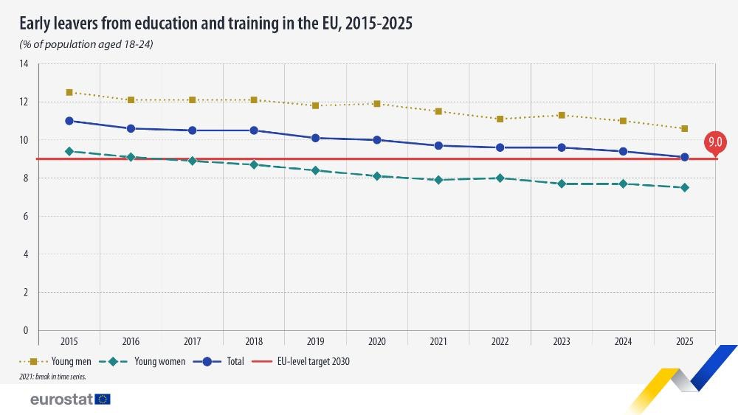
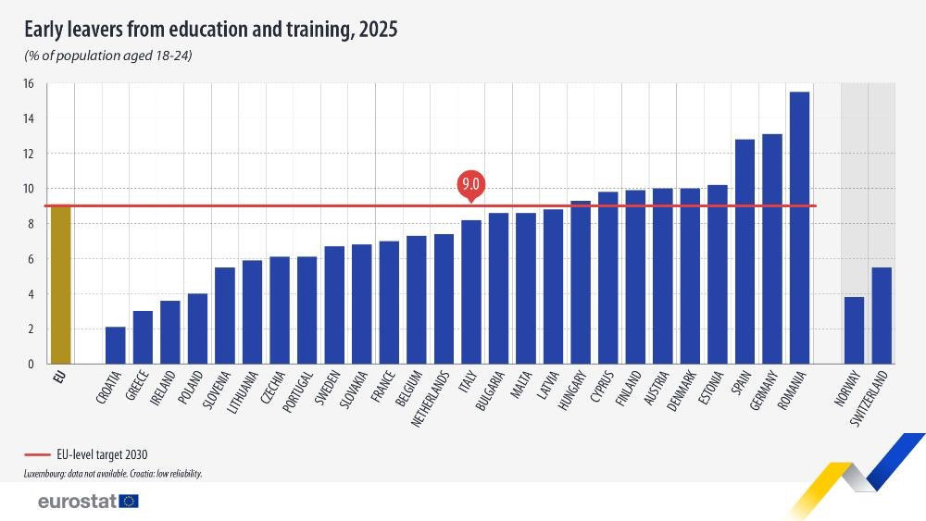
“Vivamus porta
est sed est.”
POLICY BRIEF 2026 | 2
1. INEQUALITY IN EDUCATION AND EARLY SCHOOL LEAVING
Education is an important policy area of the European Union. However, access to quality education is not the same for all students. Students' personal and family circumstances, learning difficulties, and socio-economic status can affect education results. The European Commission states that early school leaving is linked to unemployment, social exclusion, poverty and poor health conditions (European Commission, n.d.-a).

There has been progress in reducing early school leaving in the EU. According to Eurostat data, the rate of early school leavers among people aged 18–24 fell from 11.0% in 2015 to 9.1% in 2025. This shows that the EU is close to its 2030 target of below 9%. In 2025, 17 EU countries had already reached this target level (Eurostat, 2026).
However, progress in the EU average is not the same in all countries. In 2025, the early school leaving rate was 2.1% in Croatia, 3.0% in Greece, and 3.6% in Ireland. It was 15.5% in Romania, 13.1% in Germany, and 12.8% in Spain (Eurostat, 2026). These differences show that, although there is a common EU target, education results are not equal between Member States.
The reasons for early school leaving are not limited to the education system alone. for this reason, the main problem is not only to reduce the early school leaving rate, but to ensure that students stay in the education system and have equal access to quality education.

2. EU EDUCATION POLICY AND CURRENT ACTIONS
One of the main frameworks of the EU in education is the European Education Area (EEA). Within this framework, the EU focuses on areas such as quality and equality in education, basic skills, reducing early school leavings, student well-being and supportive learning environments (European Commission, n.d.-b).
The EU aims to reduce the rate of early school leaving to below 9% by 2030. This target is monitored through Eurostat data and European Education and Training Monitoring mechanisms (Eurostat, n.d.).

The EU also works to reduce early school leaving and low basic skills through the Pathways to School Success approach. The Council Recommendation of 2022 recommends strengthening early support and prevention policies, paying attention to the well-being of students and teachers, and developing targeted policies for students who need additional support (European Commission, n.d.-c).

The new Education Package prepared by the European Commission in 2026 has identified basic skills, teachers and trainers and digital education infrastructure as three main areas. The commission specifically aims to improve students' performance in the areas of reading, mathematics, science, digital skills, and citizenship (European Commission, 2026a).

Additionally, the Basic Skills Support Scheme will support underperforming students in acquiring basic skills before completing their compulsory education. The development of a mentoring system for teachers in their early career is also planned (European Commission, n.d.-d).
POLICY BRIEF 2026 | 2
Graphic (OPTIONAL)
However, education systems are largely regulated at the national level. Therefore, instead of completely replacing the Member States' systems, the EU operates through common goals, coordination, data sharing, and policy support. This situation demonstrates that the success of EU education policies also depends on how effectively Member States implement these policies.

3. STRONGER AND MORE INCLUSIVE EDUCATION FOR DISADVANTAGED STUDENTS
Instead of changing existing education policies, the EU should strengthen practices, especially for disadvantaged students. For this, three areas stand out: early support, teacher support and monitoring of educational inequalities.

Students at risk of early school leaving should be identified earlier, and academic, social, and guidance support should be provided to these students. The European Commission recommends the combined implementation of prevention, intervention, and remediation policies to reduce early school leaving (European Commission, n.d.-c).

Subsequently, teachers' working conditions, professional development, and well-being should be supported. According to the Commission report published in 2026, approximately 40% of teachers in the EU are 50 years of age or older. This situation increases the importance of teacher support that can adapt to new educational needs (European Commission, 2026b).

Author : Ecenaz Özalp, Student of International Relations at Çağ University

This Policy Brief has been prepared as part of the participants / students’ assessment in the framework of the EU Politics lecture.
The content of this policy brief lies entirely with the author. It does not reflect the official opinion of Çağ University.
Finally, educational inequalities should be monitored not only on the EU average, but also by taking into account differences between countries, regions and different student groups.

Instead of creating a new education system, the EU should strengthen early support, teacher support, and monitoring of educational inequalities.
5. European Commission. (2026a, July 30). Commission launches Call for Evidence on new Education Package. European Education Area.
6. European Commission. (2026b, June 11). Strengths and challenges of teaching profession detailed in new report. European Education Area.
7. Eurostat. (n.d.). Policy context – Education and training. European Commission.
8. Eurostat. (2026, June 4). Early school leavers down to 9.1% in 2025. European Commission.

REFERENCES
1. European Commission. (n.d.-a). Early school leaving. European Education Area.
2. European Commission. (n.d.-b). School education initiatives. European Education Area.
3. European Commission. (n.d.-c). Pathways to School Success. European Education Area.
4. European Commission. (n.d.-d). Basic skills. European Education Area.

