  - Summary
  - Normative Goals, Realist Limits: The Discourse-Practice Gap in EU Environmental Policies
  - Role: Environmental Policy Expert
  - Target Audience: EU institutions

KEY POINTS

1. The Environmental Action Programmes, which outline the main framework of EU environmental policy, are in the nature of policy declarations of intent that are not legally binding.

2. The EU’s green transition goals conflict with the industrial costs of member states—as seen in the case of the Lisbon Strategy—and environmental targets are compromised during times of economic crisis.

3. Instead of normative pressures, flexible targets tailored to the varying economic and industrial capacities of member states should be set, and concrete European Union funding and financial support mechanisms should be established.

The European Union was originally established with economic growth as its primary objective—without explicitly incorporating environmental considerations into its founding purpose under the 1957 Treaty of Rome; however, as environmental pollution began to threaten free competition, the free movement of goods, the common market, and economic growth, the Union adopted high-level environmental goals through Environmental Action Programmes (EAPs) and various treaties starting in 1973. Nevertheless, the fact that EAPs lacked legal binding force—serving merely as political statements of intent—combined with the conflict between adopted goals and the economic realities of member states, led to a deviation from these targets in initiatives such as the Lisbon Strategy.
This policy brief recommends that the European Commission adopt targets aligned with the economic and industrial capacities of member states, implement concrete financial support mechanisms to reduce the costs of the green transition, and establish a realistic sustainable management model that preserves the global competitiveness of European industry.
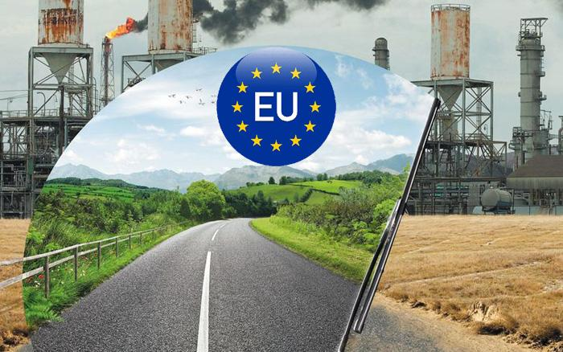

ÇAĞ POLICY BRIEF ISSUE 2026 | 2
When examining the founding objectives of the European Union—the foundations of which were laid by the 1957 Treaty of Rome—it emerges primarily as a structure aiming to foster economic growth and establish a common market and regional cohesion among EU member states.
However, as the environmental damage caused by industrialization and economic growth became apparent—threatening economic activities, the functioning of the common market, free competition, and quality of life—it was concluded that achieving economic development while disregarding the environment was no longer feasible. Accordingly, starting in 1973, the EU incorporated environmental issues into its common policies through Environmental Action Programmes (EAPs).
In contrast, the fact that the Environmental Action Programmes implemented from 1973 to the present have lacked legal binding force—remaining instead at the level of political declarations of intent—has created a significant disparity between high-level normative goals on paper and the economic and industrial costs borne by member states.
POLLEN BRIEF 2026 | 2
In this context, as seen in the Lisbon Strategy, high environmental targets are easily compromised during times of potential crisis.
The European Union’s Politicization of the Environment and Its Fundamental Principles
While the Treaty of Rome, signed in 1957, contained no direct provisions regarding environmental protection, the EU eventually concluded—in light of escalating environmental pollution and the realization that it adversely affected economic development alongside human health—that it was impossible to focus solely on economic growth without taking environmental factors into account. In this context, the first major turning point in the legal architecture occurred with the Single European Act, which entered into force on July 1, 1987; by amending the Treaty of Rome to include a dedicated section on the environment, the legal framework for a Common Environmental Policy was established.
At this point, the matter was placed on a legal footing through the strengthening of environment-related provisions contained in the Single European Act within the framework of the 1992 Maastricht Treaty, and the inclusion of the concept of “sustainable development” among the Union’s fundamental objectives.
“Vivamus porta
est sed est.”
The Lisbon Treaty—which committed to prioritizing eco-friendly infrastructure services, the efficient use of natural resources, direct financial support for the green transition, and halting the loss of biodiversity by 2010—brought this process to its peak.
Alongside the institutionalization process shaped by treaties, the EU's measures to combat environmental issues—mandated by Article 130R of the Single European Act—have been based on four fundamental principles: the Polluter Pays Principle, which requires the internalization of environmental costs and obliges polluters to cover the expenses associated with preventing, controlling, and cleaning up pollution; the Precautionary Principle, which—emphasizing its legal dimension—mandates the adoption of preventive measures when there is a suspicion of potential environmental harm or negative consequences, even in the absence of absolute scientific certainty; the Prevention at Source Principle, which advocates for averting environmentally damaging situations at their origin rather than addressing them after they arise; and the Integration Principle, which requires the incorporation of environmental protection policies into all other policy areas.
POLICY BRIEF 2026 | 2
Transformation of ÇEPs and the 8th ÇEP Interim Evaluation
To translate these fundamental principles and treaty obligations into action, Environment Action Programmes have been established since 1973. Although Environment Action Programmes are primarily statements of political intent without direct binding force, they have evolved over time from reactive measures focused on controlling environmental pollution into comprehensive programmes aimed at sustainable development. This long development process reached its current peak with the entry into force of the 8th Environment Action Programme (2022–2030) in May 2022, serving as the common environmental policy agenda that forms the foundation of the European Green Deal. The 8th EAP, which guides EU policy through 2030, sets highly ambitious normative targets—aligned with a regenerative growth model—to reduce greenhouse gas emissions by 55% by 2030 and achieve climate neutrality by 2050. However, as highlighted in the 8th EAP Mid-term Review Report, although comprehensive legislative changes have been adopted, these normative commitments remain limited in impact because they have not yet been implemented on the ground due to factors such as economic pressures and energy costs.
Author : Buse KOÇAK, Department of International Relations, Çağ University

This Policy Brief has been prepared as part of the participants / students’ assessment in the framework of the EU Politics lecture.
The content of this policy brief lies entirely with the author. It does not reflect the official opinion of Çağ University.

the industrial capacity of member states, global market competitiveness, the structuring of green transition measures to avoid deindustrialization, the provision of concrete financial support to offset the costs of clean energy and technology investments, and a realistic governance framework.
FOOTNOTES
1. Yaman, K., & Gül, M. (2018). Kuruluşundan günümüze Avrupa Birliği’nin çevre politikası. Ekonomi, İşletme ve Yönetim Dergisi, 2(2), 198–217.
2. Aydın, A. H., & Çamur, Ö. (2017). Avrupa Birliği çevre politikaları ve çevre eylem programları üzerine bir inceleme [An investigation on European Union environmental policy and environmental action programs]. [Dergi adı].
3. European Commission, Directorate-General for Environment. (2024, March 13). 8th EAP mid-term review confirms 2030 climate & environmental targets within reach. European Commission

Policy Recommendations
In summary, while the European Union’s environmental policy process—spanning from the 1957 Treaty of Rome to the present—has achieved a broad and inclusive institutionalization extending from economic integration to normative legal objectives, its success in on-the-ground implementation has been constrained by the economic realities of its member states.
As evidenced by the Environmental Action Programmes implemented since 1973 and the recent 8th EAP Evaluation Report, high normative goals based merely on declarations of political intent fail to provide sustainable solutions when they stall during times of crisis. For the European Commission to demonstrate sustainable and successful global leadership in environmental policy, it must move beyond abstract, normative rhetoric toward a realistic governance model that incorporates flexible interim targets and addresses key practical factors:
POLICY BRIEF 2026 | 2

