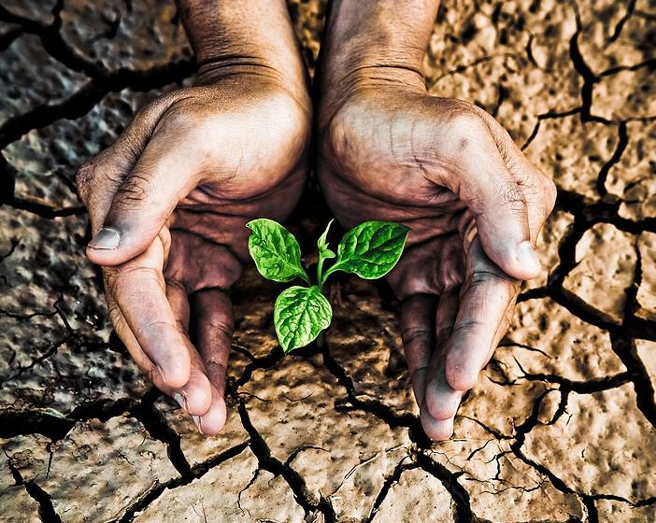
- 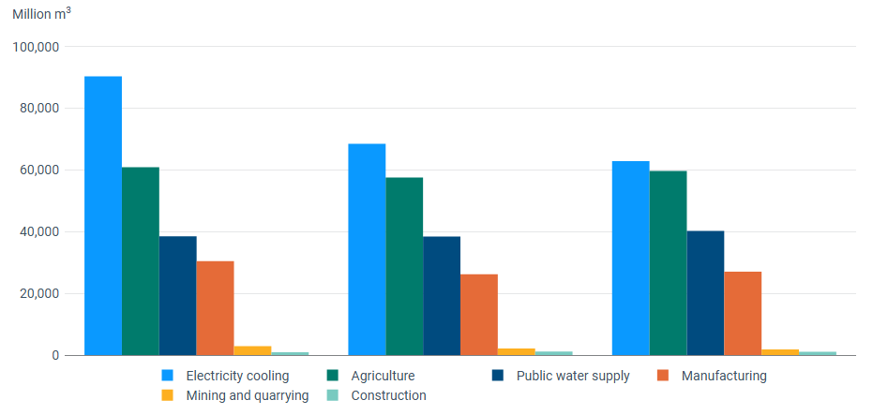
In summary, this study examines how the European Union has responded to increasing drought and water scarcity, and to what extent its related policies can strengthen Europe’s long-term water security and climate resilience. The hypothesis of my study is that the EU is shifting from a crisis-response-oriented approach toward a more preventive and long-term water resilience strategy; however, differences in implementation, infrastructure deficiencies, and increasing climate pressures may constrain this process. The findings show that water scarcity and drought pose risks not only in terms of environmental issues but also in areas such as food security, agriculture, economic activities, and energy. Through the EU Water Policy, the Water Framework Directive, and the European Water Resilience Strategy, the EU is focusing on water efficiency, climate adaptation, and sustainable practices. The study recommends the protection of water resources, investment in and development of resilient infrastructure, the treatment and reuse of wastewater, the development of early warning systems, and the strengthening and improvement of coordination among EU member states.

ÇAĞ POLICY BRIEF ISSUE 2026 | 2
KEY POINTS

1. Drought and Water Scarcity

2. EU Water Policy

3. Water Security and Climate Resilience

  - Summary
  - Role: Water Policy Advisor
The EU’s Response to Drought: Water Security and Climate Resilience in a Globalising World
1. Drought and Water Scarcity
Drought and water scarcity are issues that are becoming increasingly important for the European Union and the world as time goes on. These issues are no longer viewed solely as environmental problems; they also affect agriculture, energy production, food security, economic activities, and ecosystems. According to the European Environment Agency (EEA), water stress affects approximately 20% of Europe’s land area and 30% of its population each year (EEA, 2024). In Southern Europe, where water resources are already under significant strain partly due to climate change the frequency and severity of droughts are expected to increase. Agriculture is not only one of the sectors most affected by water scarcity but also one of the leading users of water. According to the EEA, agriculture accounted for approximately 29% of the water withdrawal by economic sectors in the EU between 2000 and 2022. Southern Europe, meanwhile, accounted for approximately 60% of agricultural water withdrawals across the EU-2. This finding demonstrates that water demand is not evenly distributed across Europe (EEA, 2025). Water scarcity can also affect energy production and industrial sectors that are heavily dependent on reliable water sources. In addition, inefficient infrastructure and water losses increase the pressure on already limited water resources and put them at risk. Over time, the EU has been moving away from an approach focused primarily on crisis response toward a more preventive and long-term water resilience strategy. Previous drought policies implemented in Europe have emphasized risk management rather than merely intervening after drought events have occurred, has placed increasing emphasis on prevention and coordination (Stein et al., 2016). This approach has become more pronounced under the guidance of the European Water Resilience
POLLEN BRIEF 2026 | 2
Strategy, which focuses on water efficiency, sustainable water management, adaptation to climate change, and the reduction and mitigation of water-related risks (European Commission, 2025). However, significant challenges remain. Differences among member states, insufficient investment, infrastructure issues, and difficulties in implementation and coordination can limit the effectiveness of EU policies. The EEA also emphasizes the need for stronger financing, monitoring, risk assessment, and cooperation to strengthen Europe’s climate resilience. (EEA, 2025/2026). In general, drought and water scarcity should be viewed not only as environmental issues but also as significant threats to Europe’s long-term resilience and security. Therefore, the EU must improve water efficiency, develop infrastructure, support the reuse of wastewater, establish effective drought early-warning systems, and strengthen coordination, agreement, and cooperation among member states. A proactive and coordinated approach is of great importance for ensuring long-term water security in the face of changing climate conditions.
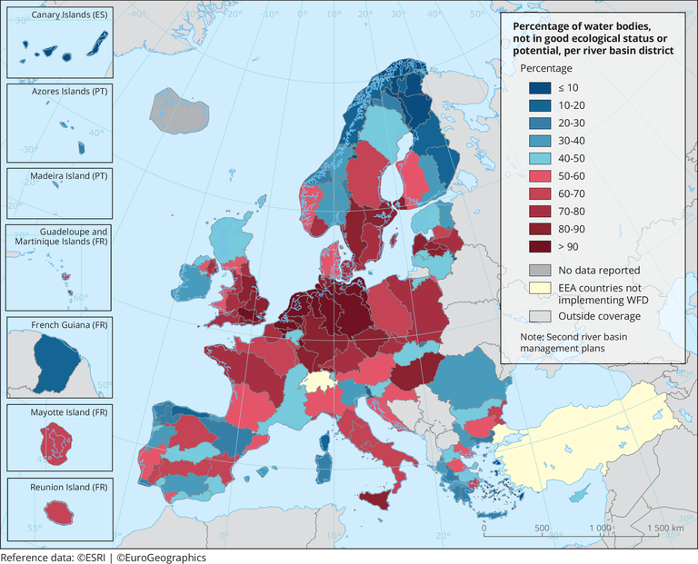
This strategy also includes various initiatives related to water reuse, infrastructure, innovation, investment, and better management and monitoring of water resources.
The EU’s approach increasingly links water policy to climate change adaptation, economic stability, and European security. As I mentioned in my research on water scarcity, it directly affects many areas: agriculture, energy, production, industry, and public health, to name a few. For this reason, it would not be accurate to say that water resilience is merely an environmental goal; rather, we can say that it is also an important part of the EU’s policies for preparing for broader crisis situations. The EEA also notes that current water management is insufficient and therefore requires stronger coordination and implementation. In this context, although the EU has established a comprehensive policy framework, the effectiveness of this policy will largely depend on how successfully member states implement their policies, to what extent they improve water efficiency, and how much they invest in resilient infrastructure. Overall, the EU’s water policy is evolving from a reactive approach focused on addressing individual drought events toward a more preventive, integrated, and resilience-focused approach. The European Water Resilience Strategy strengthens this transformation by bringing together the protection of water resources, adaptation to climate change, technological innovation, and sustainable economic development under one umbrella. Despite all this, differences among member states, infrastructure deficiencies, and the growing climate-related pressures continue to pose significant challenges. For this reason, strengthening cooperation among EU institutions, national governments, and regional authorities is of great importance for the sustainability of this project, so that EU water policies can ensure long-term water security.

2. EU Water Policy
The European Union has developed a comprehensive water policy framework to address water scarcity, drought, pollution, and the long-term sustainability of freshwater resources. The primary legal basis for the EU’s water policy is the Water Framework Directive (WFD), adopted in 2000. This directive aims to ensure that water resources in Europe achieve good ecological and chemical status and to promote sustainable water management. In addition to the WFD, the EU has developed various policies covering areas such as drinking water, urban wastewater, groundwater, flood risks, and water pollution. However, increasing climate pressures indicate that existing water policies must become more adaptive and focused on long-term resilience. According to the European Environment Agency (EEA), water stress affects approximately 20% of Europe’s land area and 30% of its population each year; Climate change, meanwhile, is expected to increase the risks of drought and water scarcity in the future. In response to these challenging circumstances, the European Commission adopted the European Water Resilience Strategy in 2025, thereby taking a significant step toward transitioning to a more coordinated, preventive, and controlled approach to water management. This strategy is based on three key objectives: improving and protecting the water cycle, developing an economy that uses water resources efficiently, and ensuring access to clean and affordable water and sanitation. One of the strategy’s key principles, “Water Efficiency First,” prioritizes reducing unnecessary water demand and increasing water use efficiency before developing additional water resources. The EU aims to increase water efficiency by at least 10% by 2030; member states are encouraged to set their own targets based on their national and regional circumstances.
POLICY BRIEF 2026 | 2
Graphic (OPTIONAL)
Improving water efficiency and reducing unnecessary water consumption are particularly important, because simply increasing the water supply cannot provide a sustainable solution to the ever-growing demand. Climate resilience requires the EU to invest in water infrastructure, technology, wastewater reuse, efficient irrigation and better monitoring systems. Early-warning and drought monitoring tools can help identify water risks and reduce the social and economic impacts of severe droughts. However, water security remains challenging because climate impacts and water availability differ across Member States, while differences in infrastructure, financing and policy implementation can limit common EU action. Therefore, stronger cooperation, investment and coordination are needed. Overall, the EU is moving towards a preventive approach that focuses on water efficiency, climate adaptation and long-term resilience. Successful implementation at national and regional levels will be essential to protect freshwater ecosystems, reduce drought-related risks and ensure reliable access to water in the future.

POLICY BRIEF 2026 | 2
3. Water Security and Climate Resilience
Water security has become an increasingly important issue for the European Union as climate change intensifies the pressure on freshwater resources. Rising temperatures, changing precipitation patterns, and more frequent droughts are significantly affecting the availability and quality of water across Europe. These developments pose serious risks not only from an environmental perspective but also in terms of agriculture, energy production, public health, and economic activities. According to the European Environment Agency (EEA), water stress significantly affects a large part of Europe every year, and climate change is expected to increasingly raise the frequency and severity of droughts and water shortages in many regions. For example, Southern Europe is particularly vulnerable due to its warmer climate and high water demand. For this reason, ensuring water security has become an important part of Europe’s long-term climate resilience. The European Union views water resilience as an increasingly integral part of its broader climate change adaptation and crisis preparedness policies. The European Water Resilience Strategy, adopted by the European Commission in 2025, aims to enhance Europe’s capacity to address water-related challenges by protecting the water cycle, increasing water efficiency, and promoting sustainable water management. This strategy also acknowledges that water management cannot be considered in isolation from other policy areas. Many regions around the world depend on safe water sources. For example, agriculture, energy, industry, biodiversity, and urban development. For this reason, the EU supports a more integrated approach in which water resources are incorporated into economic and environmental decision-making processes.

Key idea to stress out – Optional
These measures can help Member States prepare for increasing water shortages and respond to drought risks before they become more severe. Better coordination between EU institutions, Member States and local authorities is also necessary for effective and long-term water management.
3. Strengthening Climate Adaptation and Public Awareness: The EU should also strengthen climate adaptation policies and raise public awareness about responsible water use. Encouraging households, businesses and agricultural sectors to reduce unnecessary water consumption can contribute to long-term water security. At the same time, climate adaptation measures should be integrated into national and regional policies to help Europe prepare for the increasing effects of climate change.
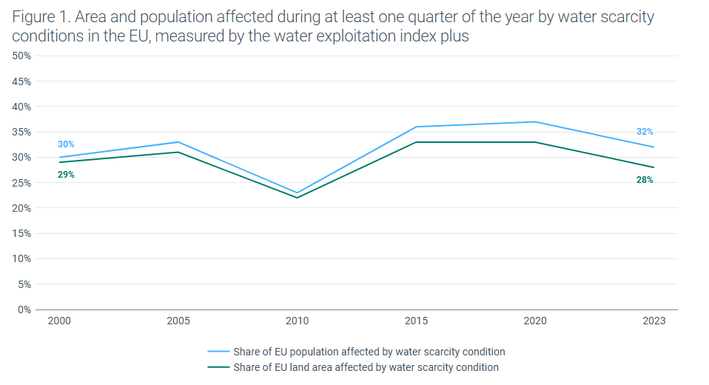
Author : İrem Tufan, Third-Year International Relations Student at Çağ University.

This Policy Brief has been prepared as part of the participants / students’ assessment in the framework of the EU Politics lecture.
The content of this policy brief lies entirely with the author. It does not reflect the official opinion of Çağ University.
1. Protecting and Preserving Water Resources: The EU should prioritise the protection and sustainable use of existing water resources to reduce the risks of drought and water scarcity. Reducing water waste, improving water efficiency and protecting freshwater ecosystems are essential for ensuring that water remains available for future generations. A preventive approach can also reduce the environmental and economic impacts of severe droughts.
2. Investing in Climate-Resilient Water Management: The EU should increase investment in resilient water infrastructure, wastewater reuse, efficient irrigation systems and drought early-warning technologies.
FOOTNOTES (Images/ Figures):
6) European Environment Agency. (n.d.). Water abstraction by source and economic sector in Europe. European Environment Agency.
EEA – Water Abstraction by Source and Economic Sector
Figure X. Water abstraction by source and economic sector in the EU-27.
Source: European Environment Agency (EEA).
7) European Environment Agency. (n.d.). Percentage of water bodies not in good ecological status or potential, per river basin district. European Environment Agency.
EEA – Surface Water Ecological Status Map
Figure X. Surface water bodies not achieving good ecological status in Europe.
Source: European Environment Agency (EEA).
8) Mann, G. (2024, January 17). Does water scarcity make people consider the future? Smart Water Magazine. Smart Water Magazine
Figure X. Water scarcity and long-term water management.
Source: Mann (2024), Smart Water Magazine.
FOOTNOTES:
1) European Commission. (2025). European Water Resilience Strategy. Directorate-General for Environment.
European Water Resilience Strategy
2) European Environment Agency. (2024). Europe’s state of water 2024: The need for improved water resilience (EEA Report 07/2024). European Environment Agency.
EEA – Europe’s State of Water 2024
3) European Environment Agency. (2025). Water savings for a water-resilient Europe. European Environment Agency.
EEA – Water Savings for a Water-Resilient Europe
4) European Environment Agency. (2025). Climate resilience in Europe, 2025: Progress and challenges. European Environment Agency.
EEA – Climate Resilience in Europe 2025
5) Stein, U., Özerol, G., Tröltzsch, J., De Stefano, L., Landgrebe, R., & Jaspers, F. G. W. (2016). European drought and water scarcity policies. In E. Z. I. et al. (Eds.), Drought and water scarcity in Europe. Springer.
Springer – European Drought and Water Scarcity Policies

