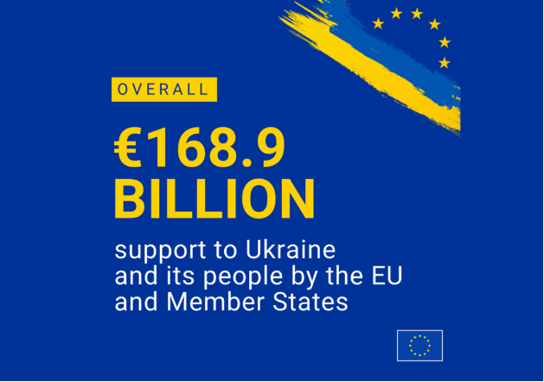
This policy brief examines how the European Union’s response to the Russia-Ukraine war has transformed its foreign and security policy. The main research question is: How has the EU’s response to the war affected its approach to European security? The brief hypothesizes that the war has pushed the EU beyond traditional diplomatic and economic measures towards a more active role in defence and security. The findings show that the EU has significantly increased its financial, humanitarian, and military support for Ukraine while expanding sanctions against Russia. At the same time, challenges such as sanctions circumvention through third countries, economic costs, and the sustainability of long-term support remain. The brief recommends strengthening sanctions enforcement, increasing cooperation with third countries, maintaining sustainable support for Ukraine, and enhancing Europe’s defence capabilities. Ultimately, a durable peace should remain the EU’s primary objective, supported by diplomacy, Ukraine’s sovereignty and territorial integrity, and a stronger European security framework.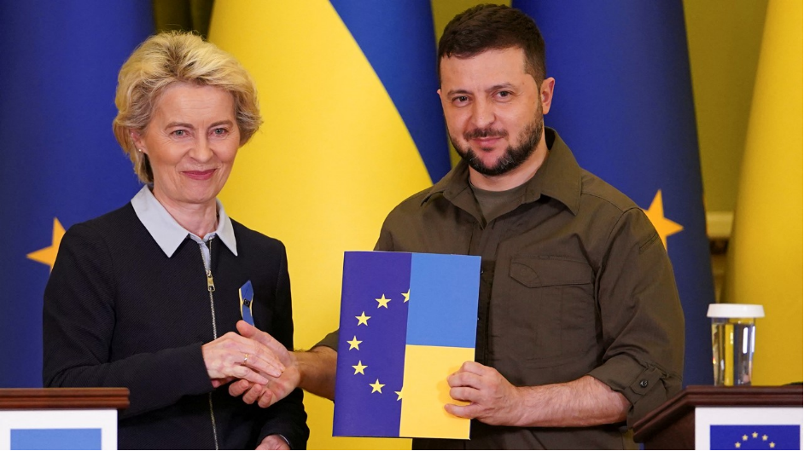

ÇAĞ POLICY BRIEF ISSUE 2026 | 1
KEY POINTS
1. The sanctions process following 2022 has led tho changes in the EU’s decision-making mechanisms and the role of the European Commission.
2. Ukraine’s security is increasingly linked to European security.
3. The Eu supports a just and lasting peace based on Ukraine’s participation in negotiations.

  - Summary
  - Role: European Foreign and Security Policy Researcher
The EU’s Ukraine Policy: War, Sanctions and the Future of European Security
2)European Security
Another challenge concerns the effective implementation of sanctions and preventing their circumvention through third countries. Beyond these issues, the European Union’s policies regarding war have also become increasingly linked over time to a broader European security framework. This connection has increased the importance of strengthening Europe’s own defence capabilities and reducing strategic dependencies. The EU has therefore placed greater emphasis on improving its defence readiness and addressing critical capability gaps. At the same time, continued military support for Ukraine has created a need for greater cooperation between European and Ukrainian defence industries. It is evident that, in the EU’s approach, financial and military support are not separate from one another. Safeguarding Ukraine’s economic resilience, supporting its military capabilities, and preparing for the reconstruction process are addressed as components of a long-term policy framework. For this reason, the EU’s support for Ukraine can be viewed not merely as a temporary aid policy aimed at mitigating the effects of the current war, but rather as a more comprehensive approach that supports Ukraine’s long-term resilience. The European Union has not limited itself to providing only short-term aid to Ukraine but has also assisted in many areas. For example, it is developing mechanisms to ensure that support—including military, financial, economic, and political assistance—is sustained over the long term. The European Council, in particular, emphasizes the need to accelerate the production of certain defense systems.
These include the production and delivery of air defense systems, ammunition, unmanned aerial vehicles, and missiles. In addition to all this, efforts to develop and improve cooperation between the European and Ukrainian defense industries are also being supported. We can say that this means the support provided to Ukraine is

Russia’s war against Ukraine has brought about a significant shift in the European Union’s approach to foreign policy and security. The war, has also led to certain changes in the European Union’s sanctions decision-making mechanisms and the role of the European Commission. Korkea-aho and Lonardo (2025) demonstrate that during this period, the Commission’s influence in the sanctions process has gradually increased, and third countries and economic interest groups have become more visible. Throughout this entire sequence of events, the European Union’s official policy is to support the establishment and implementation of a just and lasting peace based on Ukraine’s sovereignty and territorial integrity. The European Union’s financial assistance to Ukraine is also backed by specific funding sources. During this process, Ukraine’s accession process to the European Union is moving forward, while Europe’s defense capabilities are It aims to strengthen this by 2030. In this context, from the European Union’s perspective, the key issues are ensuring the sustainability of support, enforcing sanctions to secure world peace, and safeguarding the future of European security. At the same time, continued military support for Ukraine has increased the importance of strengthening Europe’s own defence capabilities. The war has also challenged the European security environment and encouraged the EU to reconsider its defence capabilities and strategic dependencies. As the war continues, ensuring the long-term sustainability of financial, military and humanitarian support has become an important challenge for the EU. This support is crucial for Ukraine’s ability to maintain essential public services and preserve its economic stability amid the war. The EU’s support is also aimed at strengthening Ukraine’s defense capabilities and mitigating the economic and humanitarian consequences of the war.

Problem Definition 2026|1 2026 | 1

“Vivamus porta
est sed est.”
Ukrainian defense industries are also being supported. We can say that this means the support provided to Ukraine is
This also makes the effective implementation of sanctions and the prevention of sanctions circumvention important issues for the EU.
These include the production and delivery of air defense systems, ammunition, unmanned aerial vehicles, and missiles. In addition to all this, efforts to develop and improve cooperation between the European and Ukrainian defense industries are also being supported. We can say that this means the support provided to Ukraine is
now directly linked to the strengthening and expansion of Europe’s own defense capabilities.
The diplomatic dimension of the Russia-Ukraine war is also a significant issue for the EU. The Council of Europe aims to achieve a comprehensive, just, and lasting peace based on the United Nations Charter and the principles of international law. At the same time, it advocates for Ukraine’s inclusion in shaping the peace process. Ensuring Ukraine’s long-term security is also a key aspect of this approach. There are many articles and statements from official websites on this topic. The EU continues to provide support to Ukraine and is conducting diplomatic efforts aimed at ending the war.
The sanctions against Russia, on the other hand, are quite strategic and far-reaching. Following Russia’s actions against Ukraine, NATO suspended all practical civilian and military cooperation with Russia in 2014.

POLICY BRIEF 2026|1

3) Peace and Diplomacy:
After Russia’s full-scale invasion of Ukraine in 2022, NATO stated that it could no longer consider Russia a partner. From the perspective of sanctions policy, the war has also led to changes in the EU’s decision-making mechanisms. According to Korkea-aho and Lonardo (2025), Russia’s invasion of Ukraine marked a significant turning point in the EU’s sanctions decision-making process. In the wake of the war, alongside the standard sanctions process, a faster and extraordinary decision-making process emerged, and the European Commission’s influence in this process has increased. At the same time, third countries and economic interest groups have also become more visible in shaping sanctions policies. These developments show that the war has affected not only the EU’s foreign policy but also the institutional functioning of its sanctions policies.
This war has also underscored the importance of the EU strengthening its own defense capabilities. While military support for Ukraine continues, the EU has identified gaps in its current defense capabilities and has worked to enhance defense cooperation among EU member states. The EU has provided substantial financial aid At the same time, reducing strategic dependencies has become a key element of the EU’s broader security approach.
The development and expansion of defense cooperation between the EU and Ukraine will contribute to and enhance Europe’s long-term security capabilities. For this reason, the war has become closely linked not only to ensuring Ukraine’s security but also to the future structure and level of preparedness of European security.

Graphic (OPTIONAL)

Key idea to stress out – Optional
POLICY BRIEF 2026 | 1

Graphic (OPTIONAL)
The war between Russia and Ukraine has affected the entire world. In particular, it has had broader implications for the European Union’s security and defense policies. The ongoing military support for Ukraine is playing a significant role in helping Europe recognize its own shortcomings and improve its defense system. In this regard, while the Council of Europe aims to significantly strengthen Europe’s defense readiness by 2030, it also emphasizes the need to reduce strategic dependencies. The EU also considers it important to increase cooperation with Ukraine in the defense industry sector to boost defense production and develop new defense capabilities. For this reason, the war, It has increasingly linked Ukraine’s security to the broader European security environment and encouraged the EU to adopt a more long-term approach to its defense and securitypolicies. 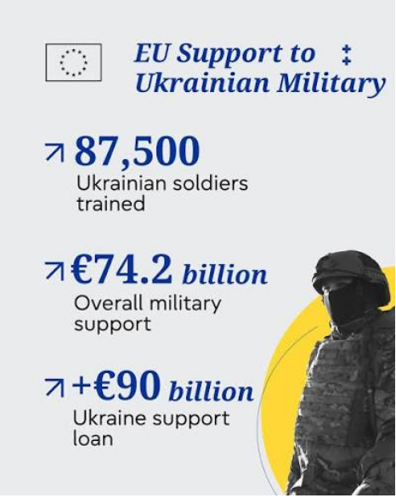

From a humanitarian perspective, the continuation of the war in Ukraine raises serious concerns about the human cost of armed conflict. The loss of civilian and military lives, the displacement of millions of people and the continuing destruction of infrastructure demonstrate that the consequences of the war extend far beyond the battlefield. In my view, the continuation of violence cannot be considered a sustainable way of resolving political disputes, as each additional day of conflict creates further human suffering and economic and social damage. Although the European Union has introduced extensive sanctions against Russia and provided financial, humanitarian and military support to Ukraine, the continuing nature of the war raises questions about the effectiveness and long-term impact of these measures. This also makes the effective implementation of sanctions and the prevention of sanctions circumvention important issues for the EU.
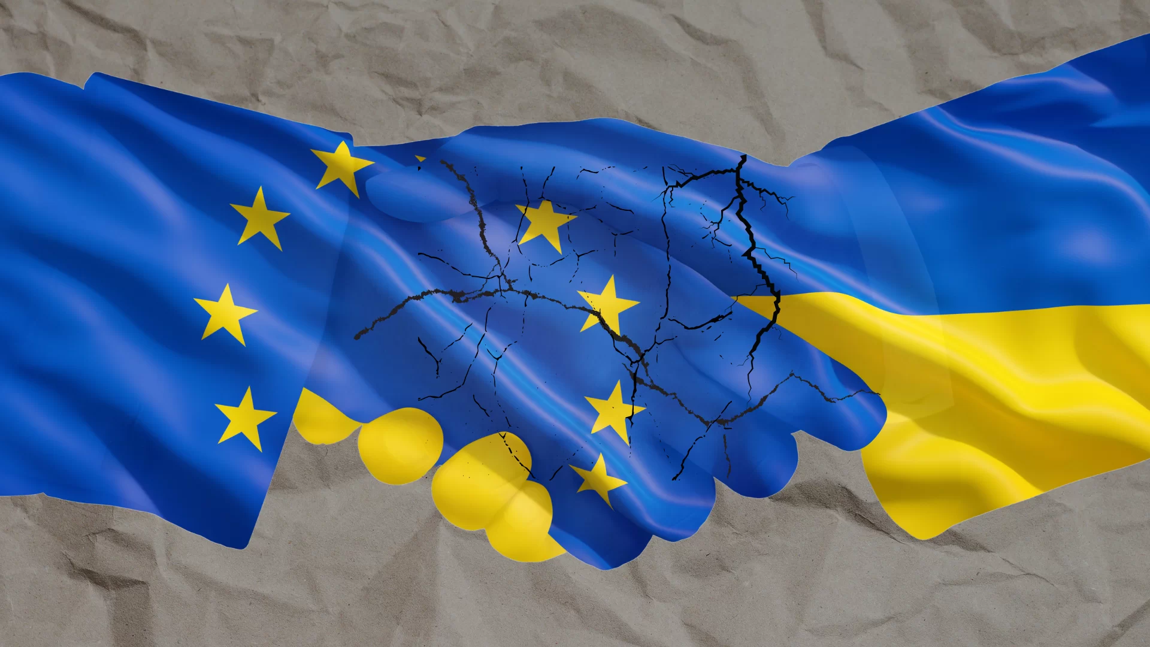

Author : İrem Tufan, Third-Year International Relations Student at Çağ University.

This Policy Brief has been prepared as part of the participants / students’ assessment in the framework of the EU Politics lecture.
The content of this policy brief lies entirely with the author. It does not reflect the official opinion of Çağ University.
At the same time, the EU’s support for Ukraine and its efforts to strengthen European defence capabilities show that the war has become closely connected to the wider European security environment. Ultimately, a sustainable response should address both Ukraine’s security and the humanitarian consequences of the conflict, while keeping the possibility of a just and lasting peace at the centre of European policy.

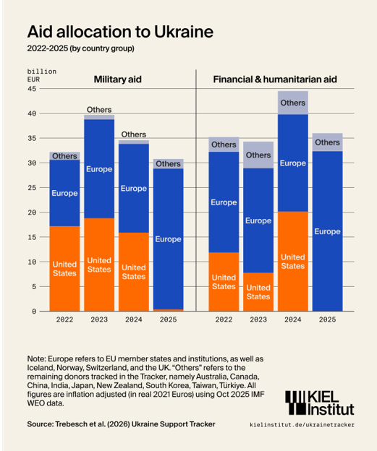
North Atlantic Treaty Organization. (2014, April 7). Measures following NATO Ministers’ decision to suspend all practical cooperation with Russia. https://www.nato.int/en/news-and-events/articles/news/2014/04/07/measures-following-nato-ministers-decision-to-suspend-all-practical-cooperation-with-russia
Tezcan, G. (2025). Rusya-Ukrayna Savaşı ve Avrupa Birliği genişleme politikasına ilişkin gelecek senaryoları. Journal of Business Innovation and Governance, 8(2), 81–97. https://doi.org/10.54472/jobig.1829064
Torlak, P. (2022). Rusya-Ukrayna Savaşı AB güvenliğine nasıl yansıdı? EURO Politika, 14, 31–34. https://dergipark.org.tr/tr/pub/europ/article/1217538
Üste, A. N., & Mantoğlu, A. S. (2023). Ukrayna-Rusya savaşı bağlamında Avrupa’da aşırı sağın yükselişi: 2022 Fransa seçimleri ve Marine Le Pen örneği. Sosyal Ekonomik Araştırmalar Dergisi, 23(1), 25–38. https://doi.org/10.30976/susead.1182282
Tezcan, G. (2025). Rusya-Ukrayna Savaşı ve Avrupa Birliği genişleme politikasına ilişkin gelecek senaryoları. Journal of Business Innovation and Governance, 8(2), 81–97. https://doi.org/10.54472/jobig.1829064
Torlak, P. (2022). Rusya-Ukrayna Savaşı AB güvenliğine nasıl yansıdı? EURO Politika, 14, 31–34. https://dergipark.org.tr/tr/pub/europ/article/1217538
FOOTNOTES :
Battır, O., & Yiğittepe, L. (2023). Rusya-Ukrayna savaşında yaptırımlar ve enerji güvenliği: Karşılıklı ekonomik bağımlılıklar perspektifinden bir değerlendirme. Yönetim ve Ekonomi Dergisi, 30(3), 549–573. https://doi.org/10.18657/yonveek.1222200
Batı, G. F. (2024). Avrupa Birliği-Rusya ilişkileri ve Karadeniz jeopolitiği. Anadolu Strateji Dergisi, 6(1), 29–36. https://dergipark.org.tr/tr/pub/anasamasd/article/1507277
Council of the European Union. (n.d.). EU sanctions against Russia. https://www.consilium.europa.eu/en/policies/sanctions-against-russia/
European Council. (2026, June 18). European Council conclusions on Ukraine and on European defence and security. https://www.consilium.europa.eu/en/press/press-releases/2026/06/18/european-council-conclusions-on-ukraine-and-on-european-defence-and-security/
Kiel Institute for the World Economy. (2026, February 11). Ukraine support after 4 years of war: Europe steps up. https://www.kielinstitut.de/media/news/ukraine-support-after-4-years-of-war-europe-steps-up/
Korkea-aho, E., & Lonardo, L. (2025). How Russia’s war against Ukraine changed EU sanctions decision-making. Journal of European Integration, 48(5), 813–834. https://doi.org/10.1080/07036337.2025.2545921
Source: Eurostat. (2026, September 10). [Webpage title]. European Commission. https://ec.europa.eu/eurostat/web/products-eurostat-news/w/ddn-20260910-1

FOOTNOTES:
Üste, A. N., & Mantoğlu, A. S. (2023). Ukrayna-Rusya savaşı bağlamında Avrupa’da aşırı sağın yükselişi: 2022 Fransa seçimleri ve Marine Le Pen örneği. Sosyal Ekonomik Araştırmalar Dergisi, 23(1), 25–38. https://doi.org/10.30976/susead.1182282

Source: Eurostat. (2026, September 10). [Webpage title]. European Commission. https://ec.europa.eu/eurostat/web/products-eurostat-news/w/ddn-20260910-1

