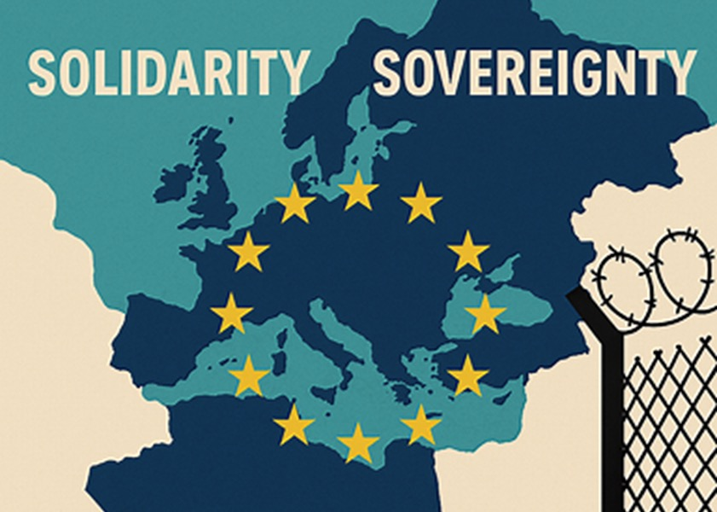
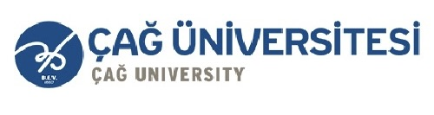

ÇAĞ POLICY BRIEF ISSUE 2026 | 1
FROM SOLIDARITY ON PAPER TO SOLIDARITY IN PRACTICE
Author: Ecenaz Özalp
Role: International Relations Student
Target Audience: Academics and Students
Can the EU's new solidarity mechanism share migration and asylum responsibilities between Member States in an effective and fair way? The main hypothesis of this study is that creating the mechanism by law alone does not guarantee effective responsibility-sharing. Its success also depends on implementation capacity, predictability, and monitoring. The findings show that migration pressure is not equally shared among Member States, and Cyprus, Greece, Italy, and Spain face more pressure. The 2026 Solidarity Pool is an important step, but there are still problems with making responsibility transfers work effectively. Therefore, the EU should not replace the current solidarity mechanism but should improve three areas: the predictability of solidarity commitments, flexibility in different forms of solidarity, and stronger monitoring at the EU level.
Summary
KEY POINTS

1. The migration pressure is not distributed equally among EU Member States, and this situation creating particular pressure on countries located on the frontline.

2. The Migration and Asylum Pact establishes a permanent solidarity mechanism based on resettlement, financial contributions, and alternative measures.

3. The EU should strengthen the predictability, monitoring, and implementation of solidarity commitments to ensure fair responsibility sharing.
1. THE MAIN PROBLEM: UNEQUAL RESPONSIBILITY
Migration and asylum continue to be significant challenges for the European Union. However, the pressure created by migration is not distributed among Member States. Countries located on the external borders of the EU may face greater pressure due to their geographical location and role in the acceptance and processing of asylum applications.
This situation poses a challenge for the Common European Asylum System. When responsibility is concentrated in a limited number of Member States, these countries may face more pressure on their admission systems, administrative capacities and financial resources. Therefore, the EU's new Asylum and Migration Management Regulation (AMMR) places the principle of “solidarity and fair sharing of responsibility” at the center of EU asylum and migration management.¹
The Migration and Asylum Pact seeks to address this issue by establishing a permanent solidarity mechanism. However, the central policy problem is no longer simply whether the EU has a solidarity framework. The more important question is whether this framework can be implemented effectively, predictably and fairly among Member States.
POLICY BRIEF 2026 | 1
“Vivamus porta
est sed est.”
The Solidarity Pool established for 2026 demonstrates this inequality in a concrete way. The Council has designated Cyprus, Greece, Italy and Spain as a member states under migration pressure. The EU has established a reference level of 21,000 resettlement or other solidarity efforts or a financial contribution of 420 million euros for the 2026 solidarity pool.² These figures show that the EU is moving towards a more structured system, but they also reveal the ongoing need for effective responsibility-sharing.

2. THE SOLIDARITY MECHANISM AND PROBLEMS IN IMPLEMENTATION

The Migration and Asylum Pact came into effect on 12 June 2026, following a two-year transition period. One of the key elements of the pact is a new framework for solidarity and shared responsibility among Member States.³

The main legal basis of this mechanism is the EU Regulation No. 2024/1351 on asylum and migration management. Article 56 establishes the Annual Solidarity Pool as the main solidarity response tool for Member States under migration pressure.⁴

The system offers three basic forms of solidarity:
First, resettlement enables the transfer of persons applying for international protection from a Member State under pressure to another Member State.
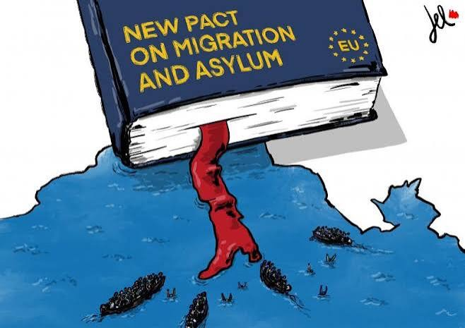
Secondly, financial contributions can be used to support migration, reception, asylum, border management, operational support, and related activities.
Thirdly, alternative solidarity measures may include elements such as operational support, capacity building, personnel, facilities, and technical equipment.⁵

This flexibility is one of the strengths of the new mechanism. Member States have different political, administrative and financial capacities, and allowing different forms of contribution can make participation more feasible. At the same time, flexibility creates a policy challenge: different forms of solidarity do not necessarily provide the same type of support to Member States under pressure.

In terms of implementation, some issues still persist. The European Commission's assessment dated May 2026 stated that the Member States have made progress in their preparations for the implementation of the Pact, but the legal and operational transformation is continuing.⁶ After the implementation of the Pact, the Commission's assessment dated July 16, 2026 showed that concrete steps are still needed for the implementation of responsibility transfers.⁷
Therefore, the current fundamental problem is not the absence of a solidarity mechanism within the EU, but rather how effectively and regularly the mechanism can be implemented in practice.

3.PREDICTABILITY, MONITORING, AND IMPROVING IMPLEMENTATION

Instead of changing the existing solidarity mechanism, the EU should strengthen its implementation. Three key priorities stand out for this purpose: predictability, flexibility, and accountability.

First, solidarity commitments should become more predictable. Knowing in advance what level and type of support Member States under migration pressure can receive can help them plan their reception and asylum systems more effectively. A clearer and more regular implementation of the annual solidarity cycle is important in this respect.
Graphic (OPTIONAL)
POLICY BRIEF 2026 | 1

POLICY BRIEF 2026 | 1
Second, the flexibility of the current system should be maintained. Member States should continue to be able to choose between relocation, financial contributions, or alternative measures. However, this flexibility should be supported by evaluating whether the contributions are effective. In particular, it should be monitored how much financial contributions or alternative measures respond to the real needs of countries under pressure.

Third, monitoring and accountability should be strengthened. The European Commission and the EU Solidarity Coordinator should regularly follow the solidarity contributions that Member States promise and implement. More transparent reporting on relocation, financial contributions, and alternative measures can help identify implementation gaps more quickly. The EUAA’s guide on the operational implementation of the solidarity mechanism also shows that relocation depends not only on legal arrangements but also on administrative and operational capacity.⁸

Therefore, the most appropriate approach for the EU is to strengthen the implementation of the current mechanism instead of creating a new mechanism. More predictable commitments, flexible but measurable forms of solidarity, and a strong monitoring system can help ensure a fairer sharing of responsibility among Member States.
FOOTNOTES

1. European Parliament & Council of the European Union. (2024, May 14). Regulation (EU) 2024/1351 of the European Parliament and of the Council of 14 May 2024 on asylum and migration management. Official Journal of the European Union.

2. Council of the European Union. (2025, December 8). Migration and asylum: Member states agree on solidarity pool.

3. European Commission, Directorate-General for Migration and Home Affairs. (2026, June 12). New migration and asylum rules enter into application: What is changing?

4. European Parliament & Council of the European Union. (2024, May 14). Regulation (EU) 2024/1351 of the European Parliament and of the Council of 14 May 2024 on asylum and migration management (Article 56). Official Journal of the European Union.

Author : Ecenaz Özalp, Student of International Relations at Çağ University

This Policy Brief has been prepared as part of the participants / students’ assessment in the framework of the EU Politics lecture.
The content of this policy brief lies entirely with the author. It does not reflect the official opinion of Çağ University.
5. European Parliament & Council of the European Union. (2024, May 14). Regulation (EU) 2024/1351 of the European Parliament and of the Council of 14 May 2024 on asylum and migration management (Article 56[2]). Official Journal of the European Union.

6. European Commission. (2026, May 8). State of play on the implementation of the Pact on Migration and Asylum (COM/2026/196 final).

7. European Commission, Directorate-General for Migration and Home Affairs. (2026, July 16). Commission presents the assessment on the application of the new asylum responsibility rules.

8. European Union Agency for Asylum. (2026, March 17). Practical guide on the solidarity mechanism: Operational implementation of relocation.

