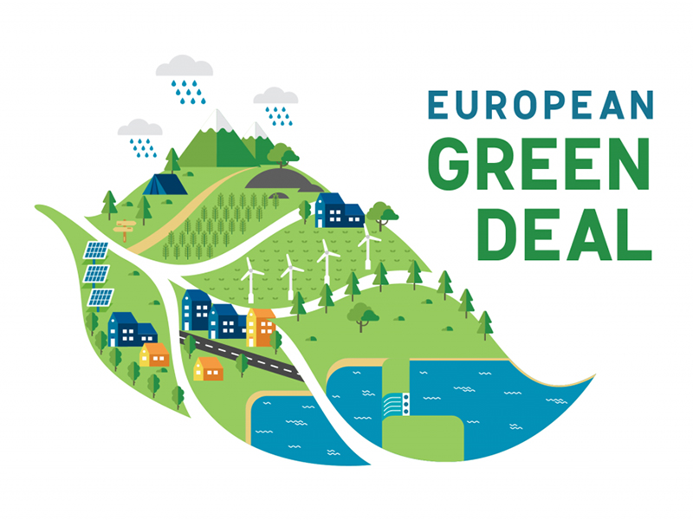
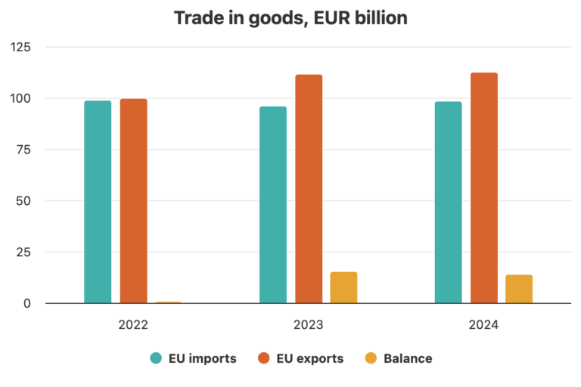
The climate crisis is one of the most significant ecological problems of our time, affecting life, the economy, and sustainability. To mitigate the adverse effects of this crisis, the European Union (EU) established the "European Green Deal." The European Green Deal represents a political and strategic approach aimed at achieving the green transition. It has significant implications for Turkey-EU trade relations, particularly within the economic field.
In this context, the research question of the policy brief is: “What are the economic challenges Turkey faces during its alignment with the European Green Deal, and what recommendations can be developed to mitigate these challenges?” The central hypothesis of the policy brief is that providing financial support to firms and developing relevant policies during Turkey’s transition to the Green Transformation will help alleviate the economic problems encountered. Research conducted within this framework has highlighted that firms face particular difficulties in securing financing. Accordingly, it is recommended that financial support for firms be increased and policies be developed in this area to facilitate the transition to the green transformation.
  - Summary
KEY POINTS

1. Türkiye is facing economic challenges in the process of aligning with the European Green Deal.

2. It is observed that manufacturing companies are increasing their costs due to difficulties in the economic field.

3. It is proposed to increase financial support and formulate new policies regarding the European Green Deal alignment process.

  - Economic Challenges in Türkiye’s Alignment with the European Green Deal and Proposed Solutions

  - Role: Researcher Audience: Public institutions and policymakers making decisions on this topic (Ministry of Environment, Urbanization and Climate Change, Ministry of Trade, Directorate for EU Affairs)

ÇAĞ POLICY BRIEF ISSUE 2026 | 1
Overview of the European Green Deal
The "Rio Earth Summit" held in 1992 marked a significant step toward supporting environmental protection within the international order. The "United Nations Framework Convention on Climate Change," one of the outcomes of this summit, was the first international convention addressing the environment. The primary objective of this agreement is to stabilize greenhouse gas concentrations in the atmosphere by preventing human-induced interference with the climate system. The "Kyoto Protocol" represented the next step; it aimed to reduce greenhouse gas emissions and implement measures to address climate change. The "Paris Agreement," which entered into force in 2015, seeks to limit the rise in global average surface temperature to 2 degrees Celsius and ideally to keep it below 1.5 degrees. Furthermore, the Paris Agreement is the first universal and legally binding agreement of its kind (Aydınoğlu and Özdemir, 2022). The "European Green Deal," introduced by the European Union (EU) in 2019, is a shared framework developed to implement the Paris Agreement. The core objective of this deal is to reduce greenhouse gas emissions to net-zero by 2050.
The main goal of the agreement is to become the first climate-neutral continent by reducing greenhouse gas emissions to zero by 2050.

The objectives of the Green Deal include increasing energy efficiency through the effective use of renewable energy sources, promoting the green transition in industry, protecting biodiversity and ecosystems, and enhancing human well-being.
European Union (EU) countries are Turkey’s largest export partners; thus, the European market is of great importance to Turkey. In this context, EU regulations regarding climate and the environment directly impact Turkey’s exports. Turkey has begun taking concrete steps to align with the requirements of the European Green Deal. Its ratification of the Paris Agreement in 2021 serves as an example of the significant, tangible measures taken in this regard.
1) Challenges Experienced in the Economic Field
According to the latest data from the Ministry of Foreign Affairs, the European Union (EU) accounts for approximately 41% of Turkey’s foreign trade. As the European Union (EU) is one of Turkey’s largest trading partners, the regulations introduced during the alignment process with the Green Deal also affect importers in Turkey.
The European Union has a "Carbon Border Adjustment Mechanism (CBAM)."

POLICY BRIEF 2026 | 1
On the other hand, Turkey has an "Emissions Trading System." The fact that this system is incompatible with the EU Emissions System means that investments made in Turkey in this area do not receive adequate recognition within the European Union (EU) system. This issue leads to an increased financial burden on manufacturing companies.
Furthermore, transitioning fully to the green transformation process requires transforming production facilities into low-carbon operations.
Additionally, the green transition is not a process that a business can carry out on its own; the transformation must take place at every stage of the supply chain. (Özerdem, 2024)
2) Rising Production Costs in this Context
Thanks to the Carbon Border Adjustment Mechanism (CBAM) implemented by the European Union, sectors with high greenhouse gas emissions will face high carbon costs. Sectors with high carbon emissions, such as the iron and steel industry and the automotive sector, are particularly directly affected by this situation. As can be inferred from this, sectors that fail to adapt will face high carbon costs and may find themselves in need of economic financial support.
The primary objective of the Carbon Border Adjustment Mechanism (CBAM) is to prevent excessive carbon usage and steer production toward processes that generate lower greenhouse gas emissions. For instance, consider an importing company in Turkey that has shipped iron abroad; a certain amount of carbon emissions is generated during the production of that iron. Under the Carbon Border Adjustment Mechanism (CBAM), the importer is required to pay a carbon cost based on the greenhouse gas emissions embodied in the shipped iron. The process of complying with this mechanism is of great importance to the Turkish economy; otherwise, the importing company would face increased costs. Indeed, this mechanism entails incurring carbon costs. Sectors affected by this situation not only face additional carbon costs but also see their market competitiveness constrained.

Figure 1 : Turkey trade with Europe – import/export analysis
POLICY BRIEF 2026 | 1
Small and medium-sized enterprises (SMEs) , in particular, can face difficulties in this situation. In other words, we can say that they will need financial support. The emergence of additional costs places a strain on businesses, leading them to downsize or close down; this problem may create risk for employment.
On the other hand, to fully transition to the green transformation process, manufacturing plants must be made low-carbon. (Ministry of Trade of the Republic of Türkiye, n.d) In this context, capital investments need to be increased to achieve technological renewal. If investments are not secured, businesses will find themselves in a difficult situation.
3) Increasing Financial Support and Formulate New Policies
Financial support is required due to the high costs associated with the Carbon Border Adjustment Mechanism (SME). The need for additional expenditures and the resulting employment challenges pose risks to the future of businesses. Increased capital investment is necessary to achieve the technological upgrades required for the green transition. My recommendations regarding this matter are outlined on side.

Recommendations :
• As previously mentioned, small and medium-sized enterprises (SMEs) require financial support. Providing these enterprises with support such as grants or funds could facilitate their adaptation to the process. Furthermore, small and medium-sized enterprises should be encouraged to adopt green technologies, and the necessary financial support should be provided.
• During this process, public institutions and the financial sector must collaborate, and adaptation to the process should be facilitated through various forms of mutual support between institutions.
• In particular, the provision of suitable financing options by institutions in the financial sector for green transition investments could economically facilitate the adaptation process for companies.
• Turkey must develop new policies to enable companies facing challenges with the Carbon Border Adjustment Mechanism (CBAM) to comply with carbon regulations. Since these policies will help reduce carbon emissions, they will also help reduce financial difficulties.

POLICY BRIEF 2026 | 1
REFERENCES:
1. Aydınoğlu, A. U., & Özdemir, B. E. (2022). Yeşil Mutabakat: Tarihçe ve akademik araştırmaların incelenmesi. Trakya Üniversitesi İktisadi ve İdari Bilimler Fakültesi E-Dergi, 11(2), 107-121
2. Özerdem, F. (2024). İklim Krizinin Gölgesi Altında Avrupa Yeşil Mutabakatı ve Türkiye’yi Bekleyen Zorluklar. Akademi Sosyal Bilimler Dergisi, 11(31), 51-65.
3. Global Trade Insights (2025) Turkey trade with Europe import-export analysis. https://tradeint.com/insights/turkey-trade-with-europe-2025-import-export-analysis/
4. Narter Hukuk. Avrupa Yeşil Mutabakatı ve Türkiye’ye etkileri https://narterlaw.com/avrupa-yesil-mutabakati-ve-turkiyeye-etkileri

5. Küçük, G., & Yüce Dural, B. (2024). Türkiye’nin Avrupa Yeşil Mutabakatına Uyumu Kapsamında Yeşil Ekonomi Performansı: Değerlendirme ve Perspektifler. Sosyoekonomi, 32(60), 445-467.
6. Demir, M. (2025). Türkiye’nin İklim Değişikliği Politikaları ve 2053 Net Sıfır Emisyon Hedefi: Taahhütler, Uygulamalar ve Karşılaşılan Güçlükler. Çevre İklim ve Sürdürülebilirlik,
7. Gör, Y., & Dündar, H. (2026). Avrupa Yeşil Mutabakatının Türkiye’deki Enerji Yoğun Sanayiler Üzerindeki Etkisinin Değerlendirilmesi: Borsa İstanbul Örneği. İnsan ve Toplum Bilimleri Araştırmaları Dergisi, 15(1), 419-439.
8. Uyduranoğlu, A., Gevrek, Z. E., & Acar, S. (2023). Avrupa Yeşil Mutabakatına Uyum Çerçevesinde Türkiye’deki İşletmelerin Emisyon Ticaretine Verdikleri Desteği Etkileyen Faktörler Ankara Avrupa Çalışmaları Dergisi 22(1) 257-289.
9. T.C. Ticaret Bakanlığı. Yeşil mutabakat. https://ticaret.gov.tr/dis-iliskiler/yesil-mutabakat/genel-bilgi

Author: Sude Nur Akbulut, Undergraduate student in the Department of International Relations at Çağ University.
This Policy Brief has been prepared as part of the participants / students’ assessment in the framework of the EU Politics lecture.
The content of this policy brief lies entirely with the author. It does not reflect the official opinion of Çağ University.

