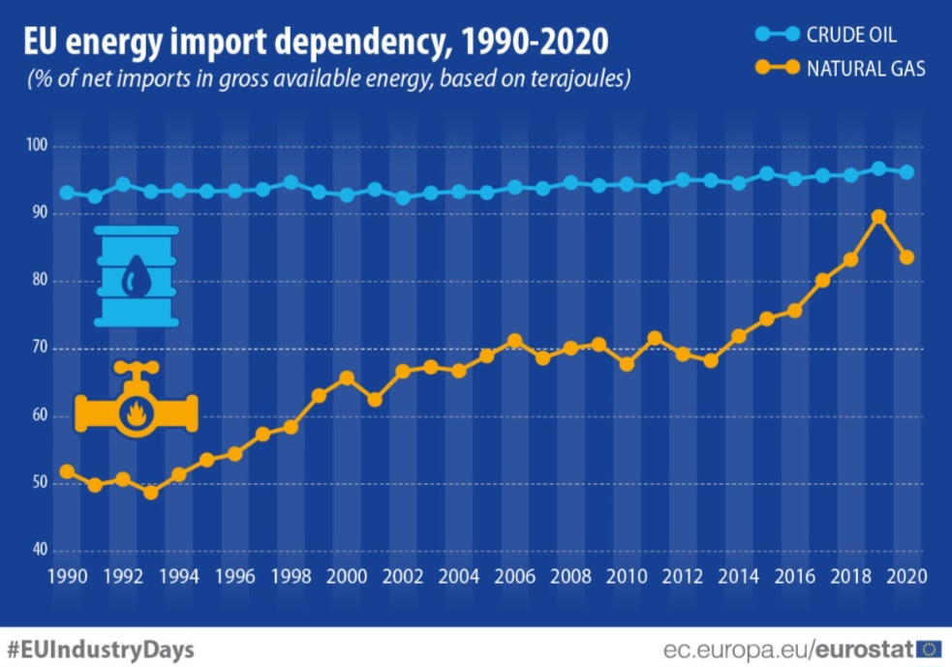

  - “What policies can the European Union implement to reduce its energy dependence on Russia and ensure energy security after the Ukraine War?”
  - (Role: European Commission Member. Audience: European Commission – Directorate-General for Energy (DG ENER)
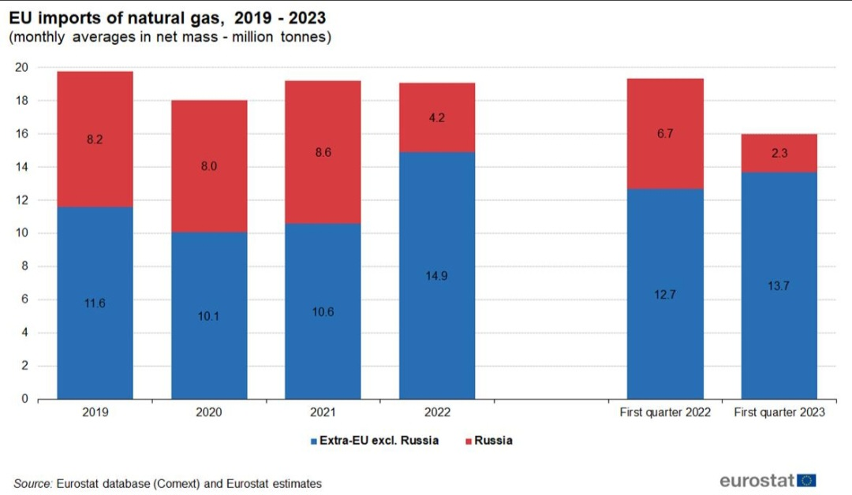

ÇAĞ POLICY BRIEF ISSUE 2026 | 1
KEY POINTS

1.Energy Security: The EU’s capacity to obtain energy in a reliable, uninterrupted, and sustainable manner.
2. Energy Dependency: The EU’s reliance on external sources to meet its energy needs, particularly through natural gas imports, and its dependence on external suppliers.

3. EU-Russia Gas Dependency: The EU’s high dependence on Russian natural gas before the Ukraine War and the risks that this dependence created for energy security after the war.

The strategic importance of energy directly affects the foreign policy preferences of states. The European Union (EU) is an actor with high energy consumption but without sufficient domestic energy resources. Until recently, the primary source of energy supply in the EU’s energy imports was the Russian Federation (Russia). However, the Russia–Ukraine War, which started in 2022 and is still ongoing, has brought energy relations between the EU and Russia almost to the point of zero. With the Russia–Ukraine War, the EU has entered a period in which it will reorganize its energy policies. This study analyzes the effects of the Russia–Ukraine War, which started in 2022, on EU energy policies and evaluates how energy relations with Russia, which was the Union’s largest energy partner before the war, have changed in the current post-war context. The study also discusses possible future scenarios for the EU’s energy policies. It seeks to answer the question, “What policies can the European Union implement to reduce its energy dependence on Russia and ensure energy security after the Ukraine War?” It argues that the EU can strengthen its energy security by diversifying its energy supply, increasing the use of renewable energy, and improving energy efficiency. These measures are also at the center of the EU’s REPowerEU strategy.
  - Summary
2.Energy Dependence
Energy is a crucial issue with global, not just regional, implications. It impacts numerous important areas, from the economy to the environment. More research is needed as the world strives to understand the importance of renewable energy. This issue also affects the EU in many ways. Energy dependence refers to the extent to which the European Union relies on energy imports to meet its energy needs. “According to Eurostat data, the EU’s dependence on energy imports reached 57.3% in 2024. This means that net imports account for nearly three-fifths of the EU’s gross available energy.
The EU’s dependence on imports varies by energy type. In 2024, net imports met 96.6% of the EU’s oil and petroleum products needs, 85.0% of its natural gas needs, and 34.2% of its solid fuel needs. During the same period, oil and petroleum products accounted for 67% of the EU’s total energy imports, while natural gas accounted for 24%.” (Eurostat,2026)
The high level of external energy dependence makes EU energy policy increasingly important. “The European Commission’s REPowerEU Plan focuses on reducing energy consumption, accelerating the widespread adoption of renewable energy, and diversifying energy supplies.”

1.Energy Security
Energy security refers to the ability of the European Union to ensure a reliable, uninterrupted, and sustainable supply of energy. The EU is highly concerned about security of energy suppy due to its
High dependency on energy importation. The reason for increase of the EU consideration is efforts of Russia to use the energy against the EU and the EU member states. The challenges which the EU faces let to requirement of common energy policy and external energy policy. But since member states consider energy as a national issue, they are reluctant to transfer their competence to the EU. The EU tries to guarantee energy supply by completing energy internal market and extending rules based on liberal principles. In this context, the EU is in an effort to institutionalise its biteral and regional relations with the countries which provide energy supply. The European Commission emphasizes that a resilient EU energy system should be able to provide secure supplies even during such disruptions. Therefore, energy security is not only about having enough energy, but also about ensuring that energy can be supplied reliably and that the energy system can withstand and recover from disruptions.

POLLEN BRIEF 2026 | 1
“Vivamus porta
est sed est.”
3.EU-Russia Gas Dependency
Prior to the Russia-Ukraine War, approximately 40% of the EU’s total natural gas imports originated from Russia (Eurostat, April 2022). A similar picture emerges regarding coal imports; according to 2021 data, more than 50% of the coal imported by the EU was of Russian origin (Eurostat, May 2022). In terms of oil imports, Russia again held the largest share at 27% (Europolitika, 2022). This level of energy dependency has transformed energy into not merely an economic issue for the EU, but also a geopolitical one. The Russia-Ukraine War, which began with Vladimir Putin’s declaration of war on Ukraine on February 24, 2022, marked the beginning of a radical transformation in the European Union’s energy policies. The war not only caused disruptions in supply chains but also turned the EU’s energy-based cooperation with Russia into a political and security-related threat. This situation led the EU to reconsider its long-term energy strategies and turn toward alternative energy sources and routes that would reduce its dependence on Russia. Policies such as the REPowerEU Plan, the acceleration of the transition to green energy, and the establishment of new supply partnerships became the fundamental building blocks of the post-war period. With the REPowerEU Plan implemented in May 2022, the EU developed policies aimed at reducing its dependence on Russian fossil fuels by increasing energy savings, diversifying energy sources, and accelerating the use of renewable energy. As a result of these policies, the share of Russian gas in the EU’s total gas imports decreased from 40% in 2021 to 19% in 2024 (European Commission, 2026).
Nevertheless, Russian gas has not been completely eliminated from the EU energy market.
POLICY BRIEF 2026 | 1

According to European Commission data, the share of Russian gas in EU gas imports stood at 12% in 2025. This indicates that although the EU has significantly reduced its dependence on Russian gas, this dependence has not been completely eliminated (European Commission, 2026). Consequently, EU-Russia gas dependency demonstrates that relying on a single or limited number of external energy suppliers can pose significant risks to energy security during periods of geopolitical crisis. The policies implemented by the EU following the war have focused on diversifying energy suppliers, reducing natural gas demand, increasing renewable energy production, and gradually phasing out Russian natural gas imports.

Recommendations:
1.Accelerating the Transition to Clean Electricity by 2030
As part of the European Union’s plan to reduce its dependence on Russian fossil fuels, the deployment of renewable energy sources must be accelerated to lower the demand for natural gas in power generation. Fossil fuel consumption in the transport sector should be reduced through the widespread adoption of electric vehicles, while the replacement of natural gas-fired heating systems with lower-carbon technologies—such as heat pumps—should be encouraged in the residential and commercial sectors. This approach will reduce natural gas demand in the short and medium term while supporting the EU’s long-term transition to a clean electricity system.
Graphic (OPTIONAL)

2. Establishing the European Energy Security Reserve (EESR)
The European Union should establish the European Energy Security Reserve (EESR)—a joint EU-level mechanism—to contract and maintain strategic reserves in areas such as electricity storage, demand-response capacity, renewable energy, biomethane, and low-carbon hydrogen. Designed to be activated during large-scale energy supply disruptions, this reserve will strengthen the EU's energy supply security by reducing the need for fossil fuel imports during emergencies.
3. Establishing a Sustainable Energy Use Incentive Scheme
The European Union should establish an EU-wide Sustainable Energy Use Incentive Scheme that financially rewards households, businesses, and public institutions for increasing their use of renewable energy and reducing energy consumption derived from fossil fuels. By promoting energy efficiency, the on-site consumption of renewable energy, and flexible energy usage through “Sustainable Energy Loans,” this program will strengthen the EU’s energy security by reducing the demand for imported fossil fuels. At the same time, it will address energy security and the fight against climate change in tandem by encouraging the use of renewable and low-carbon energy.

POLICY BRIEF 2026 | 1
Graphic (OPTIONAL)
Key idea to stress out
Energy dependence on external sources must be reduced—starting with Russia, given the European Union’s significant reliance on Russian energy, as evidenced following the war in Ukraine. My objective in this policy proposal is twofold : to reduce this dependence on Russian energy while simultaneously increasing the use of renewable energy, thereby attempting to mitigate the exacerbation of climate change.

References :
1.Bozdağ, H. C., & Tezcan, G. (2025). Rusya-Ukrayna Savaşı ve Avrupa Birliği’nin enerji politikaları : Krizden dönüşüme. Necmettin Erbakan Üniversitesi Siyasal Bilgiler Fakültesi Dergisi, 7(2), 498–515. https://doi.org/10.51124/jneusbf.2025.129
2. Dinçer, M. (2023). Asimetrik karşılıklı bağımlılık çerçevesinde Avrupa Birliği-Rusya enerji ilişkilerinin analizi: Ukrayna-Rusya Savaşı’nın AB enerji politikası üzerindeki etkisi. Çankırı Karatekin Üniversitesi İktisadi ve İdari Bilimler Dergisi, 13(2), 394–433. https://doi.org/10.18074/ckuiibfd.1181369
3. European Commission. (2026). REPowerEU. https://commission.europa.eu/topics/energy/repowereu_en
4. European Commission. (2026). Security of gas supply. https://energy.ec.europa.eu/topics/energy-security/security-gas-supply_en

5. Eurostat. (2022, May 2). Coal production and consumption see rebound in 2021. European Commission. https://ec.europa.eu/eurostat/en/web/products-eurostat-news/-/ddn-20220502-2
6.European Commission. (2026). REPowerEU: 4 years on. https://energy.ec.europa.eu/strategy/repowereu-phase-out-russian-energy-imports/repowereu-4-years_en
7.Eurostat. (2026, September). Eurostatistics: Data for short-term economic analysis. European Commission. https://ec.europa.eu/eurostat/cache/statistics_explained/eurostatistics/visualisation.html

8.Görgülü, E. P. (2008). Avrupa Birliği’nin enerji arz güvenliğinin sağlanması [Yüksek lisans tezi, Dokuz Eylül Üniversitesi]. https://abis-files.deu.edu.tr/avesis/29129cc3-bf6f-4574-9787-a2c1a36f039e”AWSAccessKeyId=SMJK9SXVPRL0PZ4G0T0O&Expires=1790577929&Signature=fTjSBOJe54fXpNHG3O0QayPj%2F24%3D
9.International Energy Agency. (2022, March 3). A 10-point plan to reduce the European Union’s reliance on Russian natural gas. https://www.iea.org/reports/a-10-point-plan-to-reduce-the-european-unions-reliance-on-russian-natural-gas
Author : Dilara Gayir

This Policy Brief has been prepared as part of the students’ assessment in the framework of the EU Politics lecture.
The content of this policy brief lies entirely with the author. It does not reflect the official opinion of Çağ University.

